Shopping Intention Prediction (SIP) by Deepak Bhatia

## 1.1 SUMMARY DESCRIPTION

Online shopping is very common in today’s scenario. Before making a buy decision, a typical user visits multiple sites, and compare prices of similar item from different sites. Based on certain models and data gathered during user session, this project would determine whether a user who is visiting shopping website like Amazon, Kohl’s, Best Buy etc would indeed buy a product or not. The project would consider various parameters before predicting visitor’s shopping behavior. The shopping website pages are categorized based on product types. Some of the important parameters to consider are, the number of different types of pages visited by the visitor in each session; the total time spent on each of the categorized pages; the user information (gender, location, and neighborhood). These parameters will be used to make prediction regarding shopping behavior of the user.

To summarize, the objective of the SIP project is to determine viability of precise and scalable purchasing intention prediction for e-commerce sites using clickstream and session information data.

## 1.2 I/O EXAMPLES

There are total 10 numerical and 8 categorical attributes.

The input would be the combined pageview data, session data and user info data, and the output would be the purchasing intention either True or False prediction in terms of class variable (revenue).

**Example 1:**

Input

|  |  |  |  |  |
| --- | --- | --- | --- | --- |
| ProductRelated | ProductRelated_Duration | BounceRates | ExitRates | PageValues |
| 1 | 0 | 0.2 | 0.2 | 0 |

Output: False (User is not intended to do the shopping)

**Example 2:**

Input

|  |  |  |  |  |
| --- | --- | --- | --- | --- |
| ProductRelated | ProductRelated_Duration | BounceRates | ExitRates | PageValues |
| 27 | 798.3333333 | 0 | 0.012643678 | 22.9160357 |

Output: True (User is intended to do the shopping)

## 1.3 REQUIREMENTS

### 1.3.1 Definite Requirements

The SIP shall anticipate the shopping intention of the visitor using aggregated pageview data tracked during the session in addition to visitor’s session and general information.

### 1.3.2 Requirements Not Classified Yet

The SIP shall anticipate the chances of making purchase by the visitor.

The SIP shall classify the visitors into high likelihood customer and low likelihood customers.

### 1.3.3 Nice-to-do Requirements

The SIP shall predict the chances of visitor’s plan to move from the site without making the transaction.

The SIP shall predict if women are more likely to make purchase than man.

The SIP shall predict if visitor from certain location/zip code is more likely to make purchase of certain product than a visitor from other location.

## 1.4 HOW SUCCESS WILL BE ASSESSED

The success of SIP will be determined based on the prediction results of the models using classification algorithms. The model with higher accuracy would be considered better. If the best model provides the accuracy > 80% in determining shopping behavior then the model would be called successful.

## 1.5 TECHNOLOGY EXPLANATION

There is a Revenue attribute in the dataset which is a class variable. This class variable will be used to determine whether customer would buy the product or not.

The data is best suited for supervised learning so I will be using **SVM, Random Forest and K-NN** classification algorithms to compare the accuracy and results of the models with each classifier/algorithm. If needed, I will be preprocessing the data to improve the performance and scalability of the classifiers. I will be writing code in Python3 using package like matplotlib, Scikit-learn etc.

I will be extracting and comparing the results of below classifier and show which classifier is best suited for this data.

1. Support-Vector Machine (SVM)[3][8]: SVM is a relatively simple **Supervised Machine Learning Algorithm** used for classification and/or regression. It is more preferred for classification but is sometimes very useful for regression as well. Basically, SVM finds a hyper-plane that creates a boundary between the types of data. In 2-dimensional space, this hyper-plane is nothing but a line. In SVM, we plot each data item in the dataset in an N-dimensional space, where N is the number of features/attributes in the data. Next, find the optimal hyperplane to separate the data. So by this, you must have understood that inherently, SVM can only perform binary classification (i.e., choose between two classes).

SVM Pros/Cons[9]:

|  |  |
| --- | --- |
| Pros | Cons |
| It works really well with a clear margin of separation | doesn’t perform well when we have large data set and noisy data set |
| It is effective in high dimensional spaces. | doesn’t directly provide probability estimates, these are calculated using an expensive five-fold cross-validation |
| Outliers have less impact |  |
| Best suited for extreme case binary classification |  |

1. K-nearest neighbor (KNN)[4][7]: K-Nearest Neighbors is one of the most basic yet essential classification algorithms in Machine Learning. It belongs to the supervised learning domain and finds intense application in pattern recognition, data mining and intrusion detection. It is widely disposable in real-life scenarios since it is non-parametric, meaning, it does not make any underlying assumptions about the distribution of data (as opposed to other algorithms such as GMM, which assume a Gaussian distribution of the given data). We are given some prior data (also called training data), which classifies coordinates into groups identified by an attribute. Here are few pros and cons **why KNN****[9]** **is good for my project**:

|  |  |
| --- | --- |
| Pros | Cons |
| No assumptions about data — useful, for example, for nonlinear data | Computationally expensive — because the algorithm stores all of the training data |
| Simple algorithm — to explain and understand/interpret | High memory requirement |
| High accuracy (relatively) | Stores all (or almost all) of the training data |
| Constantly evolving | Slow Prediction stage |
| Multi-class problems can also be solved. | Sensitive to outliers |
|  | Does not work well on Imbalanced data |
|  | Can’t deal with missing values. |

1. Random forest[5]: A Random Forest is an ensemble technique capable of performing both regression and classification tasks with the use of multiple decision trees and a technique called Bootstrap and Aggregation, commonly known as bagging. The basic idea behind this is to combine multiple decision trees in determining the final output rather than relying on individual decision trees. Random Forest has multiple decision trees as base learning models. We randomly perform row sampling and feature sampling from the dataset forming sample datasets for every model. This part is called Bootstrap. Here is **why Random forest****[9]** is good for my project:

|  |  |
| --- | --- |
| Pros | Cons0 |
| Decorrelate trees – it picks training sample and gives each tree a subset of the features | Features need to have some predictive power else they won’t work |
| Reduced Errors. | Predictions of the trees need to be uncorrelated |
| **Good Performance on Imbalanced datasets** | Appears as Black Box |
| Handling of huge amount of data |  |

## 1.6 DATA SOURCES

SIP model would use data extensively. I am planning to use the “Online Shoppers Purchasing Intension Dataset” from “[UCI Machine Learning Repository](https://archive.ics.uci.edu/ml/datasets/Online+Shoppers+Purchasing+Intention+Dataset)” [1].

## 1.8 REFERENCES FOR PROPOSAL PHASE

[1] https://archive.ics.uci.edu/ml/datasets/Online+Shoppers+Purchasing+Intention+Dataset#

[2] Machine Learning_ An Algorithmic Perspective (2nd ed.) [Marsland 2014-10-08] (Chapter 1-Section 1.4: Supervised Learning, Section 1.4.2: Classification, Overview of Chapter 4 and 8 to have a basic understanding of the Multi-layer Perceptron and Support Vector Machines algorithms, respectively; Chapter 13-Section 13.3: Random Forests)

[3] <https://www.geeksforgeeks.org/introduction-to-support-vector-machines-svm/>

[4] <https://www.geeksforgeeks.org/k-nearest-neighbours/>

[5] <https://www.geeksforgeeks.org/random-forest-regression-in-python/>

[6] <https://support.google.com/analytics/answer/1009409?hl=en>

[7] <https://blog.usejournal.com/a-quick-introduction-to-k-nearest-neighbors-algorithm-62214cea29c7>

[8] <https://www.analyticsvidhya.com/blog/2017/09/understaing-support-vector-machine-example-code/>

[9] <https://towardsdatascience.com/pros-and-cons-of-various-classification-ml-algorithms-3b5bfb3c87d6>

# PROJECT PROPOSAL PLUS

## 2.0 WHAT’S CHANGED

I have developed through understanding of the available dataset and the pertaining attributes. In my understanding, the Neural Nets along with Support Vector Machines (SVM) algorithm can be used to create the classification models. While doing so, the class label (“Revenue”) can be used to classify data into two categories (“False: User is not intended to do the shopping, and “True: User is intended to do the shopping). There is one more fact evident from the dataset that it has imbalance classification issue (Explained in detail in the I/O examples section) which needs to be taken care of.

Support vector Machines (SVM) algorithm - *“In many cases, we want to learn classification from data. The simplest situation obtains when the data can be divided in two so that new data can easily be classified as belonging to one of the two classifications.”*

For the same reason where dataset has class label “Revenue” for this project. My project dataset seems appropriate for Neural Nets-Perceptron, “*The perceptron, is a simple algorithm intended to perform binary classification; i.e. it predicts whether input belongs to a certain category of interest or not*” [8]

*“A perceptron is a simple neural net in which the input nodes are pass-through’s, there is one output node, and the latter has the binary-step transfer (or “activation”) function.”* [15]

Here are some more factors that make Neural Nets a suitable algorithm for the given dataset:

* No unknown [16]
  + IO data exists
* Convertible to numerical – The predictive dataset attributes can be easily converted into integers. [16]

## 2.1 SUMMARY DESCRIPTION, VERSION 2

Online shopping is very common in today’s scenario. Before making a buy decision, a typical user visits multiple sites, and compare prices of similar item from different sites. Based on certain models and data gathered during user session, this project would determine whether a user who is visiting shopping website like Amazon, Kohl’s, Best Buy etc would indeed buy a product or not. The project would consider various parameters before predicting visitor’s shopping behavior. The shopping website pages are categorized based on product types. Some of the important parameters to consider are, the number of different types of pages visited by the visitor in each session; the total time spent on each of the categorized pages; the user information (gender, location, and neighborhood). These parameters will be used to make prediction regarding shopping behavior of the user.

To summarize, the objective of the SIP project is to determine viability of precise and scalable purchasing intention prediction for e-commerce sites using clickstream and session information data.

This project is attempting to analyze the behavior of the online shoppers and predicts the chances of making a purchase by the website visitor. The clothing website displays various products as well as description about these products to provide shoppers necessary information to make a purchase. The behavior of visitors will be monitored as they browse the pages of website, and select available product and its description. The website pages are categorized based on available type of products. The project will use the data related to number of pages visited, type of pages visited and the total time spent on these pages. The project will estimate the possibility of visitor ending up as a customer after browsing through the website pages.

## 2.2 I/O EXAMPLES, VERSION 2

There are total 10 numerical and 8 categorical attributes.

The input would be the combined pageview data, session data and user info data, and the output would be the purchasing intention either True or False prediction in terms of class variable (revenue).

The dataset used in this project is collected using click to stream methodology via google analytics. Below attributes are gathered by google analytics [13], along with the user session information. The data also contributed to final results i.e. visited user session is resulted in revenue or not.

|  |  |
| --- | --- |
| **Bounce Rate** | Bounce rate is the percentage of which shows that the person left the site immediately at the entrance page. It is the user percentage who didn’t take any action and leave immediately i.e. from the same page they landed on. If the bounce rate is high for categories, like “Administrative”, “Informal” and “Product Related” it means lead will not turn into revenue. [13] |
| **Exit Rate** | Exit rate is a visitor percentage that browse site for more than one page before exiting the site. The exit rate will help identifying whether user is interested in the completing the transaction or not. It is alarming if exit rate is higher because user is not perspective buyer. [13] |
| **Page Value** | Page value metric data is used to analyze whether a **page** has contributed to a goal (revenue) conversion* or not. [13] |

The other predictive attributes which can contribute towards the SIP are, "Administrative", "Administrative Duration", "Informational", "Informational Duration", "Product Related" and "Product Related Duration".

“Special Day” is another predictive attribute i.e. the "Special Day" attribute indicates the closeness of the site visiting time to a specific special day (for example Valentine's Day, Mother’s Day) in which user sessions are more likely converted into the transaction.

**For example**, for Valentina’s day, has nonzero value between Feb 2-12 whereas 0 before and after this date unless it is close to another special day i.e. Mother’s Day. The dataset also includes OS, browser type , region, traffic type, visitor type as returning or new visitor, a Boolean value indicating whether the date of the visit is weekend, and month of the year. [1]

It looks like dataset have an imbalanced classification problem. The data has more visitors with no shopping intention (0) than shopping intention (1) [plot]. Hence, the ML algorithm might be biased towards not-shopping category. The imbalance dataset classification problem can be addressed by using one of the following techniques:

*Resampling Techniques* – like: Random Under-Sampling, Random Oversampling etc. [18]

*Algorithmic Ensemble Techniques* – like: Bagging based, Boosting based etc. [18]

*Changing the Performance Metric*- For example- Confusion Matrix, Precision, Recall and F1 Score can give more insight into the accuracy of the model than traditional classification accuracy. [17]

Example:

**Input SIP data set**:

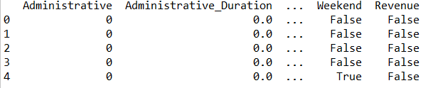

**Output Random Forest Prediction:**



## 2.3 FUNCTIONAL REQUIREMENTS

### 2.3.1 Definite Functional Requirements (first priority)

2.3.1.1 Definite Requirement #1: Estimate probability of making purchase.

The project shall anticipate the shopping behavior of the visitor with the help of aggregated pageview data gathered during the visit along with session time and user related information, and shall provide the odds of making purchase for a particular visitor.

2.3.1.2 Definite #2: Create Data visualization.

The project shall create data visualizations for easy and efficient analysis of data. I would like to take advantage of available libraries and visualization tools for clear and concise presentation of my findings.

### 2.3.2 Nice-to-do Functional Requirements (second priority)

Using only sequential clickstream data, train a long short-term memory-based recurrent neural network that generates a sigmoid output showing the probability estimate of visitor’s intention to leave the site without finalizing the transaction in a prediction horizon. [1]

It would also be nice to create visualizations to represent the data, I will be evaluating the available libraries and the available visualization tools to show case the data.

I would also like to use TensorFlow [14]to build the models, and to explore and utilize its features.

### 2.3.2.1 Nice-to-do Requirement #1: Predict shopping odds based on region.

### The project shall predict if it is more likely for a visitor from a particular zip code to place order compared to visitor from any other zip code.

### 2.3.2.2 Nice-to-do #2: Predict shopping odds based on holidays.

The project shall predict if the shopping odds get impacted by the day (weekday, weekends, special day or holidays) of the website visit.

## 2.4 V2: HOW SUCCESS WILL BE ASSESSED

Evaluating machine learning algorithm is an essential part of my project. My model may give satisfying results when evaluated using a metric say accuracy_score but may give poor results when evaluated against other metrics such as logarithmic_loss or any other such metric.

Most of the times we use classification accuracy to measure the performance of our model, however it is not enough to truly judge the selected model.

**I will be using following types of evaluation metrics for different classifications like SVM, RF KNN and GBM and compare the results.**

Definitions of evaluation metrics is as follows:

1. Classification Accuracy[10] : It is the ratio of number of correct predictions to the total number of input samples
$$Accuracy=\frac{Number of Correct Prediction}{Total Number of predictions made}$$

2. Logarithmic Loss[10]: Logarithmic Loss or Log Loss, works by penalizing the false classifications.

$$LogarithmicLoss=-\frac{1}{N}\sum_{i=1}^{N}{*}\sum_{j=1}^{M}{yij*\log{(pij)}}$$

y_ij, indicates whether sample i belongs to class j or not

p_ij, indicates the probability of sample i belonging to class j

Log Loss has no upper bound and it exists on the range [0, ∞). Log Loss nearer to 0 indicates higher accuracy, whereas if the Log Loss is away from 0 then it indicates lower accuracy.

1. Confusion Matrix[10]: It describes the complete performance of the model.

There are 4 important terms:

* 1. **True Positives(TP)**: The cases in which we predicted YES and the actual output was also YES.
  2. **True Negatives(TN)**: The cases in which we predicted NO and the actual output was NO.
  3. **False Positives(FP)**: The cases in which we predicted YES and the actual output was NO.
  4. **False Negatives(FN)**: The cases in which we predicted NO and the actual output was YES.

1. Accuracy[10]: Confusion Matrix terms can be used to calculate the accuracy
$$Accuracy=\frac{TP+TN}{TotalSample}$$

2. Area Under the Curve (AUC) [10]: Area Under Curve(AUC) is one of the most widely used metrics for evaluation. It is used for binary classification problem. AUC of a classifier is equal to the probability that the classifier will rank a randomly chosen positive example higher than a randomly chosen negative example. Before defining AUC, let us understand two basic terms:
   1. True Positive Rate (Sensitivity): True Positive Rate corresponds to the proportion of positive data points that are correctly considered as positive, with respect to all positive data points.
 $$TPR=\frac{TP}{FN+TP}$$

  2. True Negative Rate (Specificity): True Negative Rate is defined as TN / (FP+TN). False Positive Rate corresponds to the proportion of negative data points that are correctly considered as negative, with respect to all negative data points.
 $$TNR=\frac{TN}{TN+TP}$$

  3. False Positive Rate: False Positive Rate is defined as FP / (FP+TN). False Positive Rate corresponds to the proportion of negative data points that are mistakenly considered as positive, with respect to all negative data points.
$$FPR=\frac{FP}{FP+TN}$$

3. F1 Score[10]: F1 Score is the Harmonic Mean between precision and recall. The range for F1 Score is [0, 1]. It tells you how precise your classifier is (how many instances it classifies correctly), as well as how robust it is (it does not miss a significant number of instances).
$$F1 Score=2*\frac{1}{\frac{1}{precision}+\frac{1}{recall}}$$

4. Mean Squared Error (MSE) [10]: Mean Squared Error(MSE) is quite similar to Mean Absolute Error, the only difference being that MSE takes the average of the square of the difference between the original values and the predicted values. The advantage of MSE being that it is easier to compute the gradient, whereas Mean Absolute Error requires complicated linear programming tools to compute the gradient.
$$MSE=\frac{1}{N} \sum_{j=1}^{N}{{\left(y_{j}-\hat{y_{j}}\right)}^{2}}$$

5. Mean Absolute Error[10]: Mean Absolute Error is the average of the difference between the Original Values and the Predicted Values. It gives us the measure of how far the predictions were from the actual output.

$$MAE=\frac{1}{N} \sum_{j=1}^{N}{|y_{j}-\hat{y_{j}}|}$$

## 2.5 TECHNOLOGY EXPLANATION

Since the dataset being used has defined field as the class label, that is the “Revenue” field, the output would be predicting if the online user would make a purchase or not, I will be building supervised learning models using classification algorithms. The models will be build using various classification algorithms like, Random Forest [5], Support-vector machine (SVM) [2] [3], and the best model will be picked as per the performance results. I would also like to actually predict the probability of purchasing and would apply Gradient Boosting Machines to build the model to get the probabilities, and also would like to apply a Neural Network model [2] to generate the output showing the probability estimate of visitor’s intention to leave the site without finalizing the transaction in a prediction horizon.

***About the algorithms being considered to build the classification models:***

1. Support-Vector Machine (SVM)[3][8]: SVM is a relatively simple **Supervised Machine Learning Algorithm** used for classification and/or regression. It is more preferred for classification but is sometimes very useful for regression as well. Basically, SVM finds a hyper-plane that creates a boundary between the types of data. In 2-dimensional space, this hyper-plane is nothing but a line. In SVM, we plot each data item in the dataset in an N-dimensional space, where N is the number of features/attributes in the data. Next, find the optimal hyperplane to separate the data. So by this, you must have understood that inherently, SVM can only perform binary classification (i.e., choose between two classes).

SVM Pros/Cons[9]:

|  |  |
| --- | --- |
| Pros | Cons |
| It works really well with a clear margin of separation | doesn’t perform well when we have large data set and noisy data set |
| It is effective in high dimensional spaces. | doesn’t directly provide probability estimates, these are calculated using an expensive five-fold cross-validation |
| Outliers have less impact |  |
| Best suited for extreme case binary classification |  |

1. Random forest[5]: A Random Forest is an ensemble technique capable of performing both regression and classification tasks with the use of multiple decision trees and a technique called Bootstrap and Aggregation, commonly known as bagging. The basic idea behind this is to combine multiple decision trees in determining the final output rather than relying on individual decision trees. Random Forest has multiple decision trees as base learning models. We randomly perform row sampling and feature sampling from the dataset forming sample datasets for every model. This part is called Bootstrap. Here is **why Random forest****[9]** is good for my project:

|  |  |
| --- | --- |
| Pros | Cons0 |
| Decorrelate trees – it picks training sample and gives each tree a subset of the features | Features need to have some predictive power else they won’t work |
| Reduced Errors. | Predictions of the trees need to be uncorrelated |
| **Good Performance on Imbalanced datasets** | Appears as Black Box |
| Handling of huge amount of data |  |

1. Gradient Boosting Machine: GBM is another ensemble method which I am considering for this project**.**“Gradient boosting classifiers are a group of machine learning algorithms that combine many weak learning models together to create a strong predictive model. Decision trees are usually used when doing gradient boosting. [19]” “GBM (Gradient Boosting Machine) and RF (Random Forest) differ in the way the trees are built: the order and the way the results are combined. [20]  
   Gradient Boosting learns from the mistake — residual error directly, rather than update the weights of data points [21] .

Here is why GBM is good compared other classifiers:

|  |  |
| --- | --- |
| Pros | Cons |
| Often provides predictive accuracy that cannot be beat. |  |
| Lots of flexibility - can optimize on different loss functions and provides several hyperparameter tuning options that make the function fit very flexible. |  |
| No data pre-processing required |  |
| Handles missing data - imputation not required. |  |

I am also planning to use the Multilayer perceptron algorithm, “*Multilayer perceptrons are often applied to supervised learning problems: they train on a set of input-output pairs and learn to model the correlation (or dependencies) between those inputs and outputs. Training involves adjusting the parameters, or the weights and biases, of the model in order to minimize error”* *[24]*, I want to validate that applying a neural network algorithm impact the overall performance of the model or not.

I will be doing the following

1. Use Weka (software used for Machine learning) to split the data into 2 parts
   1. Training datasets
   2. Test datasets
2. Then use Python to verify the result of train and test datasets.

I will be using Weka’s attribute selection feature to select the most appropriate attributes (predictive attributes), in terms of their contributions to the output/results [3] , and would be trying to apply it in Python as well [12] .

I will be using Weka, Python3 and its packages like matplotlib, Scikit-learn etc. to build the classification models.

|  |
| --- |
| Weka Screen Shot |

## 2.6 DATA SOURCES

SIP model would use data extensively. I am planning to use the “Online Shoppers Purchasing Intension Dataset” from “[UCI Machine Learning Repository](https://archive.ics.uci.edu/ml/datasets/Online+Shoppers+Purchasing+Intention+Dataset)” [1].

## 2.8 REFERENCES FOR PROPOSAL V2

[1] https://archive.ics.uci.edu/ml/datasets/Online+Shoppers+Purchasing+Intention+Dataset#

[2] Machine Learning_ An Algorithmic Perspective (2nd ed.) [Marsland 2014-10-08] (Chapter 1-Section 1.4: Supervised Learning, Section 1.4.2: Classification, Overview of Chapter 4 and 8 to have a basic understanding of the Multi-layer Perceptron and Support Vector Machines algorithms, respectively; Chapter 13-Section 13.3: Random Forests)

[3] <https://www.geeksforgeeks.org/introduction-to-support-vector-machines-svm/>

[4] <https://www.geeksforgeeks.org/k-nearest-neighbours/>

[5] <https://www.geeksforgeeks.org/random-forest-regression-in-python/>

[6] <https://support.google.com/analytics/answer/1009409?hl=en>

[7] <https://blog.usejournal.com/a-quick-introduction-to-k-nearest-neighbors-algorithm-62214cea29c7>

[8] <https://www.analyticsvidhya.com/blog/2017/09/understaing-support-vector-machine-example-code/>

[9] <https://towardsdatascience.com/pros-and-cons-of-various-classification-ml-algorithms-3b5bfb3c87d6>

[10] <https://towardsdatascience.com/metrics-to-evaluate-your-machine-learning-algorithm-f10ba6e38234>

[11] <https://towardsdatascience.com/understanding-gradient-boosting-machines-9be756fe76ab>

[12] <https://towardsdatascience.com/a-feature-selection-tool-for-machine-learning-in-python-b64dd23710f0>, <https://www.datacamp.com/community/tutorials/feature-selection-python>, <https://machinelearningmastery.com/feature-selection-machine-learning-python/>

[13] <https://yoast.com/what-is-page-value-in-google-analytics/>

[14] <https://www.analyticsvidhya.com/blog/2017/03/imbalanced-classification-problem/>

[19] <https://machinelearningmastery.com/tactics-to-combat-imbalanced-classes-in-your-machine-learning-dataset/>

[20] <https://stackabuse.com/gradient-boosting-classifiers-in-python-with-scikit-learn/>

[21] <https://medium.com/@aravanshad/gradient-boosting-versus-random-forest-cfa3fa8f0d80>

[22] <https://towardsdatascience.com/basic-ensemble-learning-random-forest-adaboost-gradient-boosting-step-by-step-explained-95d49d1e2725>

[23] <https://medium.com/@rrfd/standardize-or-normalize-examples-in-python-e3f174b65dfc>

[24] <https://skymind.ai/wiki/multilayer-perceptron#mlp>

## Appendix:

Python code:

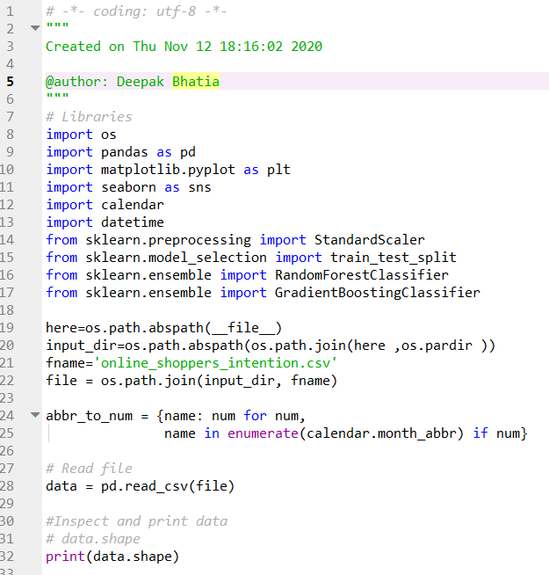





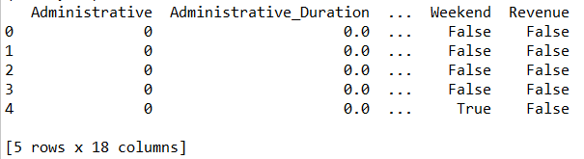



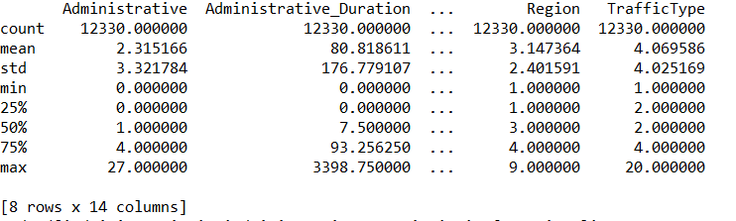

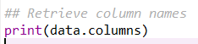

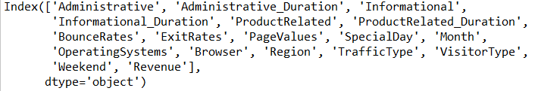

**Code:**

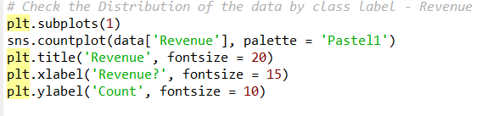

**Output**

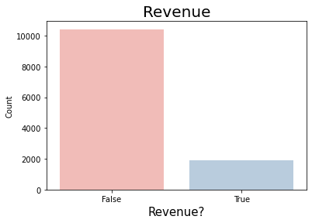

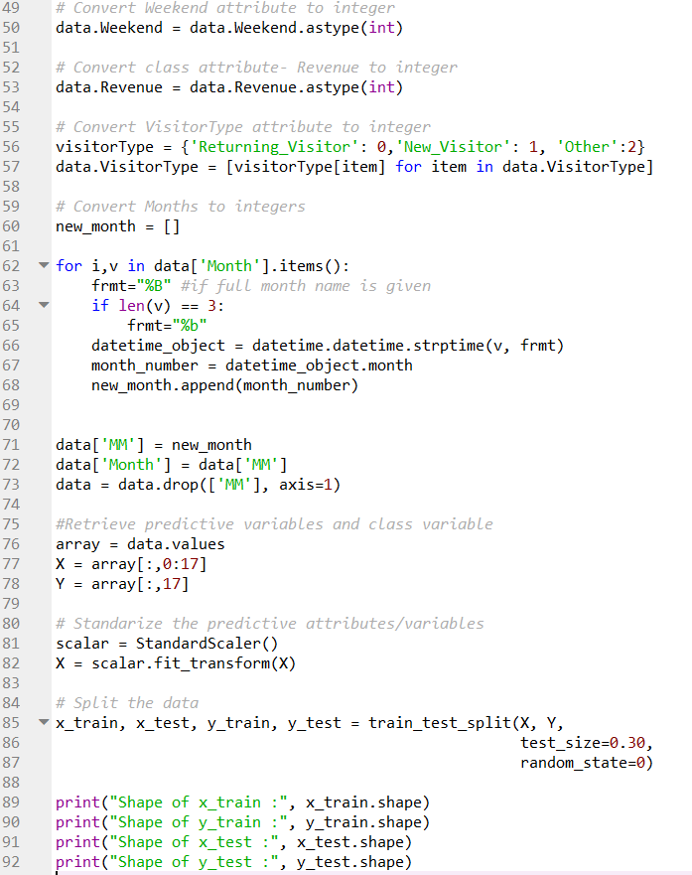

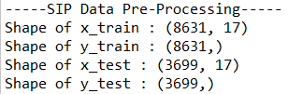

**Code:**

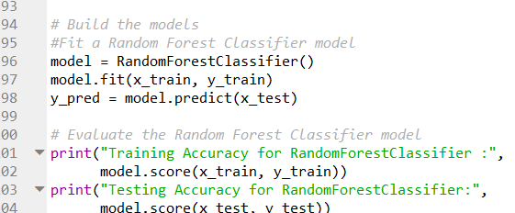

**Output:**



**Code:**

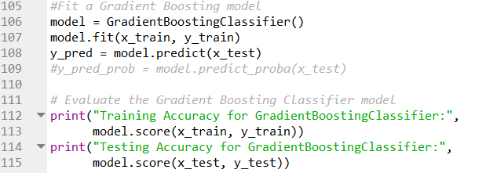

**Output:**



# Project Design

## 3.1 Final Functional requirements

3.1.1 (DF) Estimate probability of making purchase.

The project shall anticipate the shopping behavior of the visitor with the help of aggregated pageview data gathered during the visit along with session time and user related information, and shall provide the odds of making purchase for a particular visitor.

3.1.2 (DF) Create Data visualization

The project shall create data visualizations for easy and efficient analysis of data. I would like to take advantage of available libraries and visualization tools for clear and concise presentation of my findings.

### 3.1.3 (DF) Predict shopping odds based on holidays.

The project shall predict if the shopping odds get impacted by the day (weekday, weekends, special day or holidays) of the website visit.

### 3.1.4 (DF) Predict shopping odds based on region.

The project shall predict if it is more likely for a visitor from a particular zip code to place order compared to visitor from any other zip code.

3.1.5 (NF) Nice to add Tensor flow.

If time permits I would like to learn and use Tensor flow.

3.1.6 (NF) Add extra machine learning model.

I would like to add new machine learning classifier which is not identified as must to do for this project and compare the outcome of new machine learning which other models.

3.1.7 (NF) Perform Principal Component Analysis [26].

I would like to perform principal component analysis to perform dimensionality reduction. This will help reduce the noisy data from the dataset.

3.1.8 (NL) Learn Neural Network ML model.

I would like to use Neural Network model along with Keras.

## 3.2 Design and Theory

The below diagram describes the process flow of the project:

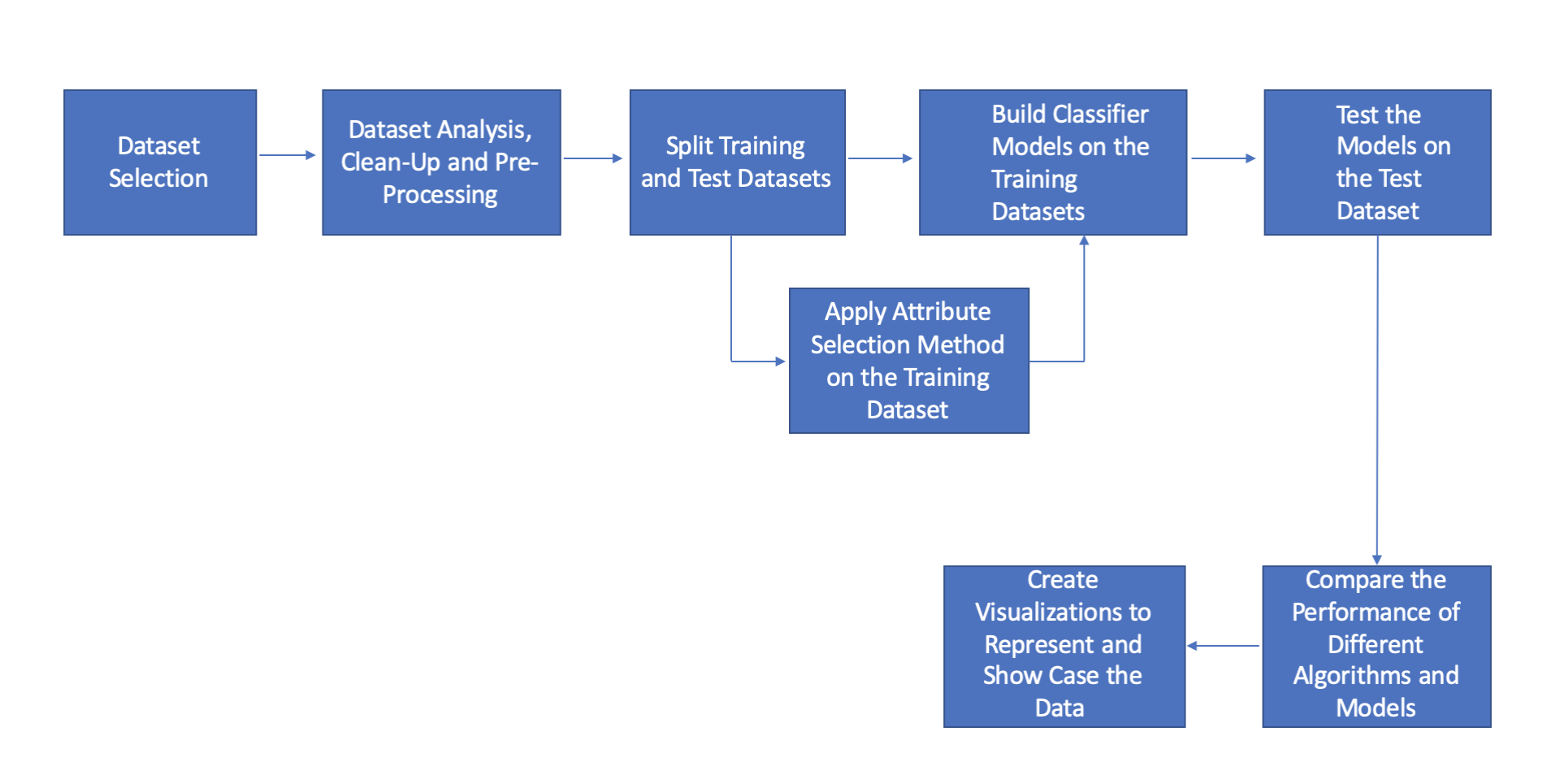

1. Dataset Selection – The first step is to select a dataset. SIP model would use data extensively. I am planning to use the “Online Shoppers Purchasing Intension Dataset” from “[UCI Machine Learning Repository](https://archive.ics.uci.edu/ml/datasets/Online+Shoppers+Purchasing+Intention+Dataset)”[1]
2. Dataset Analysis, Clean-up & Preprocessing – In this step, the data is analyzed through visualization and other techniques to find any outliers (if any). (Please refer to the code in the appendix section to see the steps we have followed to clean up and preprocess the data)
3. Split Training and Test Datasets – After preprocessing of the dataset, we will be arranging dataset into 2 parts i.e. Train and Test. The machine learning models (SVM, Random Forest etc.) will be trained and built on the training dataset and will then use Test dataset to predict the classification.
4. Build models – After splitting into 2 parts i.e. Train & Test datasets, we will build our machine learning models using the identified algorithms on the training dataset.
5. Test models – In this step we have to predict the classification using test data dataset.
6. Compare ML model performance – In this step we have to compare the performance (like Accuracy, F1-score, Precision & Recall) of different models to identify the best model.
7. Repeat steps 1 through 7 after selecting the top best attributes via ranked by the attribute selections method. To improve the performance it is important to perform attribute selection via attribute selection methods like info-gain, gain-ratio, or correlation with the class attribute.
8. Create visualizations to showcase the data – Visualization is a best way to represent the data. I will be using this step in my project so that data can be presented in a best way to the end user.

The dataset consists of following 10 numerical and 8 categorical attributes. The 'Revenue' attribute can be used as the class label.

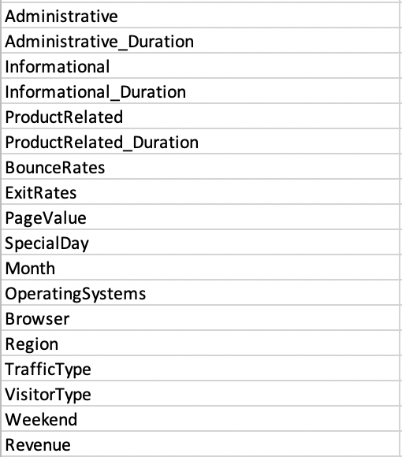

Few tuples of dataset is as follows:

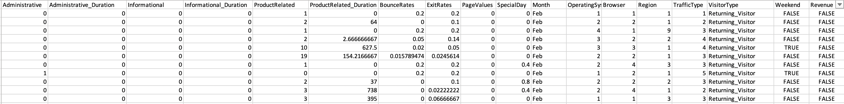

Below table list purpose of important attributes:



Pre-processing step: Scaled dataset which is a part of preprocessing step is as follows:

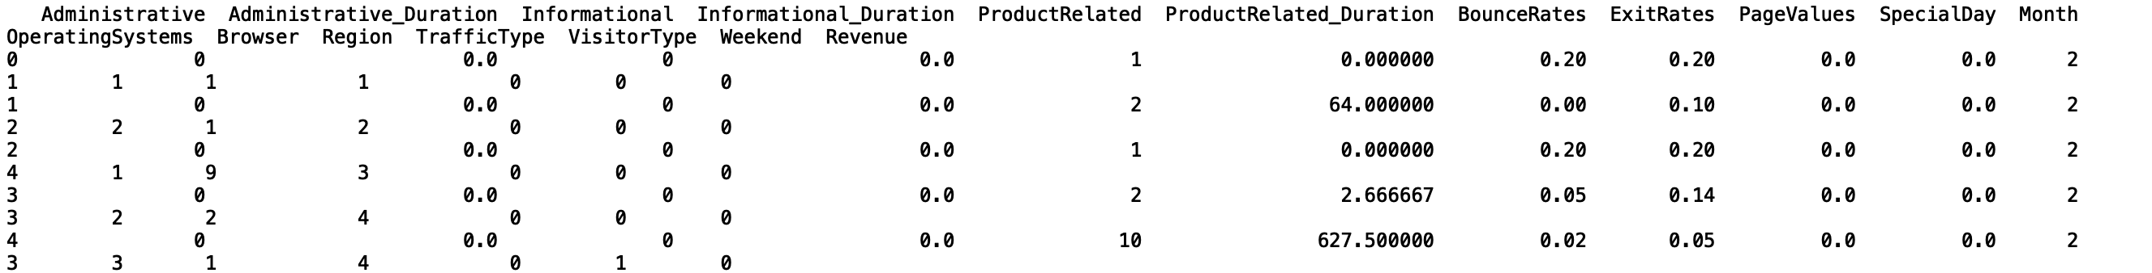

The scaling standardized the dataset which helps compare the score between attributes of different types.

## 3.3 Tools

.

Following tools will be used for this project:

|  |  |
| --- | --- |
| Tool | Description |
| Weka | Weka[25] is tried and tested open source machine learning software that can be accessed through a graphical user interface, standard terminal applications, or a Java API. It is widely used for teaching, research, and industrial applications, contains a plethora of built-in tools for standard machine learning tasks, and additionally gives transparent access to well-known toolboxes such as [scikit-learn](https://markahall.blogspot.co.nz/2015/06/cpython-integration-in-weka.html), [R](https://markahall.blogspot.com/2012/07/r-integration-in-weka.html), and [Deeplearning4j](https://deeplearning.cms.waikato.ac.nz). |
| Python 3 | Python is an interpreted, object-oriented, high-level programming language with dynamic semantics. It's high-level built-in data structures, combined with dynamic typing and dynamic binding, make it very attractive for Rapid Application Development, as well as for use as a scripting or glue language to connect existing components together. |
| Scikit-learn | Is a free software machine learning library for the Python programming language. It features various classification, regression and clustering algorithms including support vector machines, random forests, gradient boosting, k-means and DBSCAN, and is designed to interoperate with the Python numerical and scientific libraries NumPy and SciPy. |
| Matplotlib | Matplotlib is a plotting library for the Python programming language and its numerical mathematics extension NumPy. |
| Spyder | Spyder is an IDE for developing python code. |
| Python libraries | Numpy - NumPy is the fundamental package for scientific computing with Python.  Pandas - pandas is an open source, BSD-licensed library providing high-performance, easy-to-use data structures and data analysis tools for the Python programming language.  Seaborn - Seaborn is a Python data visualization library based on matplotlib. It provides a high-level interface for drawing attractive and informative statistical graphics. |

## 3.4 Risk Retirement

3.4.1 Inappropriate algorithms for ML models

After identifying the dataset, the next step is to analyze the data and explore the various ML models to identify which one is appropriate for the identified dataset. I will be using supervised classification algorithms because dataset has a class attribute.

I learnt about the applications of the decision tree algorithms. I also read online articles & blogs made me think that Random Forest classifier (RF)is an appropriate classification algorithm which can be applied easily on the selected dataset. I discussed my project with my facilitator which helped me explore Gradient Boosting Machine (GBM). I learned about SVM (Support Vector Machines) & Neural Nets which I thought can be used easily in this project. However I am primarily considering GBM and RF to build the ML models.

3.4.2 Unable to present meaningful data

Representing meaningful data is very important. To mitigate the risk to present meaningful data I need to understand and should have good handle. After going through data multiple times I understood the project data pretty well. I am identifying the important dataset attributes that can be represented in such a way that they can be easily understood. I have to explore, read and learn various python libraries that can be used by the code to create the data visualizations.

3.4.3 Optimal performance results

A significant performance result of the selected classifier is one of the highest risks of any machine learning project. To work towards it, I am planning to learn about XGBoost’ for attribute selection. It will help me to rebuild the model using the selected attributes of the dataset. I will learn how to use and apply hyperparameter tuning. The performance of the model will be impacted if the dataset is suspected to have the unbalanced classification. I will try to use different methods for example resampling techniques (over sampling), generating **Synthetic Minority Oversampling Technique** (SMOTE) samples. I have started learning about these options.

## Appendix

Code Snippet:

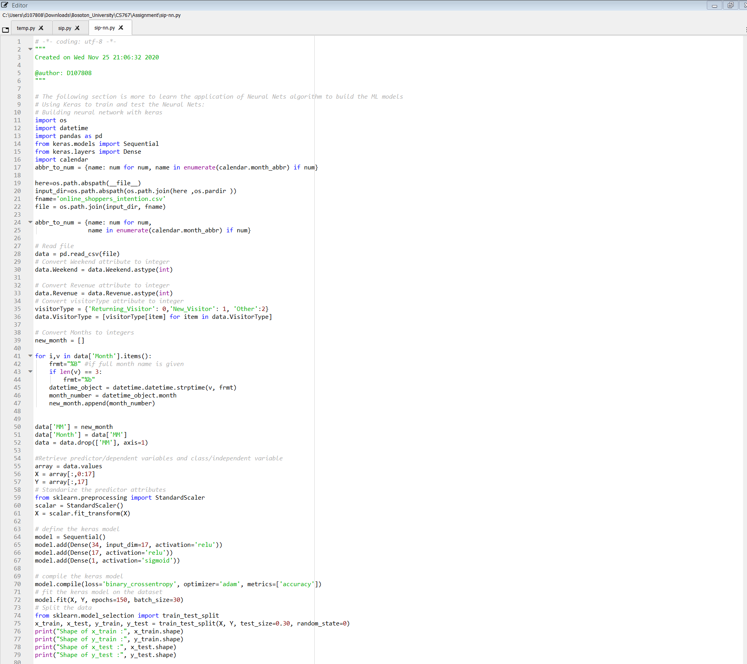

**Output**

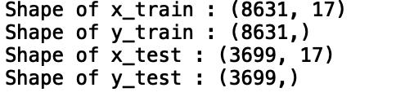

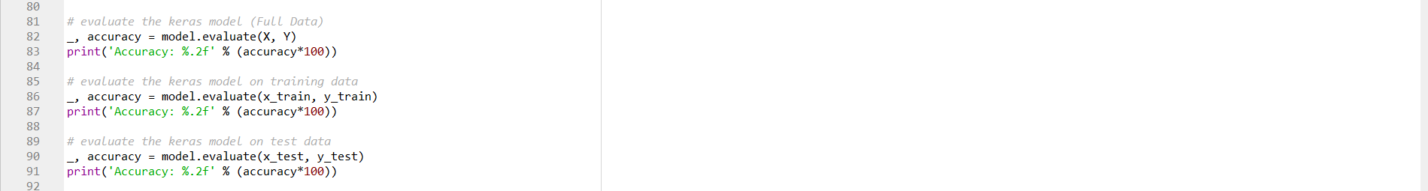

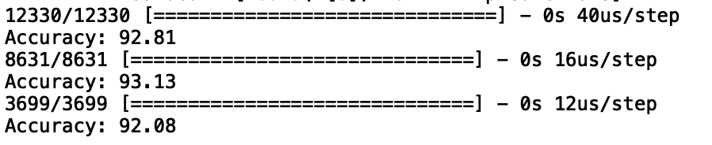

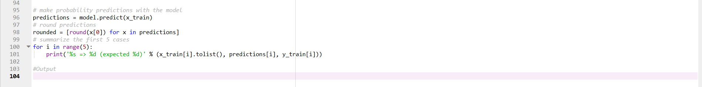

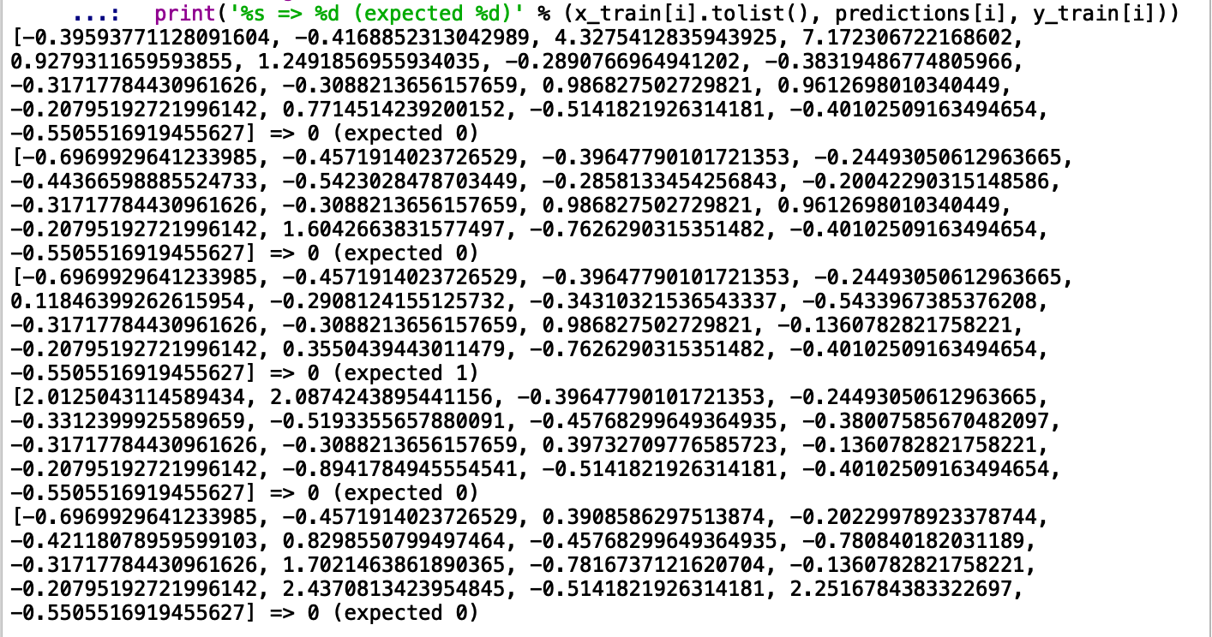

**Iteration-II**

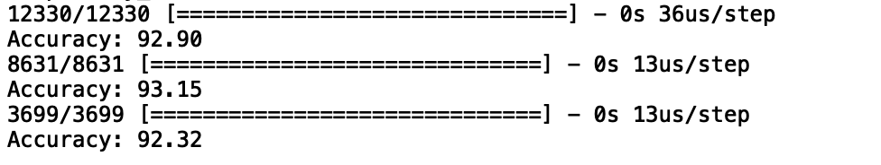

**Iteration-III**

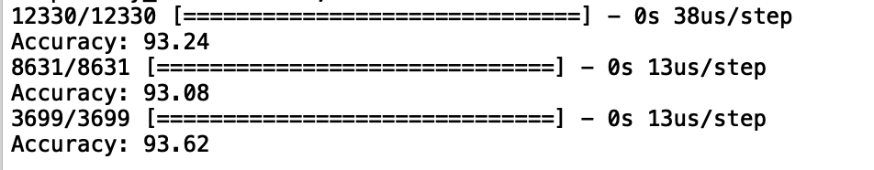

# Project Design Plus

## 4.1 Final Requirements

4.1.1 (DF) Estimate probability of making purchase.

The project shall anticipate the shopping behavior of the visitor with the help of aggregated pageview data gathered during the visit along with session time and user related information, and shall provide the odds of making purchase for a particular visitor.

4.1.2 (DF) Create Data visualization

The project shall create data visualizations for easy and efficient analysis of data. I would like to take advantage of available libraries and visualization tools for clear and concise presentation of my findings.

### 4.1.3 (DF) Predict shopping odds based on holidays.

The project shall predict if the shopping odds get impacted by the day (weekday, weekends, special day or holidays) of the website visit.

### 4.1.4 (DF) Predict shopping odds based on region.

The project shall predict if it is more likely for a visitor from a particular zip code to place order compared to visitor from any other zip code.

4.1.5 (NF) Nice to add Tensor flow.

If time permits I would like to learn and use Tensor flow.

4.1.6 (NF) Add extra machine learning model.

I would like to add new machine learning classifier which is not identified as must to do for this project and compare the outcome of new machine learning which other models.

4.1.7 (NF) Perform Principal Component Analysis [26].

I would like to perform principal component analysis to perform dimensionality reduction. This will help reduce the noisy data from the dataset.

4.1.8 (NL) Learn Neural Network ML model.

I would like to use Neural Network model along with Keras.

## 4.2 Design and Theory

Improved version of the process flow of the project is as follows:

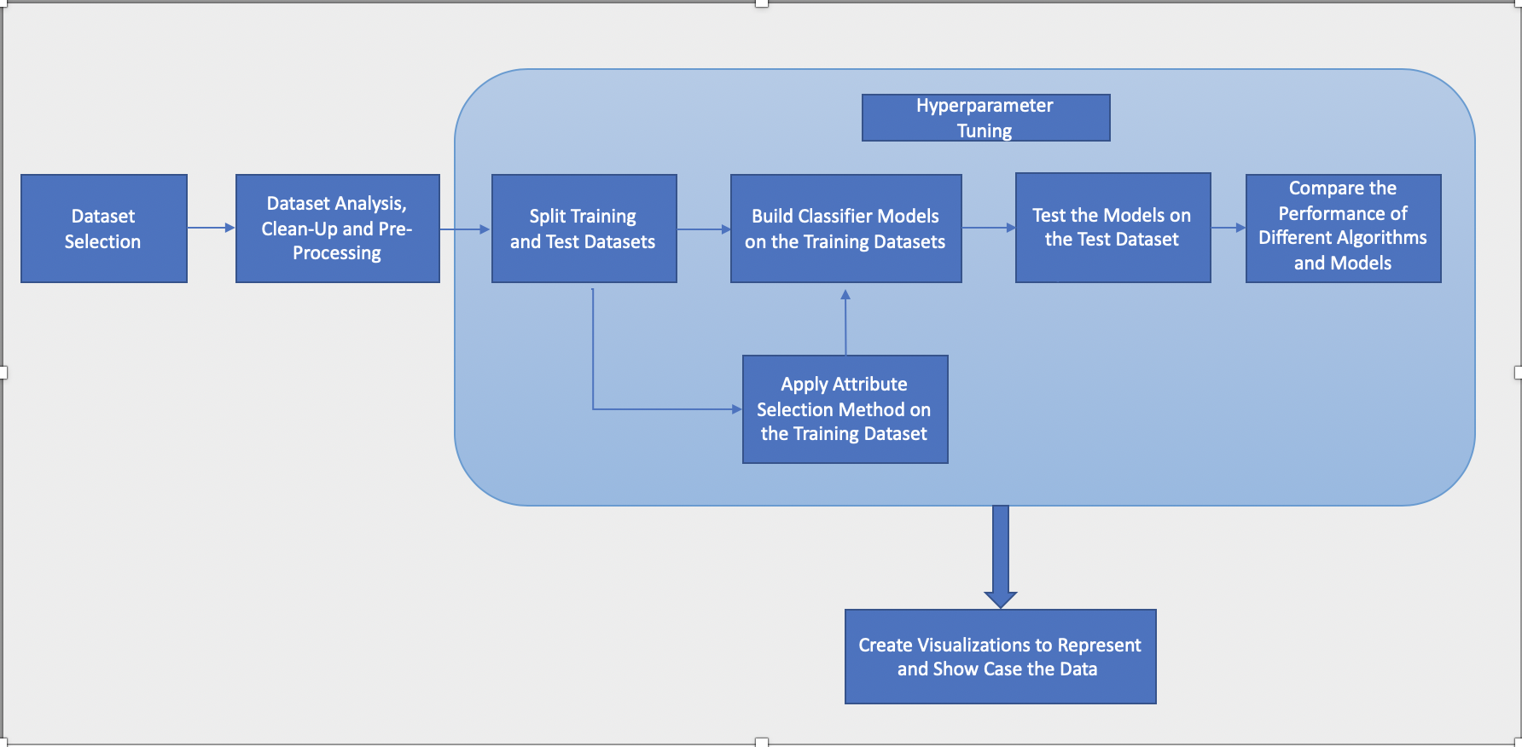

Below are the high-level process flow steps, we would be implementing, as shown in Figure-1:

1. Dataset Selection – The first step is to select a dataset. SIP model would use data extensively. I am planning to use the “Online Shoppers Purchasing Intension Dataset” from “[UCI Machine Learning Repository](https://archive.ics.uci.edu/ml/datasets/Online+Shoppers+Purchasing+Intention+Dataset)”[1]
2. Dataset Analysis, Clean-up & Preprocessing – In this step, the data is analyzed through visualization and other techniques to find any outliers (if any). (Full code and pre-processing steps are given in the Appendix).

After careful examination, analysis of the dataset, I am considering following preprocessing steps:

* Searching and removing records that contain Nas and Nulls.
* Identify and convert the attributes which need to be converted to numerical/integer data, like “month”, “visitorType”, “weekend” etc.
* Change the values of class attribute to binary values.
* Standardize the attributes. - The attributes in the given dataset have different scales. we need to standardize the dataset to put all the attributes/variables on the same scale. By standardizing the variables, we will be able to compare scores between different types of variables.

1. Split Training and Test Datasets – After preprocessing of the dataset, we will be arranging dataset into 2 parts i.e. Train and Test. The machine learning models (SVM, Random Forest etc.) will be trained and built on the training dataset and will then use Test dataset to predict the classification.
2. Build models – After splitting into 2 parts i.e. Train & Test datasets, we will build our machine learning models using the identified algorithms on the training dataset.
3. Test models – In this step we have to predict the classification using test data dataset.
4. Compare ML model performance – In this step we have to compare the performance (like Accuracy, F1-score, Precision & Recall) of different models to identify the best model.
5. Repeat steps 1 through 7 after selecting the top best attributes via ranked by the attribute selections method. To improve the performance it is important to perform attribute selection via attribute selection methods like info-gain, gain-ratio, or correlation with the class attribute.
6. Create visualizations to showcase the data – Visualization is a best way to represent the data. I will be using this step in my project so that data can be presented in a best way to the end user.
7. Hyperparameter Tuning – “*In machine learning, hyperparameter optimization or tuning is the problem of choosing a set of optimal hyperparameters for a learning algorithm. These measures are called hyperparameters and have to be tuned so that the model can optimally solve the machine learning problem.”* [29]

We will be tuning the hyperparameters for the identified ML algorithm/algorithms to improve the performance of our model/models.

**Dataset Description**

The dataset has 10 numerical and 8 categorical attributes. The 'Revenue' attribute is a class label.



Few tuples of dataset is as follows



As it is shown above, there are some predictive attributes present in the dataset that are non-numerical. As a step in preprocessing the dataset, we have changed the values of non-numeric attributes to numeric format with the help of the Scikit learn library*( please refer Tools section for more details).* I have converted “Revenue” (class attribute) to a binary value. (Full code is given in the Appendix)

Pre-processing step: Scaled dataset which is a part of preprocessing step is as follows:



As it is displayed in the above screen shot, the attributes in the provided dataset do not have same scale. Therefore, standardization of the dataset is needed to keep all the attributes and variables on the same scale. Standardization will make it easy for us to compare scores between various types of variables (Full code is given in the Appendix).

Firstly, the ML models will be created using all the attributes. Later, as per the attribute selection of the attribute selection method(s), we would pick some of the attributes and discard the rest. The built model will help us classify the new (test) data.

The output of the applied model on the test data would be the **confusion metrics**- *If Class/Revenue 1 is identified as positive event, then displaying the True Positives (Revenue 1 classified as Revenue 1), True Negatives (Revenue 0 classified as Revenue 0), False Positives (Revenue 0 classified as Revenue 1), and False Negatives (Revenue 1 classified as Revenue 0),* and the corresponding **performance metrics** (accuracy, f1-score, precision, recall, roc curve) and the probability of each event (Here, Revenue=0 or 1), after applying the model on the test dataset.

Here are the screen shots from Weka exhibiting the performance metrics of a model, run as a preliminary test on the dataset:

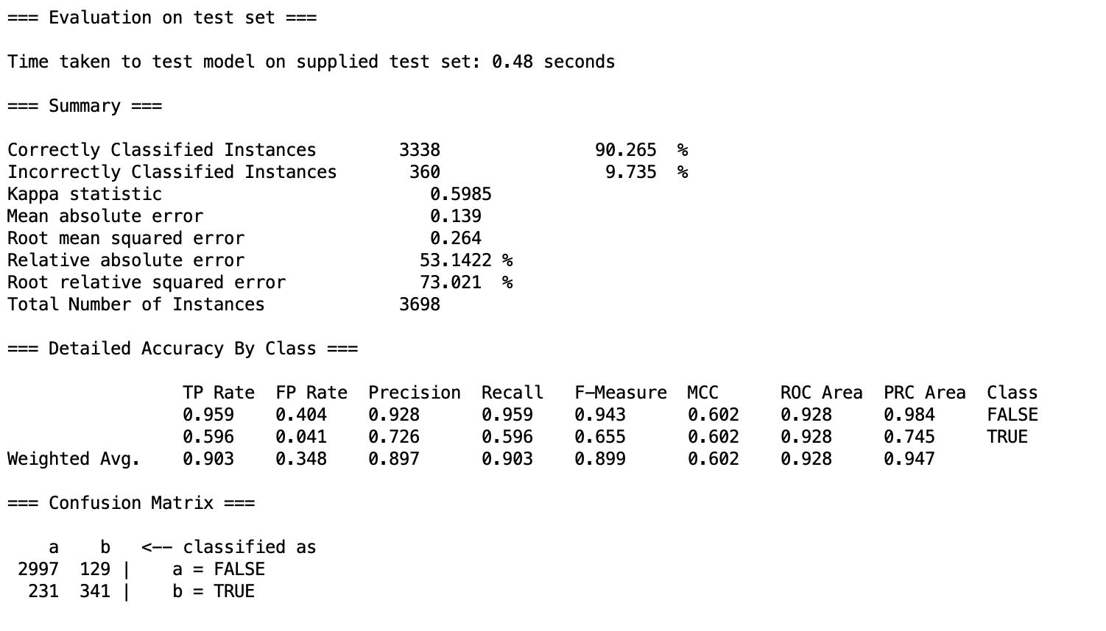

*Weka - Screen shots taken from Weka, this is displaying the prediction results on the test dataset, run as a preliminary test on the dataset:*

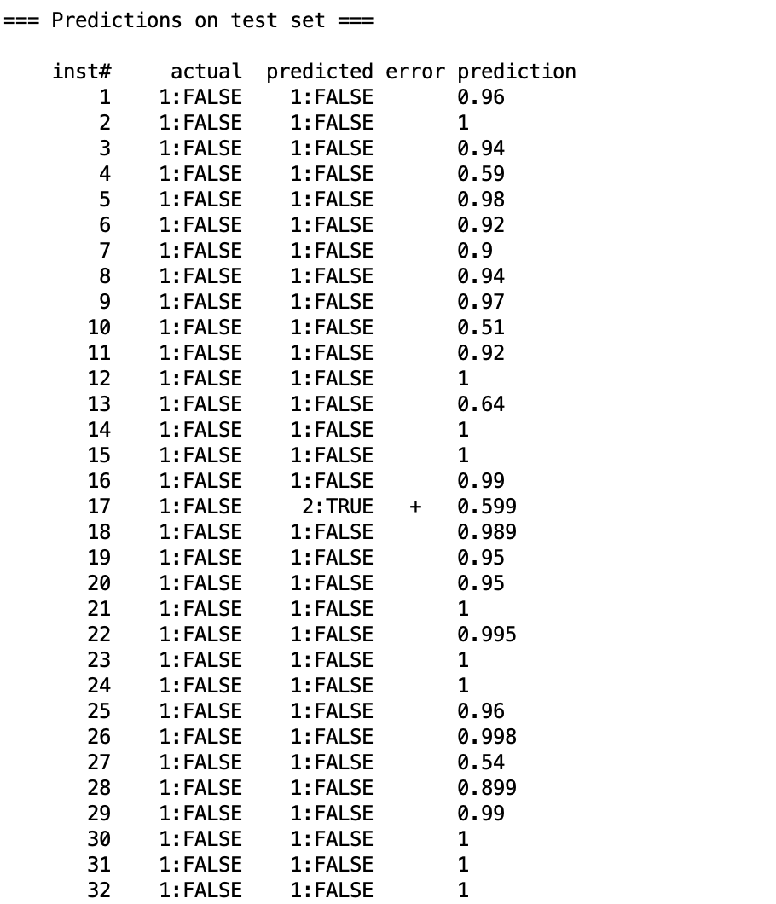

**Classifiers Identified for this project:**

Since the dataset has a class label it is a Classification problem. Classification is the method of predicting the class of a given input data point. Classification problems fall under the Supervised learning method.

I had initially identified Random Forest classification algorithm as one of the algorithms for building the ML model for this website. Then we preferred **Gradient Boosting Machines-GBM** over Random Forest, after analyzing the dataset and understanding the benefits of GBM over Random Forest *(Please refer the Appendix Section* *Identified Algorithms - RF and GBM* *for details)*

Another recommended algorithm which is considered more efficient than GBM is **XGBoost. XGBoost** stands for “Extreme Gradient Boosting”. “Both XGBoost and GBM follow the principle of gradient boosting. There are, however, the difference in modeling details. Specifically, XGBoost uses a more regularized model formalization to control over-fitting, which gives it better performance. The name XGBoost, though, actually refers to the engineering goal to push the limit of computations resources for boosted tree algorithms. Which is the reason why many people use XGBoost. For model, it might be more suitable to be called as regularized gradient boosting.” [27][28]

XGBoost focuses on the computational power, by parallelizing the tree formation [30] .

Hence, **XGBoost** being a more efficient Gradient Boosting algorithm, it will be our algorithm of **choice for this project**.

Graphical Representation of Gradient Boosting

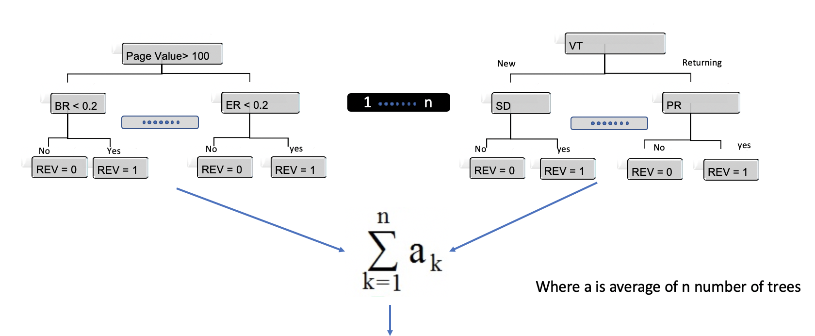

Information about attributes are as follows:

|  |  |  |
| --- | --- | --- |
| Abbreviation | Full Name | Attribute purpose |
| PV | Page Value | The "Page Value" feature represents the average value for a web page that a user visited before completing an e-commerce transaction. [11][13] |
| BR | Bounce Rates | The value of "Bounce Rate" feature for a web page refers to the percentage of visitors who enter the site from that page and then leave ("bounce") without triggering any other requests to the analytics server during that session. [9] [13] |
| ER | Exit Rates | The value of "Exit Rate" feature for a specific web page is calculated as for all pageviews to the page, the percentage that were the last in the session. [10] [13] |
| SD | Special Day | The "Special Day" feature indicates the closeness of the site visiting time to a specific special day (e.g. Mother’s Day, Valentine's Day) in which the sessions are more likely to be finalized with transaction. The value of this attribute is determined by considering the dynamics of e-commerce such as the duration between the order date and delivery date. For example, for Valentina’s day, this value takes a nonzero value between February 2 and February 12, zero before and after this date unless it is close to another special day, and its maximum value of 1 on February 8. [13] |
| PR, PRD,  AD, ADD,  INF, IND | Product Related ,  Product Related Duration, Administrative, Administrative Duration, Informational,  Informational Duration | All these attributes represent the number of different types of pages visited by the visitor in that session and total time spent in each of these page categories. The values of these features are derived from the URL information of the pages visited by the user and updated in real time when a user takes an action, e.g. moving from one page to another. [13] |
| REV | Revenue (Class Variable/Attribute) | REV = 0 is no-shopping/not-shopped event and REV = 1 is shopping/shopped event. [13] |
| VT | Visitor Type | Returning or New Visitor [13] |
| WK | Weekend | A Boolean value indicating whether the date of the visit is weekend [13] |
| MM | Month | Month of the year [13] |
| OS | Operating System |  |
| BR | Browser |  |
| RE | Region |  |
| TT | Traffic Type |  |

## 4.3 V2 Tools

Following tools will be used for this project:

|  |  |  |
| --- | --- | --- |
| Tool | Description | Project Use |
| Weka | Weka[25] is tried and tested open source machine learning software that can be accessed through a graphical user interface, standard terminal applications, or a Java API. It is widely used for teaching, research, and industrial applications, contains a plethora of built-in tools for standard machine learning tasks, and additionally gives transparent access to well-known toolboxes such as [scikit-learn](https://markahall.blogspot.co.nz/2015/06/cpython-integration-in-weka.html), [R](https://markahall.blogspot.com/2012/07/r-integration-in-weka.html), and [Deeplearning4j](https://deeplearning.cms.waikato.ac.nz). | I will be using **Weka** [25] primarily to run some preliminary tests on the dataset, like the attribute selection methods on the training dataset. Using the attribute selection methods, like InfoGainAttributeEval, GainRatioAttributeEval, I can choose the attributes with high information gain or gain ratio to build the ML model, which can help to improve the performance of the classification model.  Using **Ranker** search methodattributes are ranked by their individual evaluations. It’s used in conjunction with attribute evaluators. |
| Python 3 | Python is an interpreted, object-oriented, high-level programming language with dynamic semantics. It's high-level built-in data structures, combined with dynamic typing and dynamic binding, make it very attractive for Rapid Application Development, as well as for use as a scripting or glue language to connect existing components together. | I will be using this to develop project code. |
| Scikit-learn[27] | Is a free software machine learning library for the Python programming language. It features various classification, regression and clustering algorithms including support vector machines, random forests, gradient boosting, k-means and DBSCAN, and is designed to interoperate with the Python numerical and scientific libraries NumPy and SciPy. | Scikit-learn provide dozens of built in machine learning. After installing Scikit-learn package. I am using to StandardScaler function to scale/normalized my data, RandomForesetClassifier to predict Revenue (class attribute) can be generated or not.  from sklearn.preprocessing import StandardScaler  from sklearn.model_selection import train_test_split  from sklearn.ensemble import RandomForestClassifier  from sklearn.ensemble import GradientBoostingClassifier |
| Matplotlib | Matplotlib is a plotting library for the Python programming language and its numerical mathematics extension NumPy. | I will be using this to plot different graphs.  Sample code:  import matplotlib.pyplot as plt  plt.subplots(1)  sns.countplot(data['Revenue'], palette = 'Pastel1')  plt.title('Revenue', fontsize = 20)  plt.xlabel('Revenue?', fontsize = 15)  plt.ylabel('Count', fontsize = 10) |
| Spyder | Spyder is an IDE for developing python code. | This is the UI which is used to write, compile and execute the code. |
| Python libraries | Numpy - NumPy is the fundamental package for scientific computing with Python.  Pandas - pandas is an open source, BSD-licensed library providing high-performance, easy-to-use data structures and data analysis tools for the Python programming language.  Seaborn - Seaborn is a Python data visualization library based on matplotlib. It provides a high-level interface for drawing attractive and informative statistical graphics. | Numpy will help managing multi dimension array.  Panda’s readCSV function will be used to load and read project data.  Seaborn package help me improve and draw different types of plots. |

## 4.4 Implementation Fragments

Given below are the various steps identified for this project, in conjunction with what we have implemented till now.

* **Dataset Selection**

For this project, I was looking for an e-commerce dataset, and I selected the “Online Shoppers Intention” dataset from the UCI Machine Learning repository. The dataset consists of feature vectors of 12,330 sessions, it has 10 numerical and 8 categorical attributes. The “Revenue” attribute is a Boolean attribute, which can be used as a class label. The dataset contains the aggregated pageview data, with the attributes like “Bounce Rate” [9] , “Exit Rate” [10] , “Page Value” [11] etc., gathered by google analytics [4][12], along with the session and user information. The data also has the final results of the customers’ visit to the site, in terms of whether the particular session resulted in revenue or not.

*Please refer the appendix section “Google Analytics Metrics” for the details about these metrics.*

The dataset also contains the number of different types of pages visited by the visitor in that session and total time spent in each of these page categories. It has some other fields pertaining to user and session information.

*Please refer the appendix section “Dataset” for more details about the dataset and each of these fields*

After careful examination of the provided dataset, we would come up with a use case that would have following input attributes and the output:

The **input** would be the standardized [22] aggregated pageview data, session and user information, and the output would be the purchasing intention prediction in terms of revenue. The “Revenue” field is a Boolean field, which is “True”, if the user ends up making a purchase and “False”, if the user doesn’t make a purchase.

We would then elaborate our use-case to find out the probability of purchasing, in order to target the customers with high probability of purchasing.

We also identified some of the important business questions, which can be addressed with this dataset, like:

* + Are the visitors from a specific region more likely to make a purchase than the ones from other regions?
  + Do new visitors have more probability to generate the revenue (make a purchase) than the returning visitors?
  + Do weekends and special days influence the purchasing decision of the visitors?

Further step needed was to examine the data in detail and perform couple of preliminary tests. Weka was used to run some initial checks on the data. Python was used to check the distribution of the class label by plotting it.

*Here is the screen shot from Weka exhibiting the distribution of the dataset*

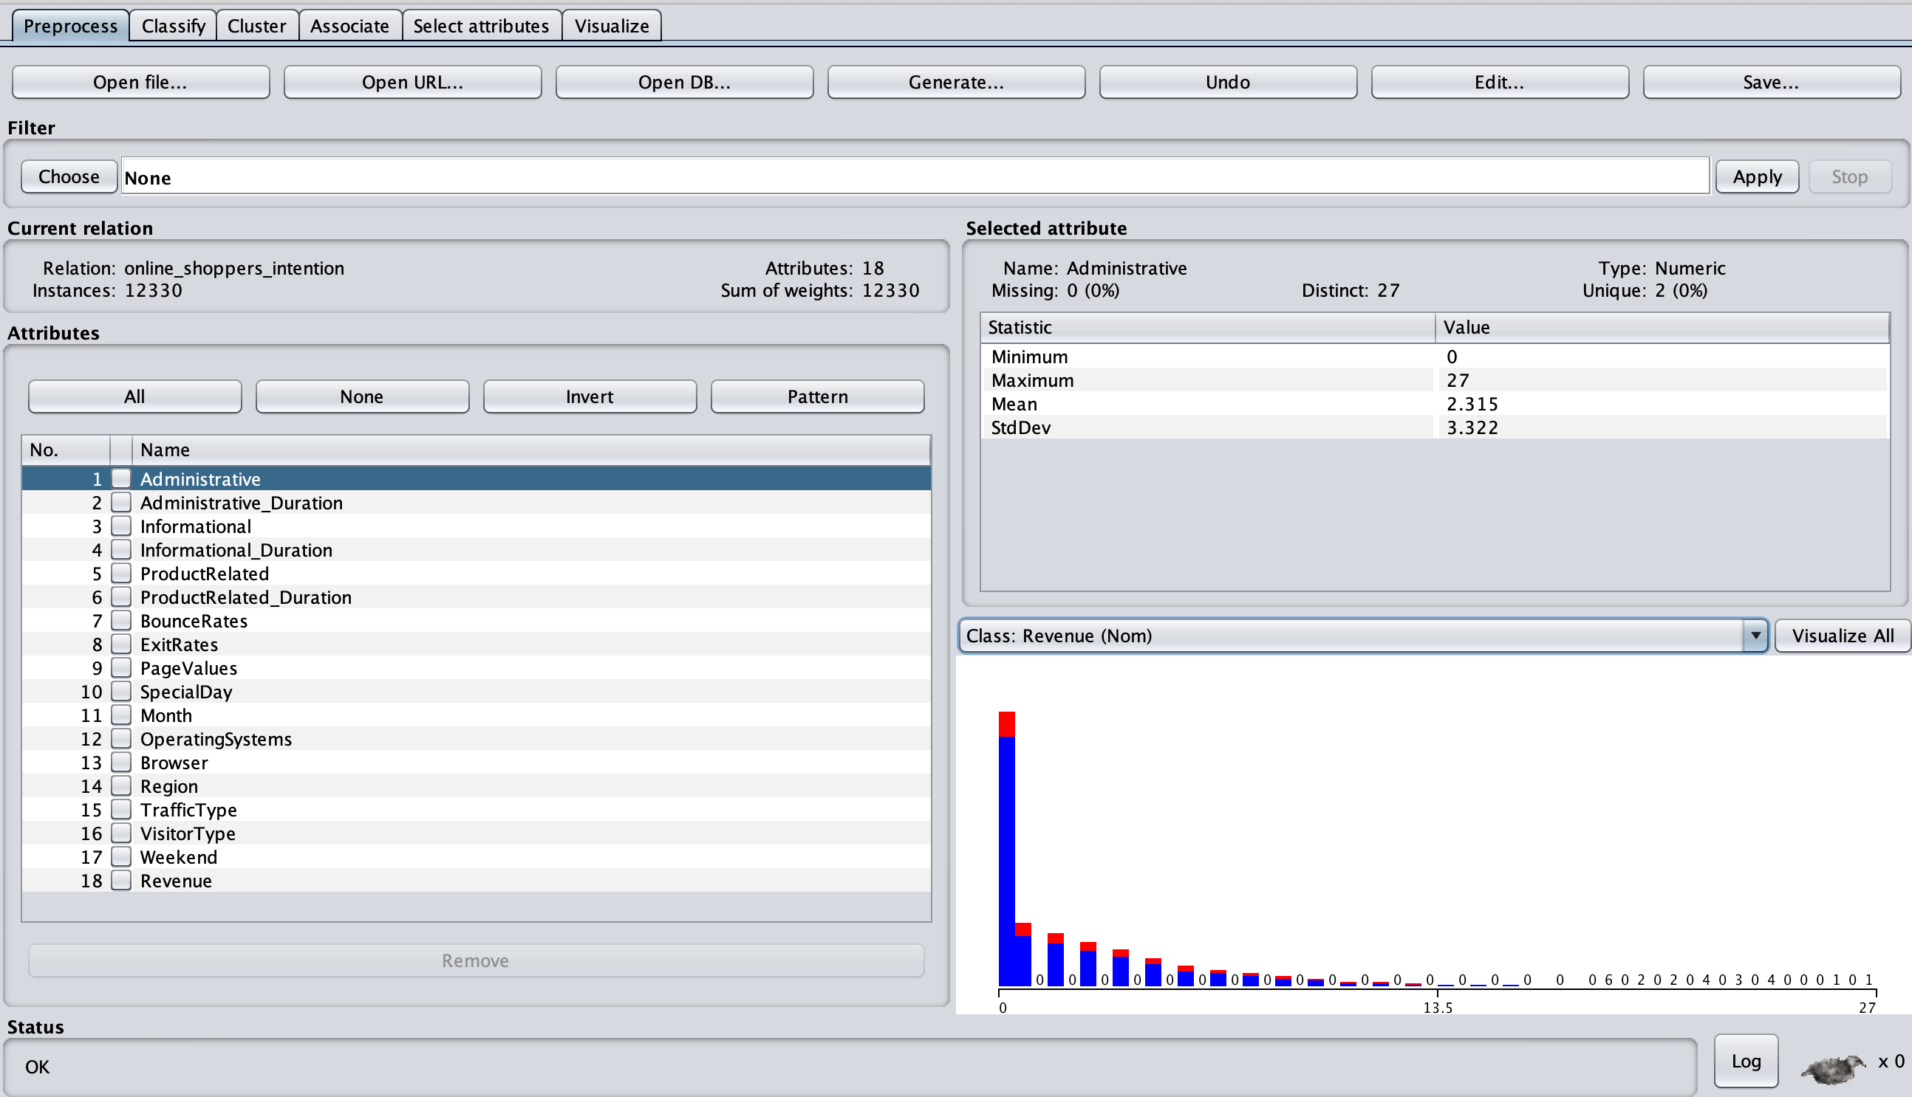

﻿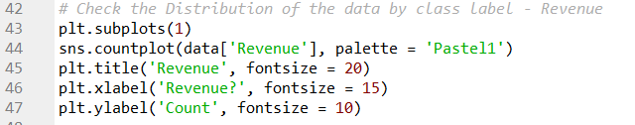

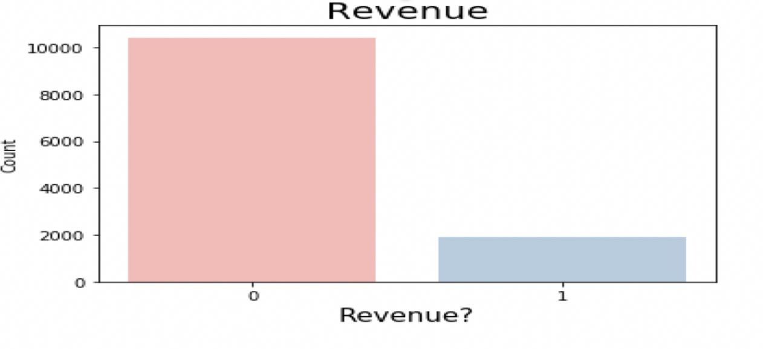

It is quite evident that the dataset seems to have an imbalanced classification problem [17] [18]. As it is obvious, the data has significantly more visitors with no shopping events (0) than shopping events. As it is obvious that data is skewed, the ML algorithm might be biased towards not-shopping category. We are considering using the “Resampling Techniques”, like “Over-sampling”, if we don’t see significant performance of the ML model/models, with the original dataset. We can also take into consideration other performance metrics, apart from accuracy to address this issue, like F1-score, ROC curve, Precision, recall etc.

* **Dataset analysis, clean-up and pre-processing**

For basic cleaning up of the dataset and preparing it for the ML models, we would need to take certain steps like:

* Dataset need to be cleaned out for any Null or NA values.

*Load Data code snippet:*

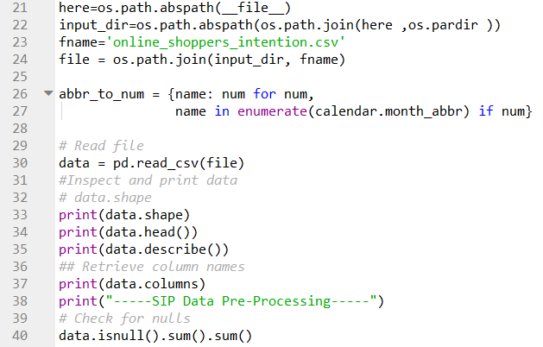

* The steps needed for pre-processing are:
  + I will make sure if there are any predictive attributes that are not in the numerical format. Such attributes will need to be converted to the appropriate format.

﻿ 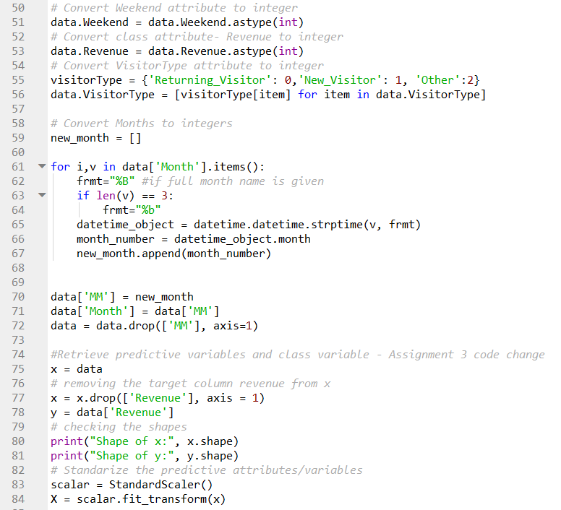

*Please refer the appendix section for full code*

* **Split Training and Test Datasets**
  + Splitting the data into Training and Test datasets.

The dataset is broken into Training dataset and test dataset so that ML model/models can be built based on training dataset and afterwards tested on the test dataset to classify the new data into classes (Here: Revenue=0, Revenue=1)

*I decided to break the data into 70:30 portions, as training versus test datasets respectively*

# Split the data from sklearn.model_selection import train_test_split

x_train, x_test, y_train, y_test = train_test_split(X, y, test_size=0.30, random_state=0)

﻿

*This was a preliminary test and we would be applying 70%-15%-15%, split ratio for Training, Testing and Validation datasets respectively. Our algorithm will be trained in the training set and hyper parameters will be tuned on the validation set. Afterwards, the performance on the test set will be checked.*

* **Build the Classifier/ML models on the Training dataset and test it on Test dataset**
* Train and build the ML models on the training dataset using identified classification algorithms.
* Apply the built models on Test dataset
* Test the built models on the test dataset (to predict the classification of the new (test) dataset).

For the purpose of classification problem, at the beginning we started with Random Forest -RF [21]Classifier, and then identified Gradient Boosting Machines – GBM [19][20] as superior and better algorithm for classification problem. We conducted some initial tests with both these classifiers, models were built and tested on test datasets.

Later we chose XGBoost [27][28]over GBM [19][20], because of its efficiency, and better features and characteristics, like regularized model formalization to control over-fitting, focus on the computational power, by parallelizing the tree formation[27].

We did some preliminary tests with XGBoost, as well. And, we did find the accuracy of XGBoost being better over GBM.

*Please refer to:*

*The* ***Identified Algorithms*** *section**under* ***4.2 V2 Design and Theory***

*and*

*The Appendix Section* *Identified Algorithms - RF and GBM* *for further details about these three algorithms and their comparisons*

Given below is the portion of the code that we used to tune/train/test the ML models with these three algorithms:

﻿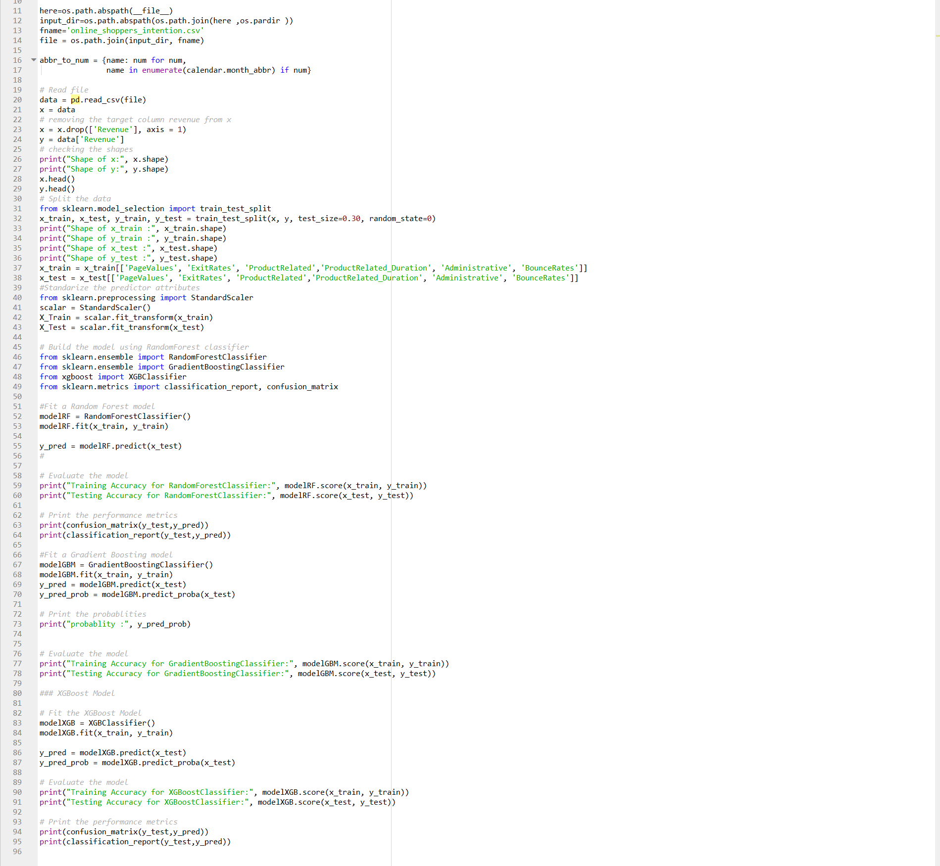

*Full code is given in the Appendix*

* **Comparison of Different algorithms and Models**
  + Take into consideration the conclusions of classification algorithms and figure out which one has best capability.

Although during the initial preliminary tests we found out the capability went up using “XGBoost” over GBM. But we are cautious as this is early stage for reaching to any conclusion, the models need to be tuned further before concluding anything about their performance.

* **Attribute Selection**
* Shrink the feature space considering variable significance, to improve the efficiency of the model.

We tried attribute selection using the ***InfoGainAttributeEval*** and ***GainRatioAttributeEval*** in Weka and trained and tested the modles using the attributes with GainRatio is “0.015” and above. The model was built and tested using GBM. We did not see improvement in the performance by applying the attribute/feature selection.

(*Please refer the* *Feature selection using Weka* *section under appendix for details*)

Code snippet:

*Detailed code is given in the* *Appendix* *and in the* [*git hub*](https://github.com/deepak0604/cs767)

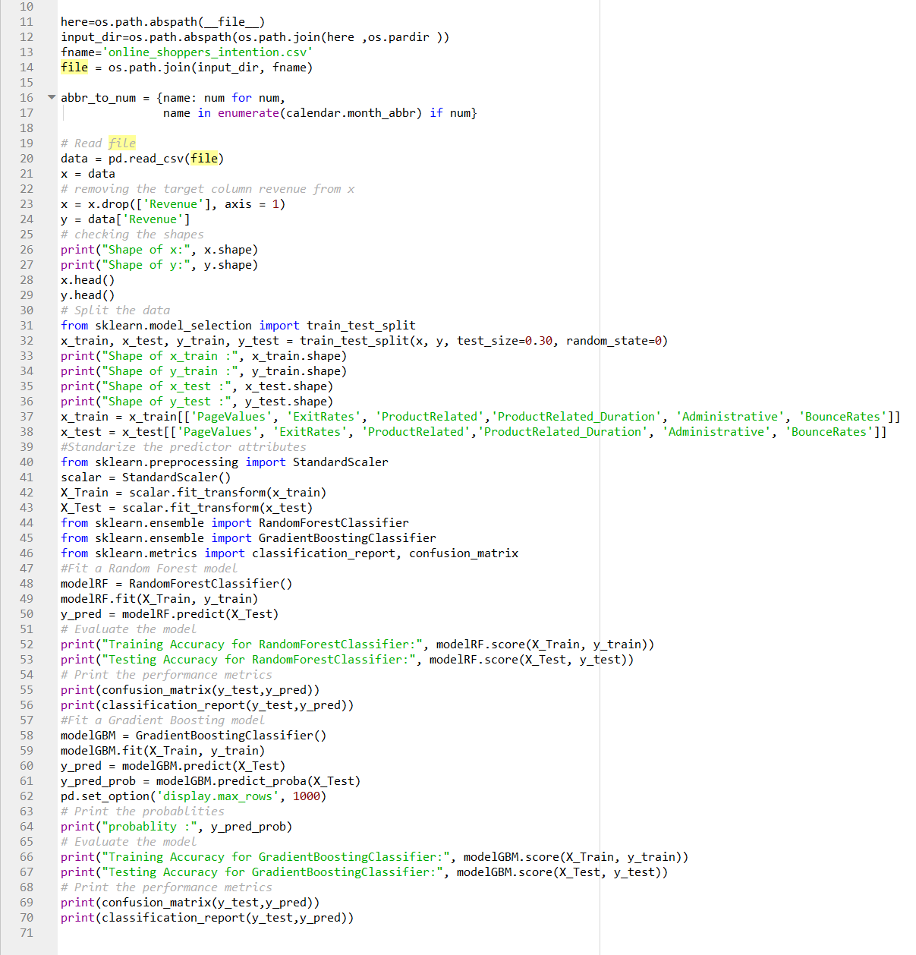

We will be using the “Feature Importance and Feature Selection with **XGBoost**” [26]

*Below is the output of the Feature Importance and Feature Selection with XGBoost, we applied on dataset:*

*Please refer the appendix section for the code, used for the “Feature Importance and Feature Selection with XGBoost”.*

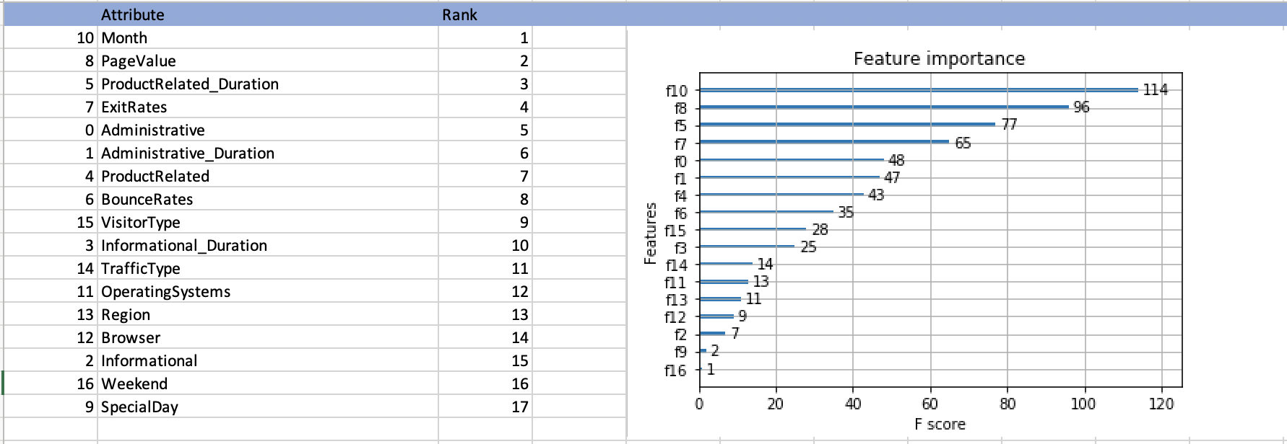

*Next we will be using these scores for feature selection in scikit-learn on the pre-trained model built with our identified algorithm – “XGBoost”, with* ***SelectFromModel*** *class, that takes a model and can transform a dataset into a subset with selected features.* *[26]*

* **Hyperparameter Tuning**

We will be *tuning the hyperparameters* [29] to improve the performance of our model/models. We will be mainly focusing on tuning the parameters for our model built with **XGBoost** classifier.

We have identified the following hyperparameters to be tuned: [29][30][31]

﻿**learning_rate/eta**:

* It controls the learning rate, i.e., the rate at which our model learns patterns in data. After every round, it shrinks the feature weights to reach the best optimum.
* Lower eta leads to slower computation. It must be supported by increase in nrounds.
* Typically, it lies between 0.01 - 0.3

﻿**n_estimators**:

* The number of sequential trees to be modeled or number of boosting.
* Should be tuned using CV (Cross Validation)

﻿**max_depth:**

* It controls the depth of the tree.
* Larger the depth, more complex the model; higher chances of overfitting. There is no standard value for max_depth. Larger data sets require deep trees to learn the rules from data.
* Should be tuned using CV (Cross Validation)

﻿**subsample:**

* It controls the number of samples (observations) supplied to a tree.
* Typically, its values lie between (0.5-0.8)

﻿**colsample_bytree:**

* It controls the number of features (variables) supplied to a tree
* Typically, its values lie between (0.5,0.9)

﻿**gamma:**

* It controls regularization (or prevents overfitting). The optimal value of gamma depends on the data set and other parameter values.
* Higher the value, higher the regularization. Regularization means penalizing large coefficients which don't improve the model's performance. default = 0 means no regularization.

*There were some initial tests performed while tuning the aforementioned parameters, manually and in iterations. The best results were produced by the highlighted values of the aforementioned parameters, accuracy ~ 90%*

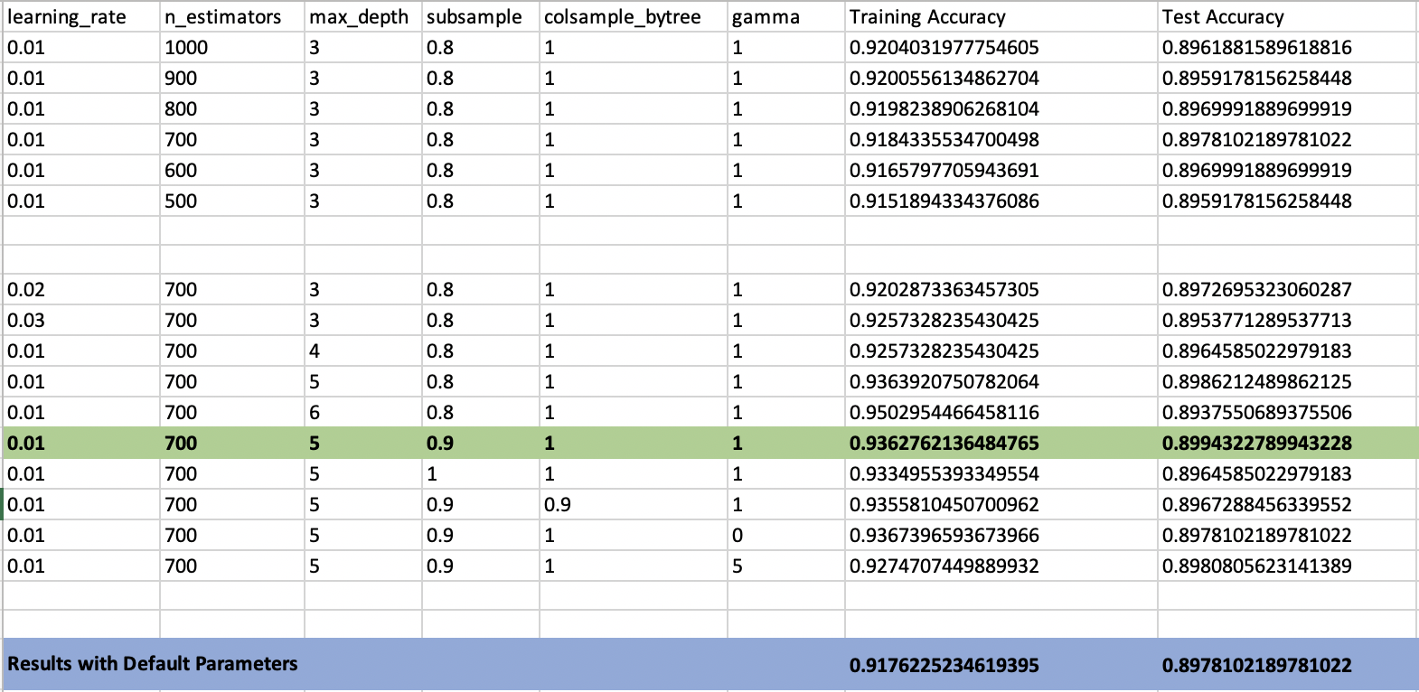

* **Create visualizations to represent and showcase the data**

I have figured out the business value of this dataset up to some point, and I will carry on to investigate it further. In order to present the data and emphasis on its business value, some visualizations are needed to be created. As of now, I am learning about libraries and tools that can help me in my objective of data visualizations. Few libraries that can be used for the purpose are: matplotlib, ﻿plotly, ﻿plotly.graph, ﻿seaborn. Tableau would also be fit for visualization purposes.

## 4.4 Risk Retirement

4.4.1 Inappropriate algorithms for ML models

After identifying the dataset, the next step is to analyze the data and explore the various ML models to identify which one is appropriate for the identified dataset. I will be using supervised classification algorithms because dataset has a class attribute.

I learnt about the applications of the decision tree algorithms. I also read online articles & blogs made me think that Random Forest classifier (RF)is an appropriate classification algorithm which can be applied easily on the selected dataset. I discussed my project with my facilitator which helped me explore Gradient Boosting Machine (GBM). I learned about SVM (Support Vector Machines) & Neural Nets which I thought can be used easily in this project. However I am primarily considering GBM and RF to build the ML models.

Not able to identify/choose the appropriate algorithms and tools to build the ML models- After choosing the dataset, the next step was to analyze the data and explore the various ML models to identify the ones which would be appropriate for the dataset. Since the dataset had a class label, I narrowed my search on Supervised Classification Algorithms [2][4][5].

Learning about the applications of the decision tree algorithms, and some of the articles, papers and blog posts, made Random Forest classifiers (RF) as one of the appropriate classification algorithms to be applied on the given dataset. Again, the feedback from my facilitator helped me to explore Gradient Boosting Machine (GBM). Although Support Vector Machines (SVM) and Neural Nets fascinated me, after learning about them, GBM was picked up as a better choice. But we we have finally considered **XGBoost** over GBM, because of its efficiency and ease of implementation, along with the features like focus on computational power, by parallelizing the tree formation and regularized model formalization to control over-fitting.

*I have done some preliminary tests with SVM and Neural Nets on the dataset and would like to implement them to build the ML models on the chosen dataset, if time permits.*

*Please refer to the code in the Appendix section to see some of the experiments I have done so far with the dataset and these algorithms.*

4.4.2 Unable to present meaningful data

Representing meaningful data is very important. To mitigate the risk to present meaningful data I need to understand and should have good handle. After going through data multiple times I understood the project data pretty well. I am identifying the important dataset attributes that can be represented in such a way that they can be easily understood. I have to explore, read and learn various python libraries that can be used by the code to create the data visualizations.

4.4.3 Optimal performance results

A significant performance result of the selected classifier is one of the highest risks of any machine learning project. To work towards it, I am planning to learn about XGBoost’ for attribute selection. It will help me to rebuild the model using the selected attributes of the dataset. I will learn how to use and apply hyperparameter tuning. The performance of the model will be impacted if the dataset is suspected to have the unbalanced classification. I will try to use different methods for example resampling techniques (over sampling), generating **Synthetic Minority Oversampling Technique** (SMOTE) samples. I have started learning about these options.

I have done some preliminary tests using these techniques, and I do see some improvement in the performance of the RF and GBM classifier (yet to try XGBoost). Since my selected ML classifiers are performing well without addressing the unbalanced classification, I can keep this for later use.

4.4.4 Inappropriate dataset:

I believe, choosing the right dataset was one of the most important steps in the whole process of applying ML on a dataset and getting the answers you need from the data. With the little knowledge I have had of ML, I was afraid of choosing not an appropriate dataset. I was primarily looking for e-commerce datasets, and though recommendation system fascinated me a lot, but with the time in hand and the knowledge I have had, and also considering the learning curve involved (learning the tools like SciKit Learn etc.), I preferred something doable instead. I picked up this dataset[1] as it had some known Google Analytics[28] parameters, which were introduced to me in one of the DA courses at BU, and I could understand the data. I still had doubts and I felt confident about the chosen dataset primarily after getting a positive feedback from my facilitator and then running some preliminary tests and checks on the data in Weka.

4.4.5 Missed to apply Pre-processing steps:

For any project it is very important to identify & apply any of the pre-processing steps needed to make the dataset more appropriate for building the ML models. To make sure that I don’t miss to identify any of the preprocessing steps needed to make the data in the given dataset, I have been doing the following:

* 1. Analyzing the data and
  2. Running some initial tests on the dataset.

It's a recursive operation, and with each repetition, I learn something new. Exploring websites, papers and posts, and facilitator feedback helped me with the process. As per my preliminary tests which I did to training the ML models and testing the models on the test results, the performance of the models is fair even before any hyperparameters are tuned or any features are chosen. I may now assume that I have defined and implemented the necessary pre-processing steps on the dataset.

### Appendix:

### Code Snippet:

Below code snippet is using Keras to train the dataset and Neural Nets to test the dataset. I have shown the outcome at each step or where applicable.



**Output**











**Iteration-II**



**Iteration-III**



### Weka Feature selection using:

I have used **Weka** to run attribute selection methods (InfoGainAttributeEval & GainRatioAttributeEval) on the train dataset. I have chosen the attributes with high information gain or gain ratio to build the ML model. High info attributes help to improve the performance of the algorithm.

Weka **Ranker method – Ranker** search methodattributes are ranked by their individual evaluations. It’s used in conjunction with attribute evaluators.

1. **InfoGainAttributeEval** - Attributes are evaluated based on information gain, which is a purity measure based on info (entropy). The attribute evaluator evaluates the worth of an attribute by measuring the information gain (also called Entropy) with respect to the class.
2. **GainRatioAttributeEval -** The GainRatioAttributeEval uses gain ratio to overcome the bias of information gain (the information gain measure prefers to select attributes having a large number of values). The attributes are evaluated based on gain ratio. It evaluates the worth of an attribute by measuring the gain ratio with respect to the class. Subsets of features that are highly correlated with the class while having low inter-correlation are preferred.

**Weka screen shots attribute applying selection method on the train dataset:**

#### Output – InfoGainAttributeEval with Ranker search method:

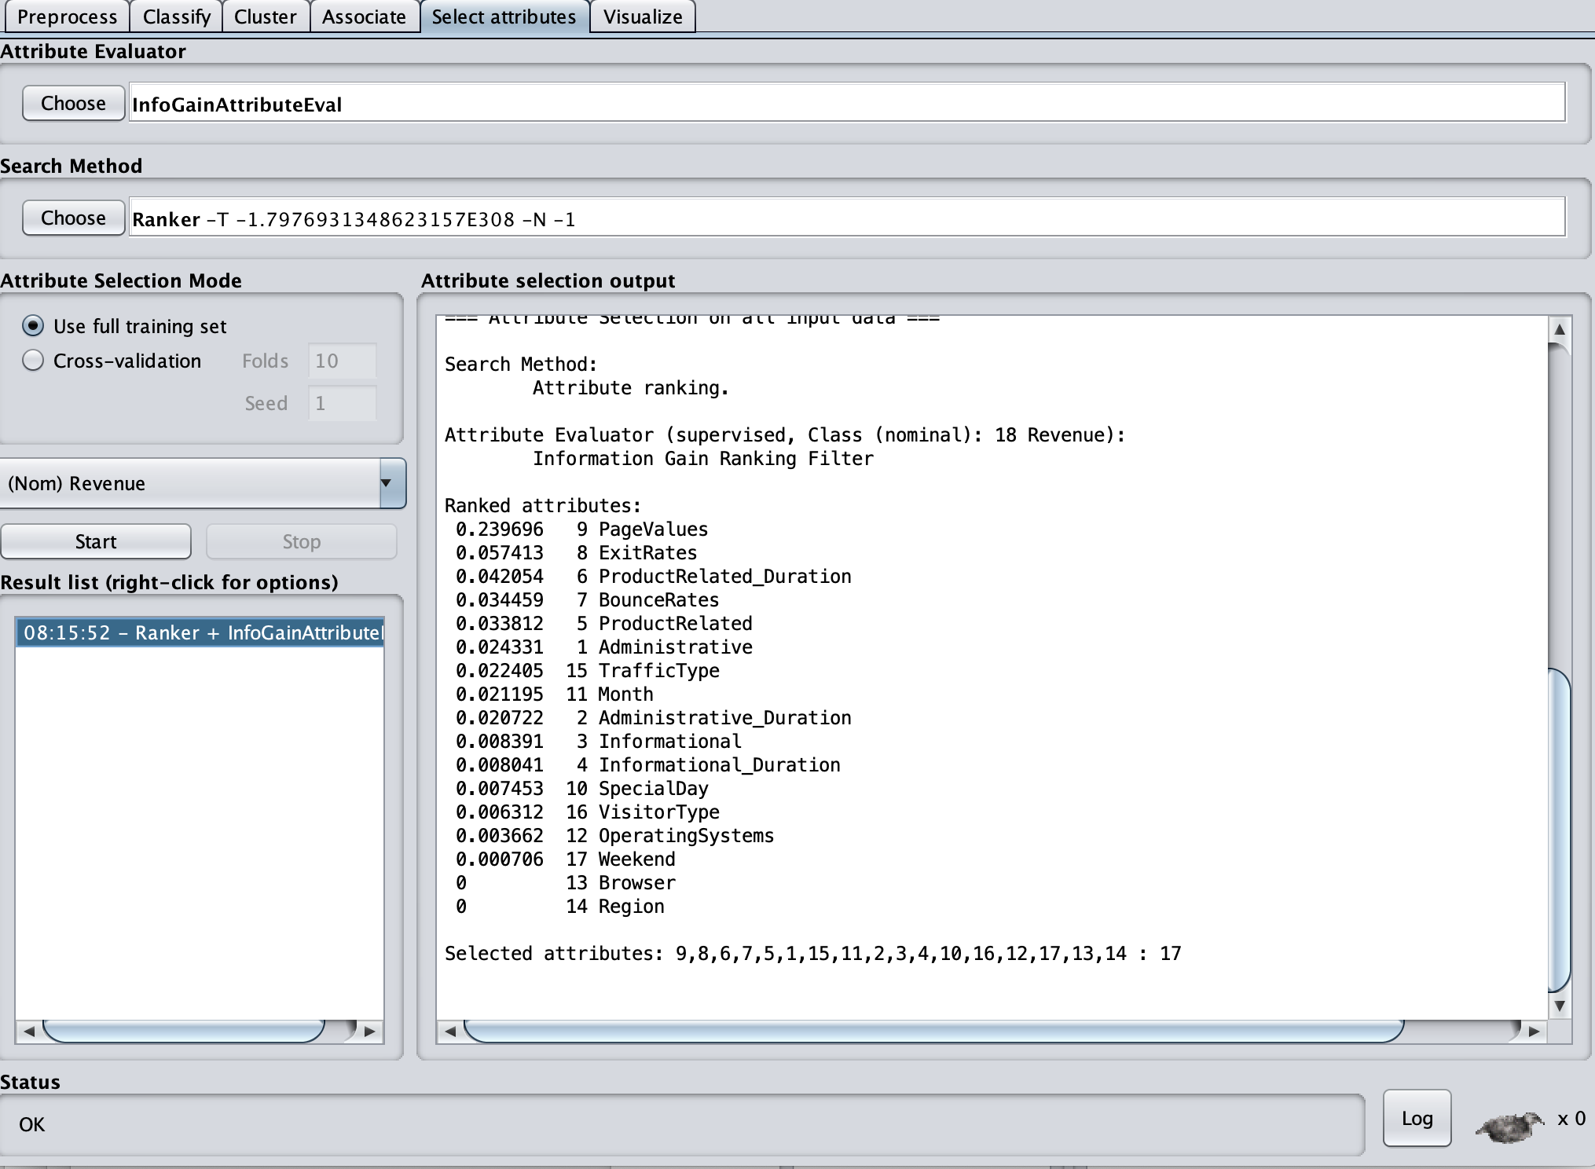*Above screen shot after applying InfoGainAttributeEval selection using Ranker search method. Rank is given to each attribute.*

#### Output - GainRatioAttributeEval selection method with Ranker search:

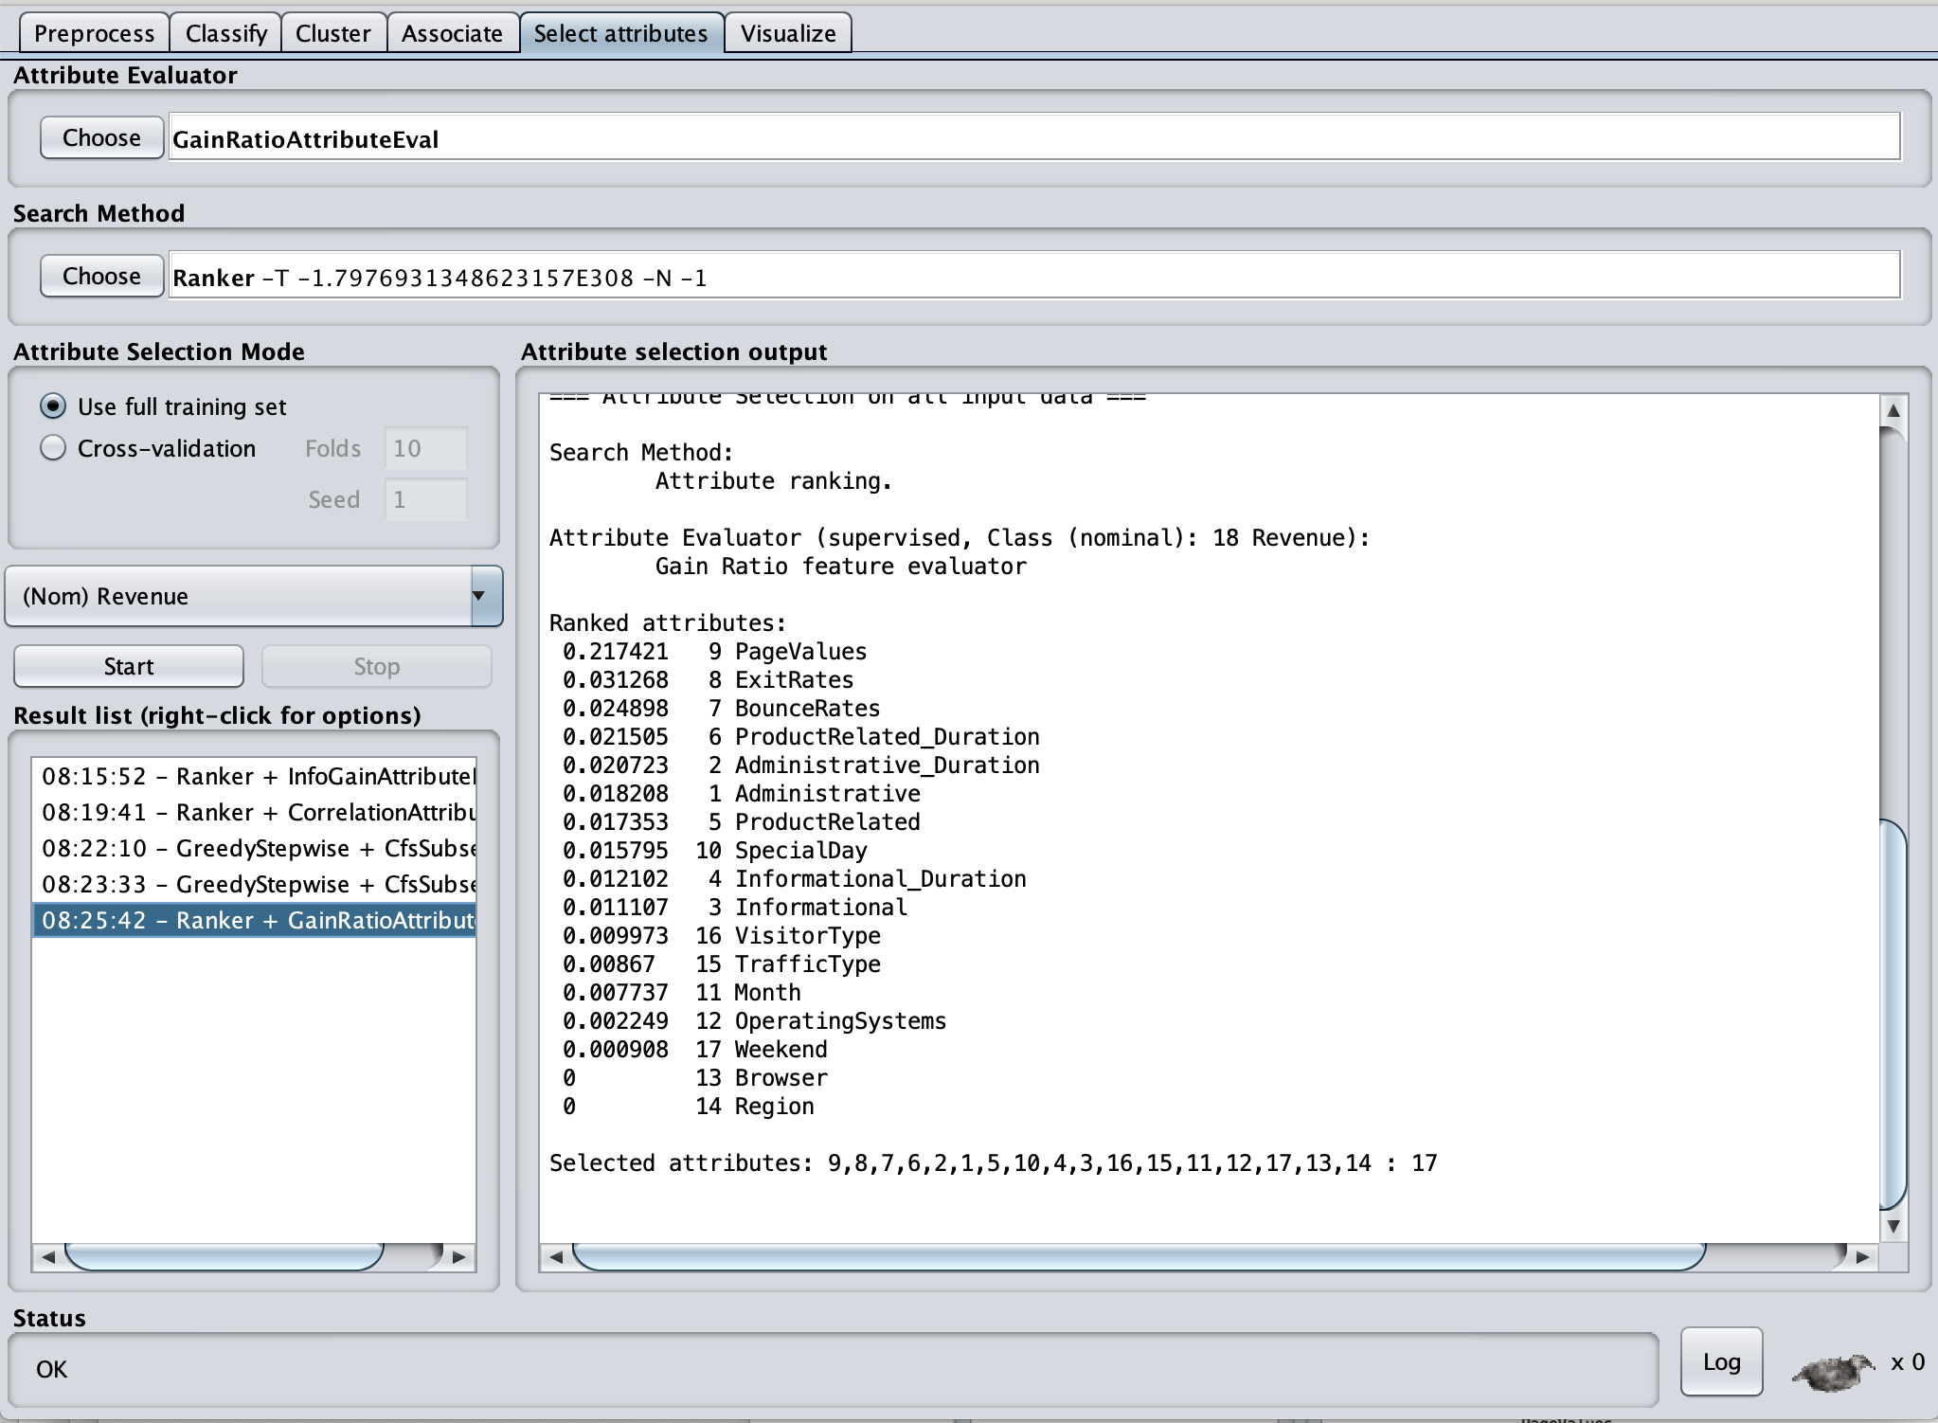

*Above screen shot after applying GainRatioAttributeEval selection using Ranker search method. Rank is given to each attribute as per the GrainRatio.*

To verify whether the selection process of the attribute has any effect on the efficiency of the ML model or not. As you notice Random Forest & GBM classifiers improves by selecting the top few attributes which are ranked by the above used attribute selection methods, we selected the attributes with the GainRatio of 0.015 and greater as ranked by the GainRatioAttributeEval attribute method. I rebuilt the ML models and tested project dataset using the high ranked selected attributes. I did not see any performance improvement of the model using the new training dataset, created by using the attribute selection method/methods. I am currently working on to implement “XGBoost” feature selection method for our identified ML algorithm, that is **XGBoost**

**Feature Importance and Feature Selection with XGBoost**

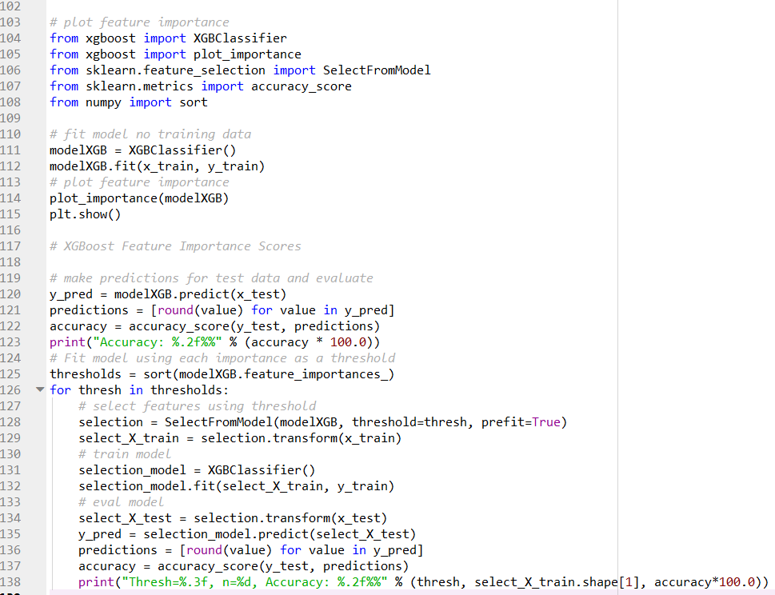

**Output**

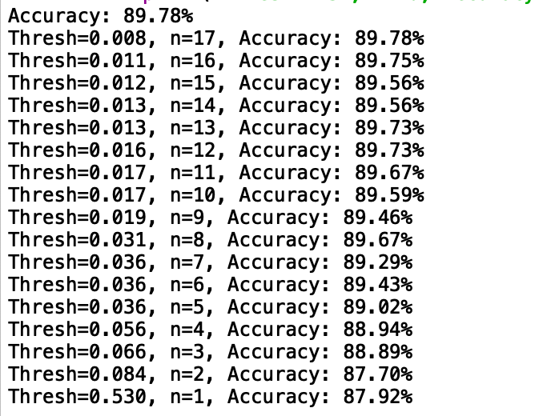

# Implementation version 1

## 5.1 Summary v1

This project is explores the shopping behavior analysis of the online shoppers in order to predict the shopping intent of the visitors. The website pages have been differentiated into different categories. The number of different types of pages visited by the visitor in each session and the total time spent on each category of the pages is captured and studies. This data is used to make predictions regarding the behavior of the visiting customers. The project also helped us in predicting the probability of a visitor ultimately making a purchase and ending up as a customer, after spending time on certain categories of the pages. As part of the project, I learnt how to apply the concepts of Machine Learning to solve the complicated and often dynamic data problems.

Functionally, while researching for the project, I learnt about the shopping intentions of the visitors by their distribution e.g., Visitor Types “(New Visitors, Existing Visitors), “Region”, whether the session was recorded on a “Weekend”, is the transaction done close to a “Special Day” (for example days around Valentine’s Day etc.) etc. I have figured out that, the “Month” of the visit has a great impact on the shopping intentions of users, for example- I saw that most of the visits that concluded in a purchase are from the month of November. The data also indicates that there are more transactions ending in shopping by the visitor (Revenue as True) on the weekdays than on the weekends. The research indicates that there are some pages which have higher bounce rates along with the higher exit rates, it tells us that the website design needs to be reviewed and revisited, since higher bounce rates along with higher exit rates mean that the users are existing from the same page they landed on, without exploring the other pages of the website. There is a chance that such tendencies constitute a normal behavior, as it might be possible that the users found what they were looking for, on the same webpage they landed on and exited from the same page as soon as the transaction is done. But, for an online shopping business if both, the bounce rate and the exit rate are high, that most likely indicates that probably the users didn’t complete the transactions, if that is the case then it would be impacting the “Revenue”. In that scenario, I might consider the need to rethink the website design and other user friendly features. I might also like to consider some marketing tactics like running some campaigns on or around specific time of the year to influence the shopping intentions of the visitors, to generate more revenue.

*Please refer the* *Google Analytics Metrics* *section under Appendix for more details about the metrics, like Bounce Rates and Exit Rates.*

## 5.2. Report on Requirements v1

### 5.2.1 (DF) Estimate probability of making purchase.

The project shall anticipate the shopping behavior of the visitor with the help of aggregated pageview data gathered during the visit along with session time and user related information, and shall provide the odds of making purchase for a particular visitor.

As per the performance results of the model I built using “XGBoost” classifier, it is clear that our model has an accuracy of 90% in predicting the purchasing intention of a visitor. Our model has a high accuracy but since having a significant accuracy is not the only metrics to be considered to test the performance of a model, I did consider calculating the other performance metrics like Precision, Recall, F1-Score. Those values were equally good. Below are the values of each of these metrics for our XGBoost ML model:

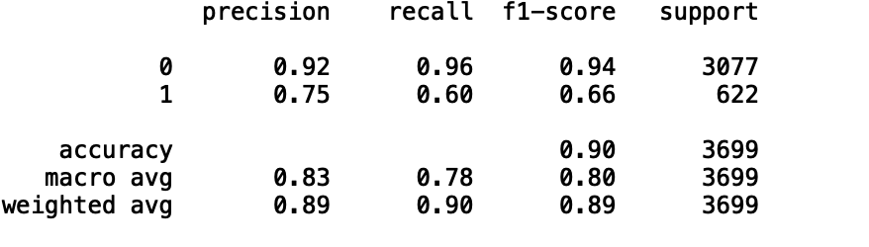

Here is the confusion matrix generated by the code:

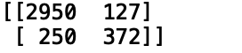

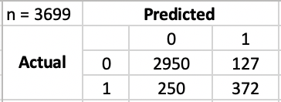

Here is the class distribution of the test dataset:

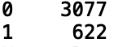

Where Negative Event is “Revenue=1” and Positive event is “Revenue=0”:

TP (True Positives) – *Revenue 0 classified as Revenue 0* => 2950

FN (False Negatives) – *Revenue 0 classified as Revenue 1* => 127

FP (False Positives) – *Revenue 1 classified as Revenue 0* => 250

TN True Negatives – *Revenue 1 classified as Revenue 1* =>372

Where:

Total Positive (Revenue=0) =>

Total Negative (Revenue=1) =>

The **Precision** – is a *% of tuples that our classifier labeled as positive are actually positive* is 92% (score-0.92).

The **Recall** -*percentage of positive tuples that the classifier labelled as positives* is 96% (score-0.96).

And, the **F1-Measure/Score** -*harmonic mean of precision and recall, a measure of a test's accuracy*, is 94% (score-0.94).

*Considering “Revenue=1” as the Positive Event and “Revenue=0” as the Negative Event, I have:*

True Negatives (TN) – *Revenue 0 classified as Revenue 0* => 2950  
False Positives (FP) – *Revenue 0 classified as Revenue 1* => 127

False Negatives (FN) – *Revenue 1 classified as Revenue 0* => 250  
True Positives (TP) – *Revenue 1 classified as Revenue 1* =>372

Where:

Actual Negatives (Revenue=0) => N = TP + FN = 2950 + 127 = 3077

Actual Positives (Revenue=1) => P = FP + TN = 250 + 372 = 622

The **Precision** -*percentage of tuples (records/rows) that our classifier labeled as positive are actually positive* is 75% (score-0.75).

The **Recall** -*percentage of positive tuples that the classifier labelled as positives* is 60% (score-0.60).

And, the **F1-Measure/Score** -*harmonic mean of precision and recall, a measure of a test's accuracy*, is 66% (score-0.66).

As it can be concluded from the above results, I see that the values of -Precision, Recall and F1-Measure/Score, considering “Revenue=0” as the positive event, are significantly big compared to the ones I got considering “Revenue=1” as the positive event. It can be interpreted that our model has greater accuracy in predicting the purchasing intention of the visitor in the cases where the visitors won’t make a purchase. If I look closely, it could be considered a good business objective to focus on. As I dig deeper in the behavior of the visitors like, who didn’t make a purchase and who are more likely to not make a purchase; and think towards filling the gaps in UI of our website, or offer specific campaigns to influence these visitors, to make purchase and generate more “Revenue”.

***Note***: *To address the unbalance in class label (imbalance classification) in our dataset I tried “﻿Resampling Technique - Oversample Minority Class”. Below are the results I got by applying this resampling technique:*

**

*Confusion Matrix:*

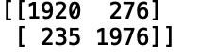

*Classification Report:*

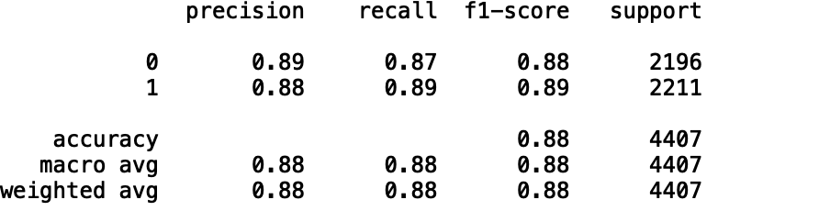

*I can see that with the “Resampling Technique of Oversampling Minority Class”, the overall accuracy has decreased a little (88% from 90%), but the values of the other metrics like- Precision, Recall and F1-Score are very close for both the events (Revenue=0 and Revenue=1). Therefore, this model has almost equal correctness of prediction in case of both events (Revenue=0 and Revenue=1).*

To predict the probability of purchasing, to target the customers with high likelihood of purchasing. I used the “﻿predict_proba” function in Python to calculate the ‘probability of purchasing’ with the ML model created using XGBoost. I printed the results with a variation. Please refer the below screen shots and the **code in the appendix section**, for details.

*Printing the probabilities of each attribute and the Actual and Predicted results:*

*Note: The values of the attributes are standardized so that are on the same scale and are given equal weightage by the model.*

*Note: This is a snippet of the results.*

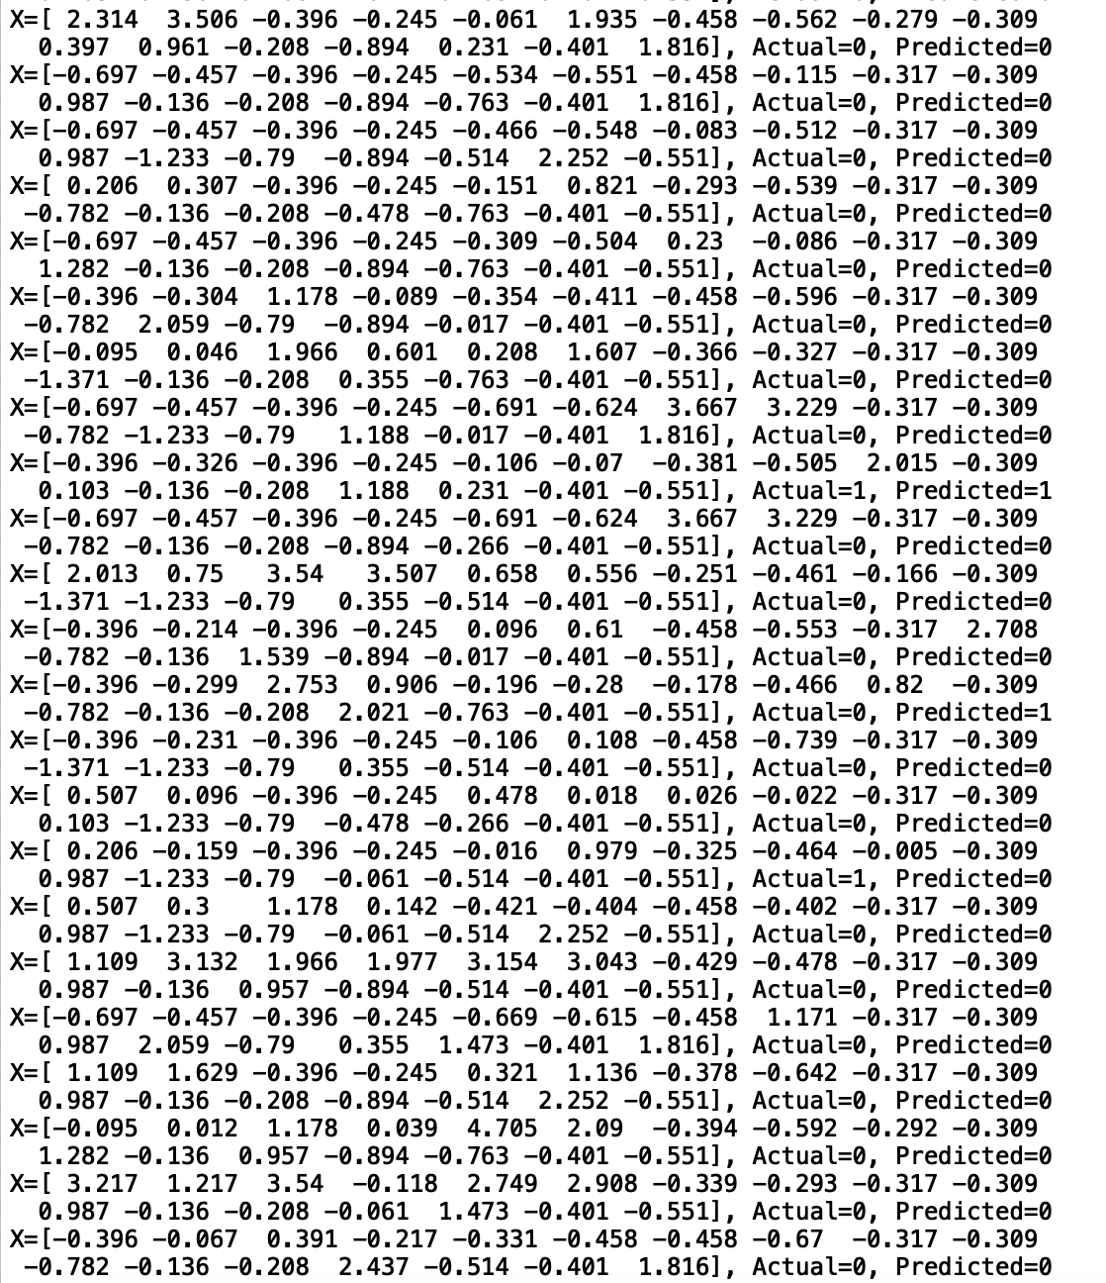

*Printing the Actual and Predicted results:*

*Note: This is a snippet of the results*

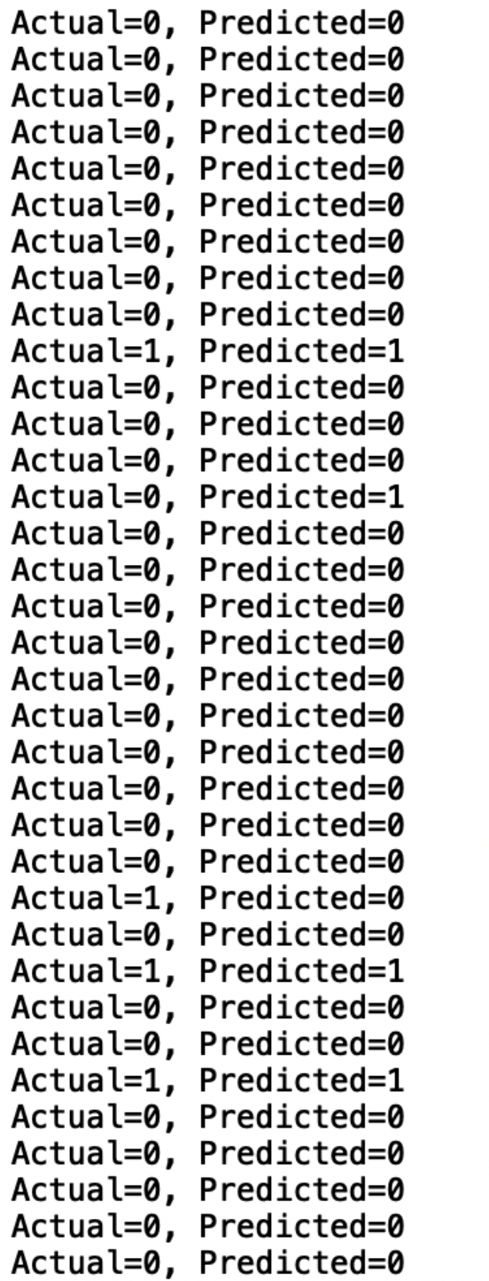

*Printing the probabilities of each attribute, the Actual value and the probabilities of Predicted results:*

*Note: The values of the attributes are standardized so that are on the same scale and are given equal weightage by the model.*

*Note: This is a snippet of the results.*

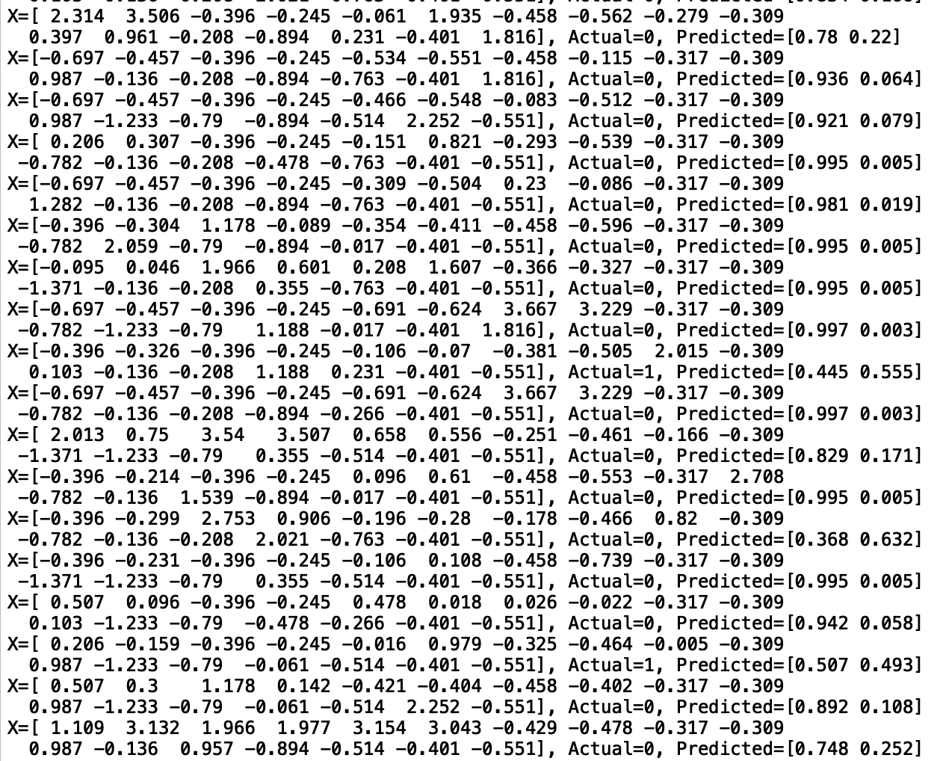

*Printing the Actual values and the probability of the Predicted results:*

*Note: This is a snippet of the results*

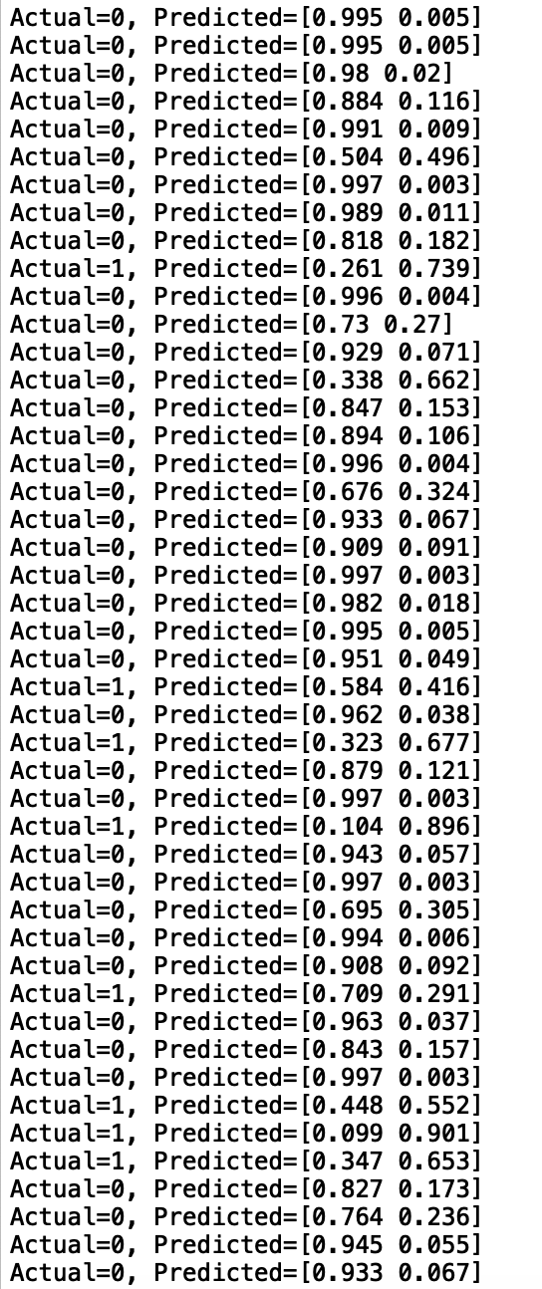

### 5.2.2(DF) Create Data visualization

In this project I would prepare data visualizations for easy and efficient analysis/consumption of data. I am considering to take help of available libraries and visualization tools for effective and efficient representation of data.

Initially I considered the Python libraries for the purpose of data visualization, but pretty quickly I realized that this endeavor can be done in Tableau as well, which is less time-consuming and does the task with equal efficiency.

Other than the above visualizations under "D3”, I am listing some of the visualizations below that I have built in Tableau:

*Graph to show if the visitors tend to make a purchase in certain months compared to others:*

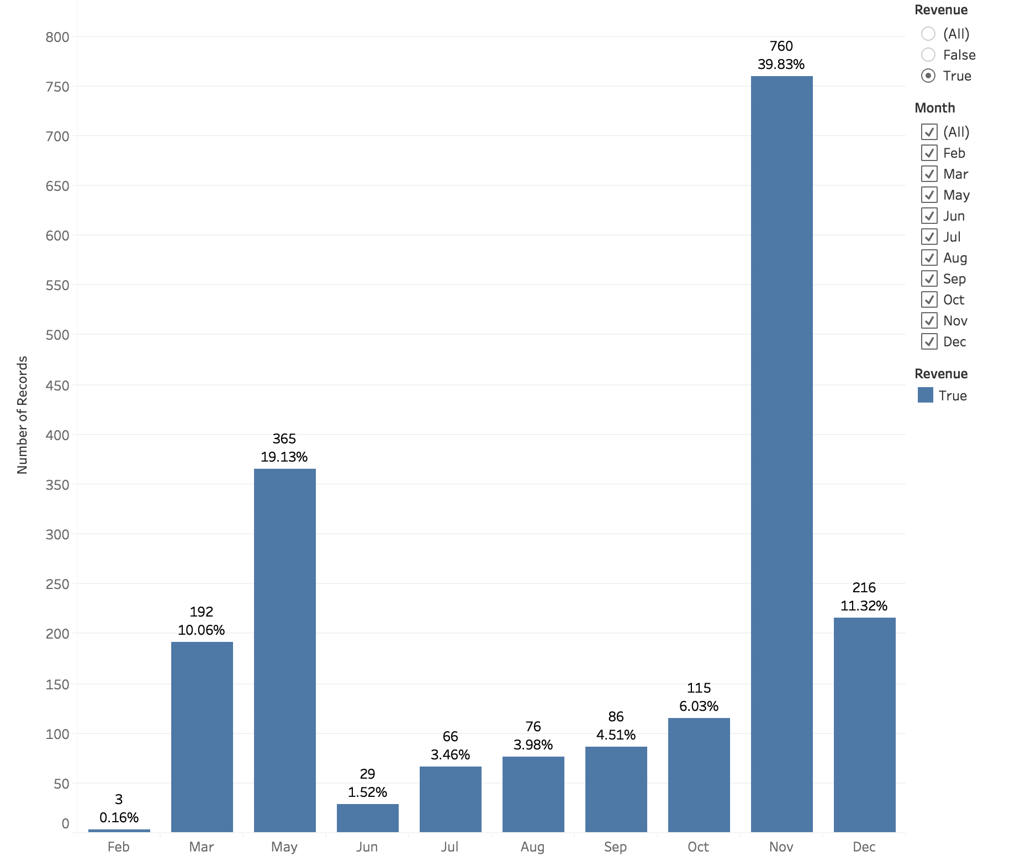

*As it is evident in the above graph, November is the month when highest number of purchases were made (almost 40%), and February is the worst performing month with lowest purchases (0.16%) were made/completed.*

*With little more digging, I can confirm that though “Nov” has highest number of transactions ending with Revenue (Revenue=1/True), there are 18.15% of transactions (from the total transactions in the dataset) with no Revenue (Revenue =0/False).*

*Further, the month of “May” has highest number of transactions, but of which only 2.96% ended up generating Revenue (Revenue=1/True)*

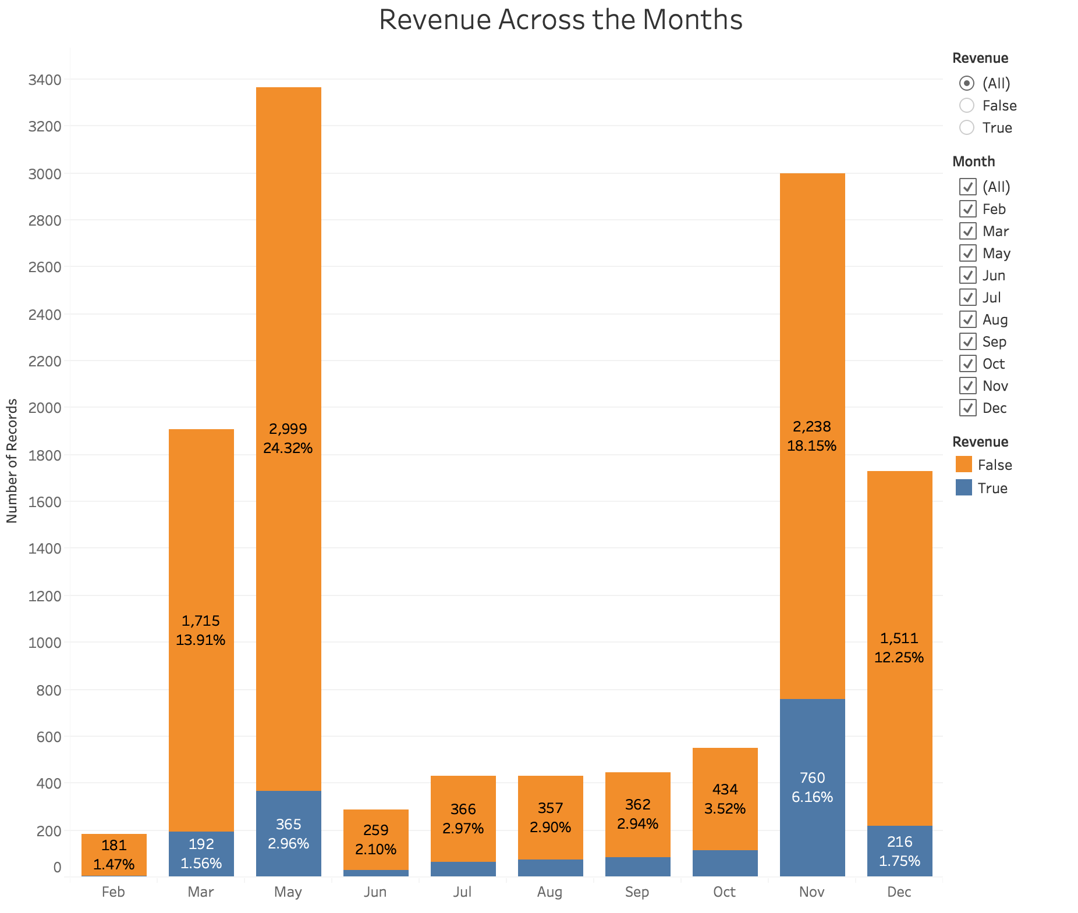

*After careful analysis of the monthly revenue, I know how many visits/transactions ended up in Revenue generation in a Month. As the data show, 25% of total visits/transactions did concluded with Revenue generation for the month of “Nov”. The month of “May” has 89% of transactions/visits not leading to generate Revenue (Revenue=0/False). It is also worth noting that 98% of transactions in “Feb” ended up without any Revenue.*

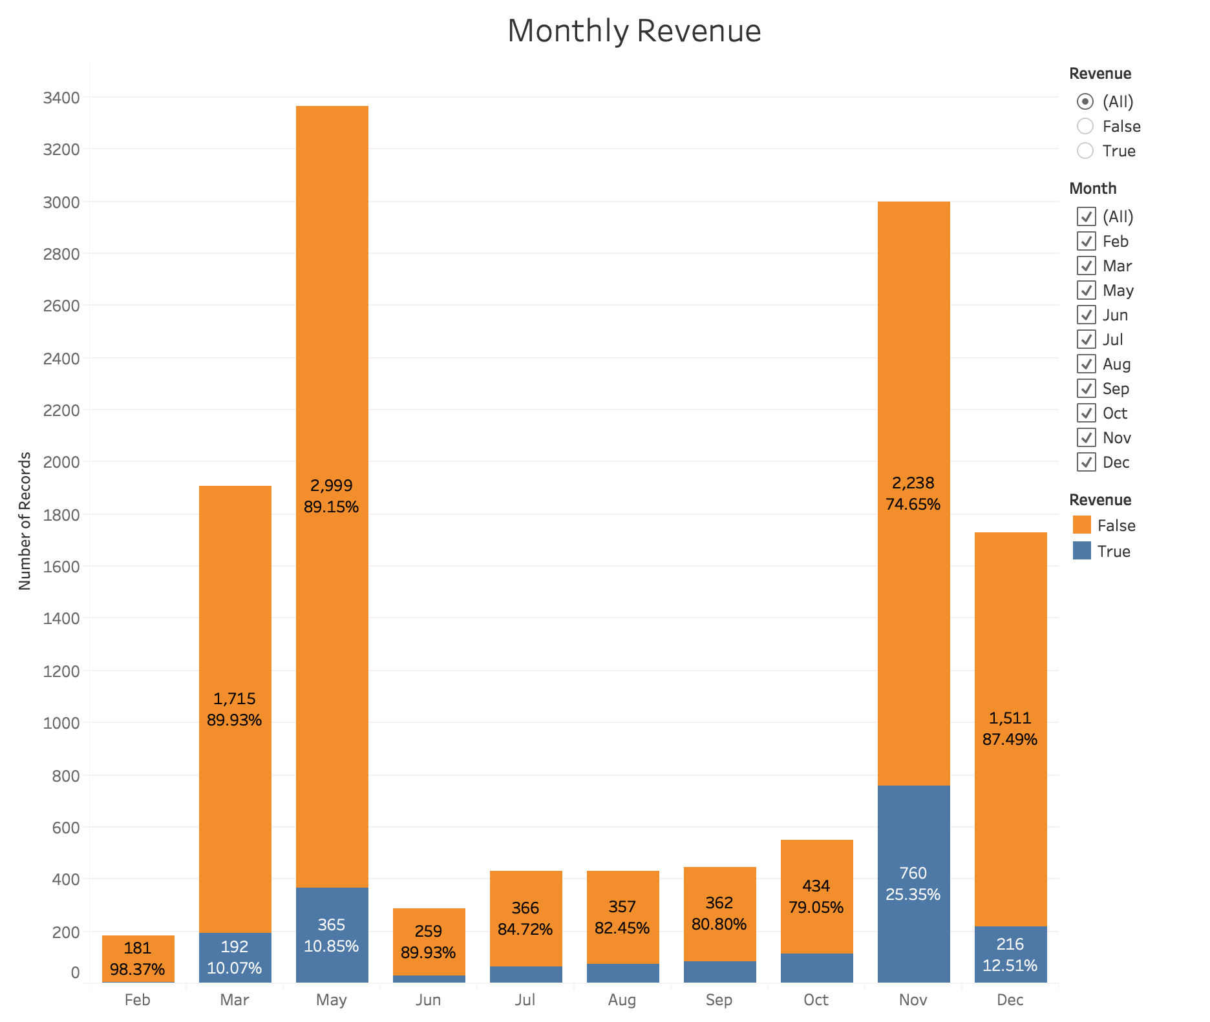

*With the above data distribution of class label-Revenue month-by-month I can perform further analysis to figure out the reason behind the very low purchases made in the month of Feb. One of the contributing factor could be that I were not running significant deals/campaigns during the month of “Feb”, and the possible solution is to set up more campaigns and good deals to lure the customers in the month of “Feb”. Similar trend is visible for the months Jul-Oct where I have a smaller number of purchases, which needs to be taken care as well.*

*Though I see most of the visits by the online shoppers in the months of May and Nov, but most of the visits didn’t generate Revenue/Shopping. This can be a point of concern for any business as it is losing the chance of converting visitors into customers. This trend or phenomenon needs to be studied further in detail to explore the possible reason behind such behavior as business cannot afford to ignore this trend.*

Bounce Rates Vs Exit Rates

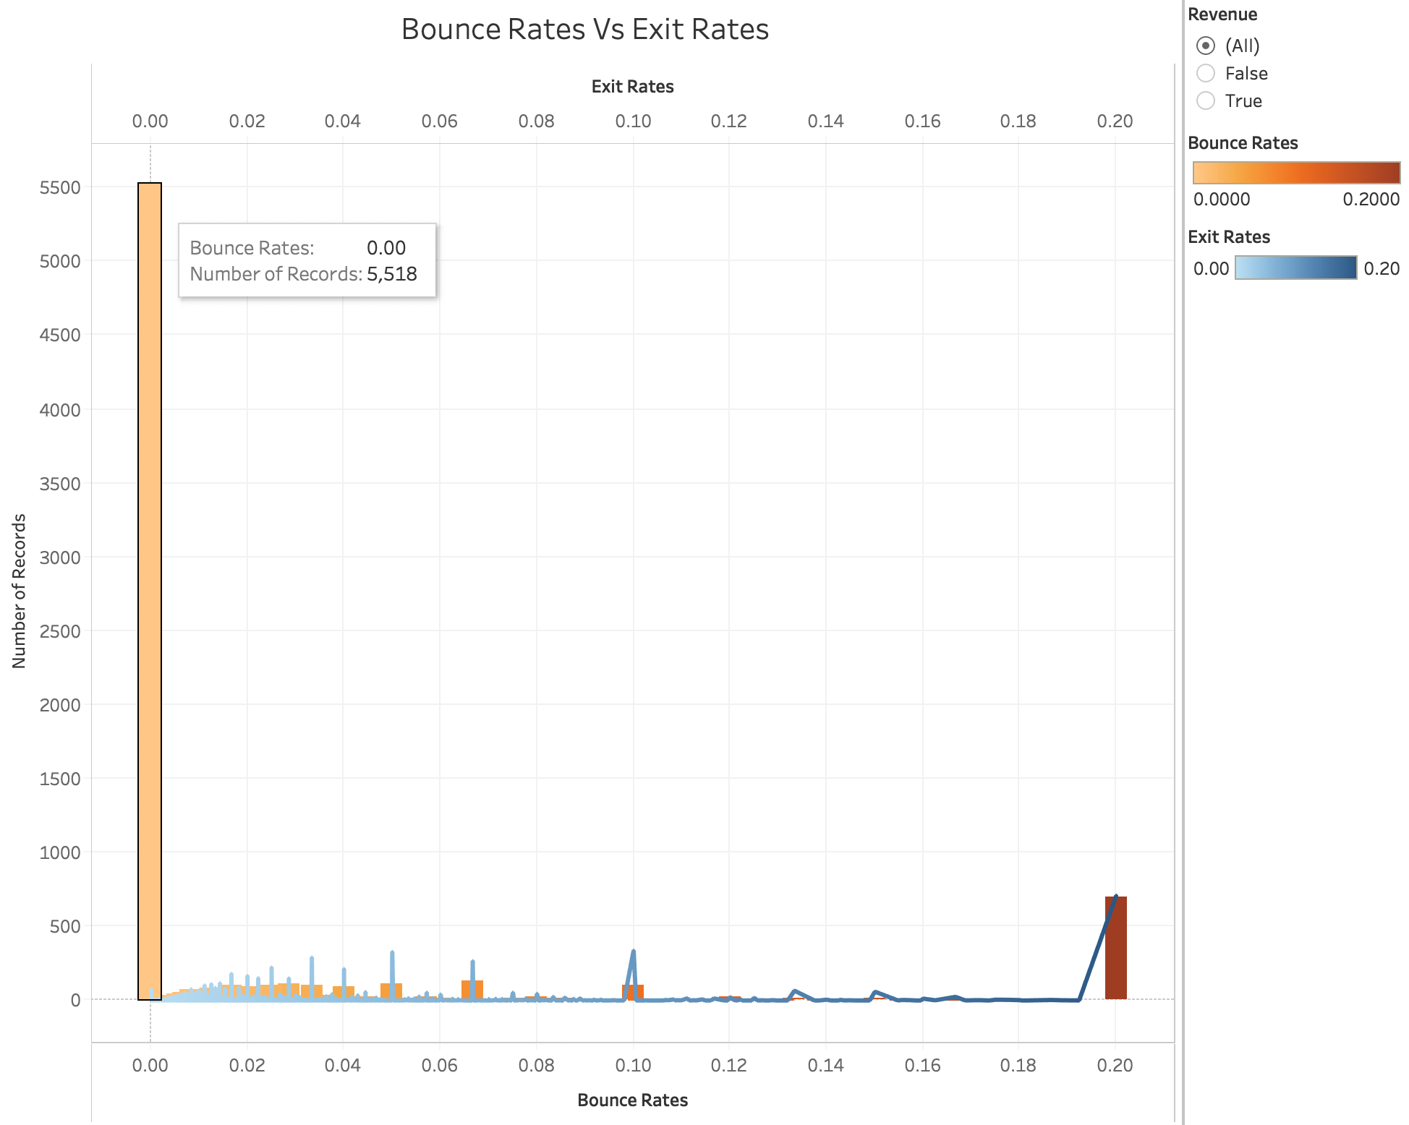

*As it is evident from the above graph, most of the records have lower bounce rates, 5518 records with 0.00 Bounce Rate. It is a healthy sign for any website to have a lower Bounce, as it indicates that visitors are not leaving the site or web pages. Also, data shows us that most of the pages with high exit rates have lower bounce rates, which again is certainly a positive sign, as it tells us that the web pages from which the visitors generally exit the site are not the ones which are abundant most frequently.*

*I can also see that there are 700 records showing the high Bounce Rates as well as high Exit Rates. This indicates that there are some website pages or features which need to be revisited, as chances are that these could be the pages where the visitors landed and abundant the site immediately. Such type of instances do not bode well for the online shopping business model.*

*Though it can be debatable that this might not be abnormal behavior, as it might be the case that the users purchased what they were wanting, on the same webpage they landed on and exited from the same page, as soon as the transaction was performed. But, for an online shopping site if both, the bounce rate and the exit rate are high, that indicates the high chances the users didn’t complete the transactions, which would be negatively impacting the “Revenue”.*

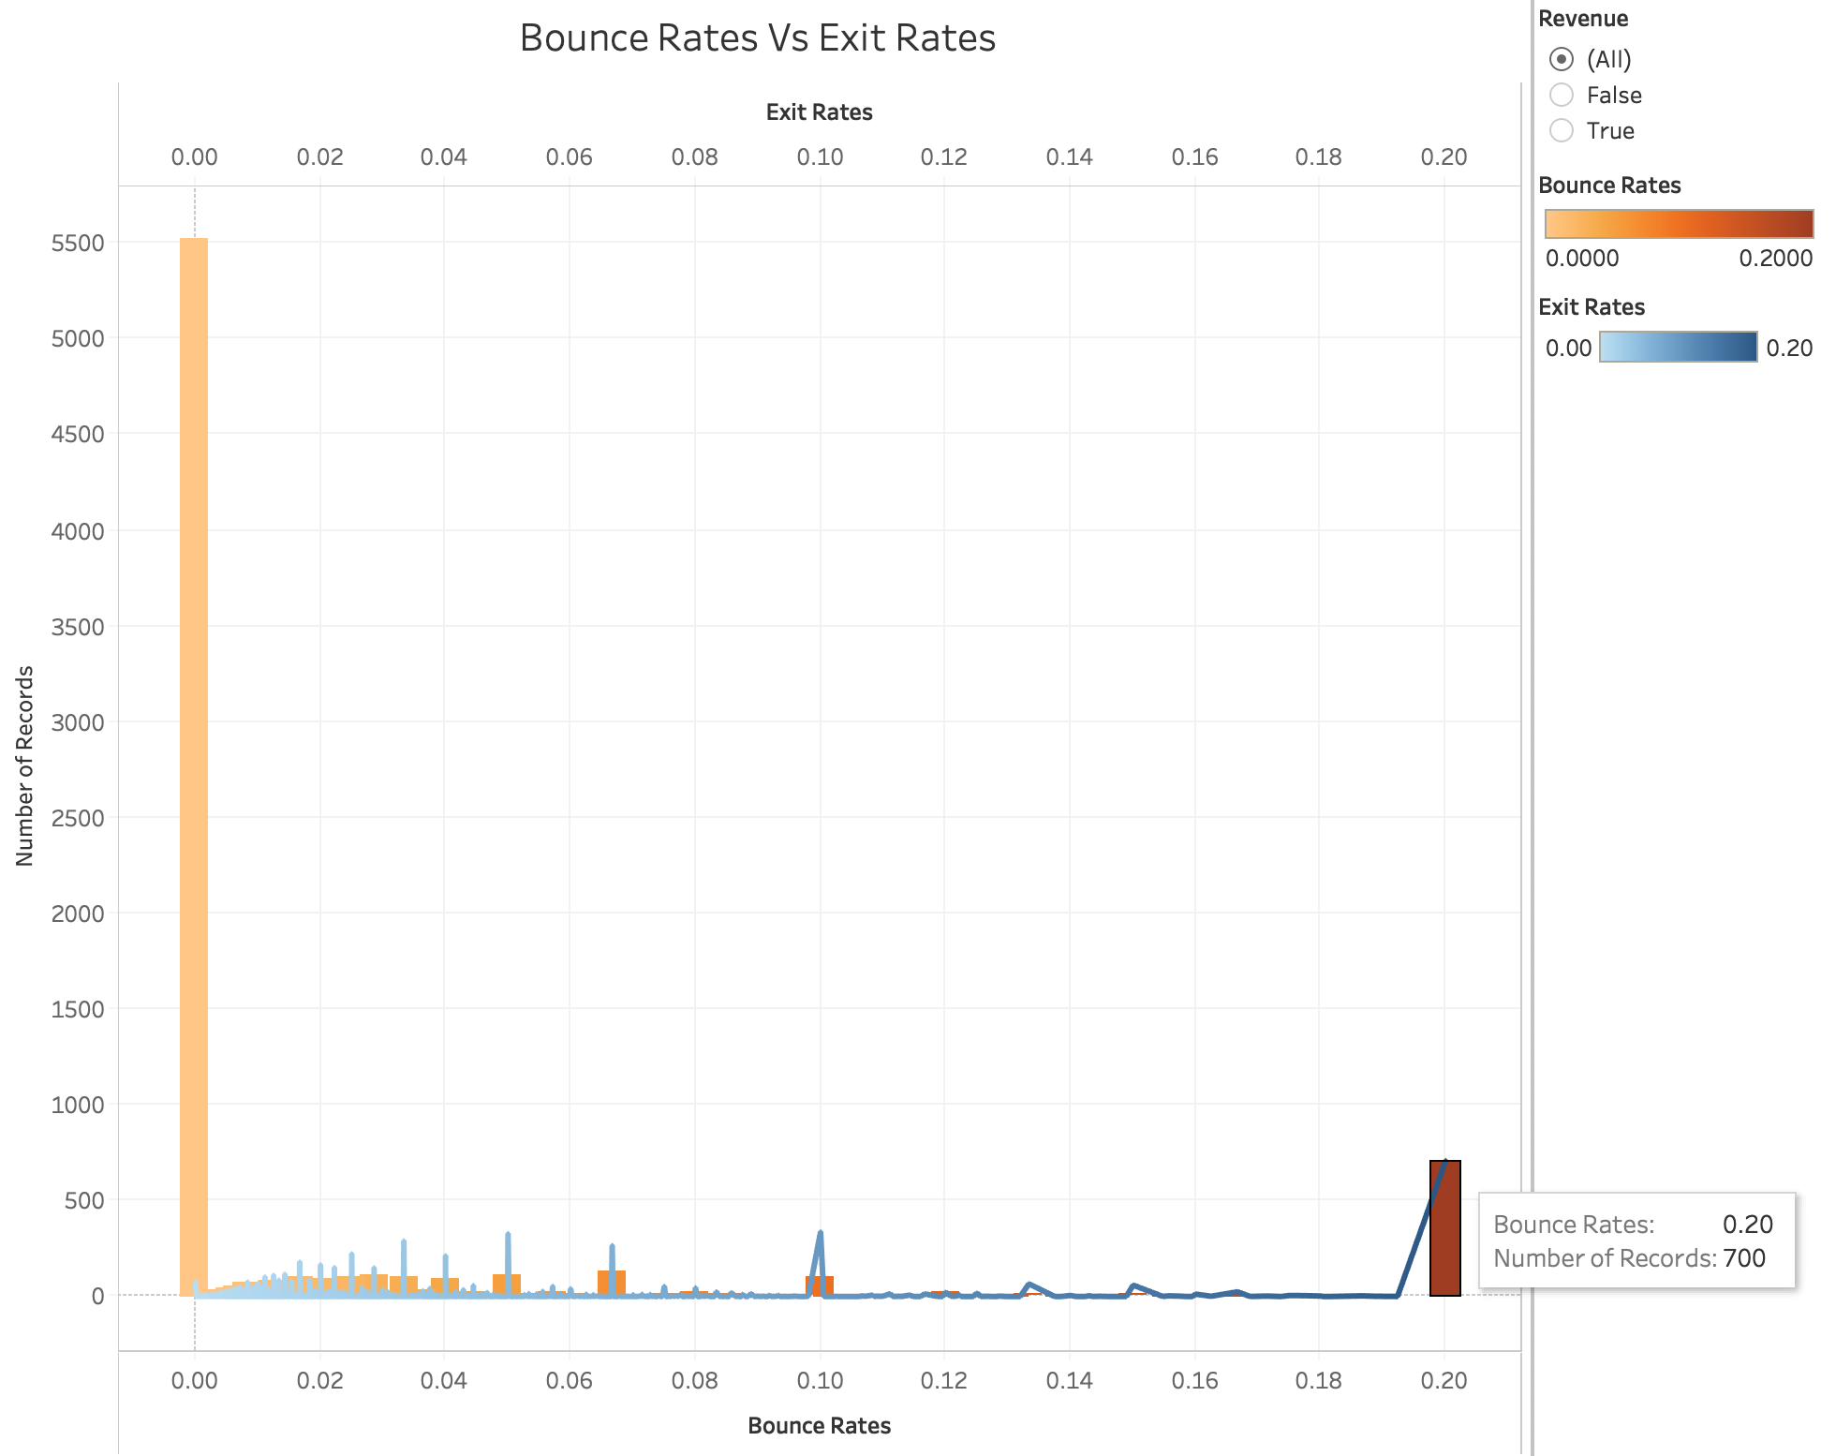

### 5.2.3 (DF) Predict shopping odds based on holidays.

The project shall figure out if the shopping odds are in any way influenced by the day (weekday, weekends, special day or holidays) of the website visit by the visitor.

*As I can see from the below graph, more visits ended up in “Revenue” generation during the weekdays than in weekends.*

*After studying these specific shopping behaviors of the online shoppers, I can use these metrics to increase the chances for the visitors to make purchases in the weekends, for example, by running special weekend campaigns, like special discounted prices etc.*

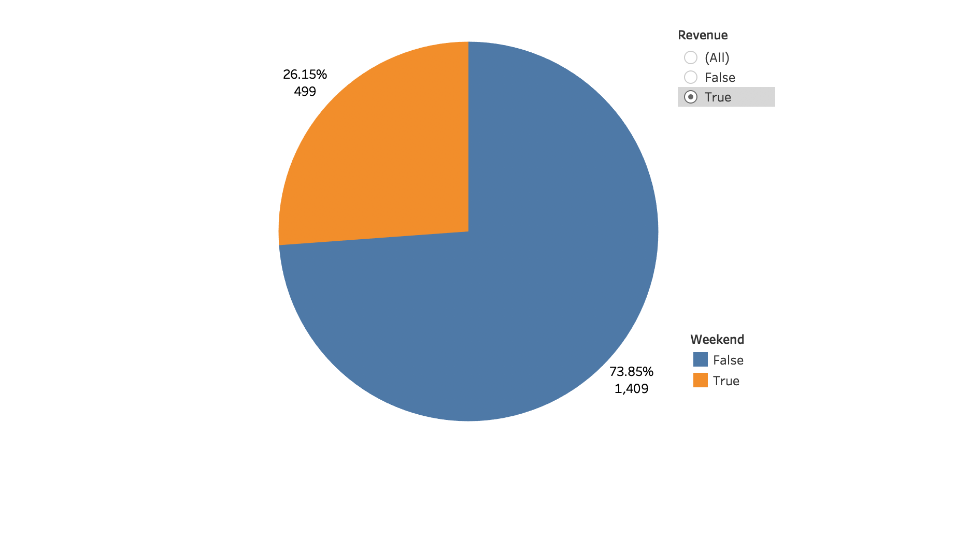

*As it is evident from the below graphs, I can interpret that “Special Days” actually don’t influence the shopping intentions of the visitors that much. In the dataset the “Special Days” have values closer to “1”. As I can see in the graph, the max number of visits/transactions with “Revenue as True/1” are not from “Special Days” or close to Special Days (1831 visits/transactions with Revenue=True/1 are not from a special day or close to a special day (Special Day = 0.00).*

*I can recommend business to announce special deals to influence the visitors to make a purchase near the “Special Days”. Like “Free shipping on all orders” etc.*

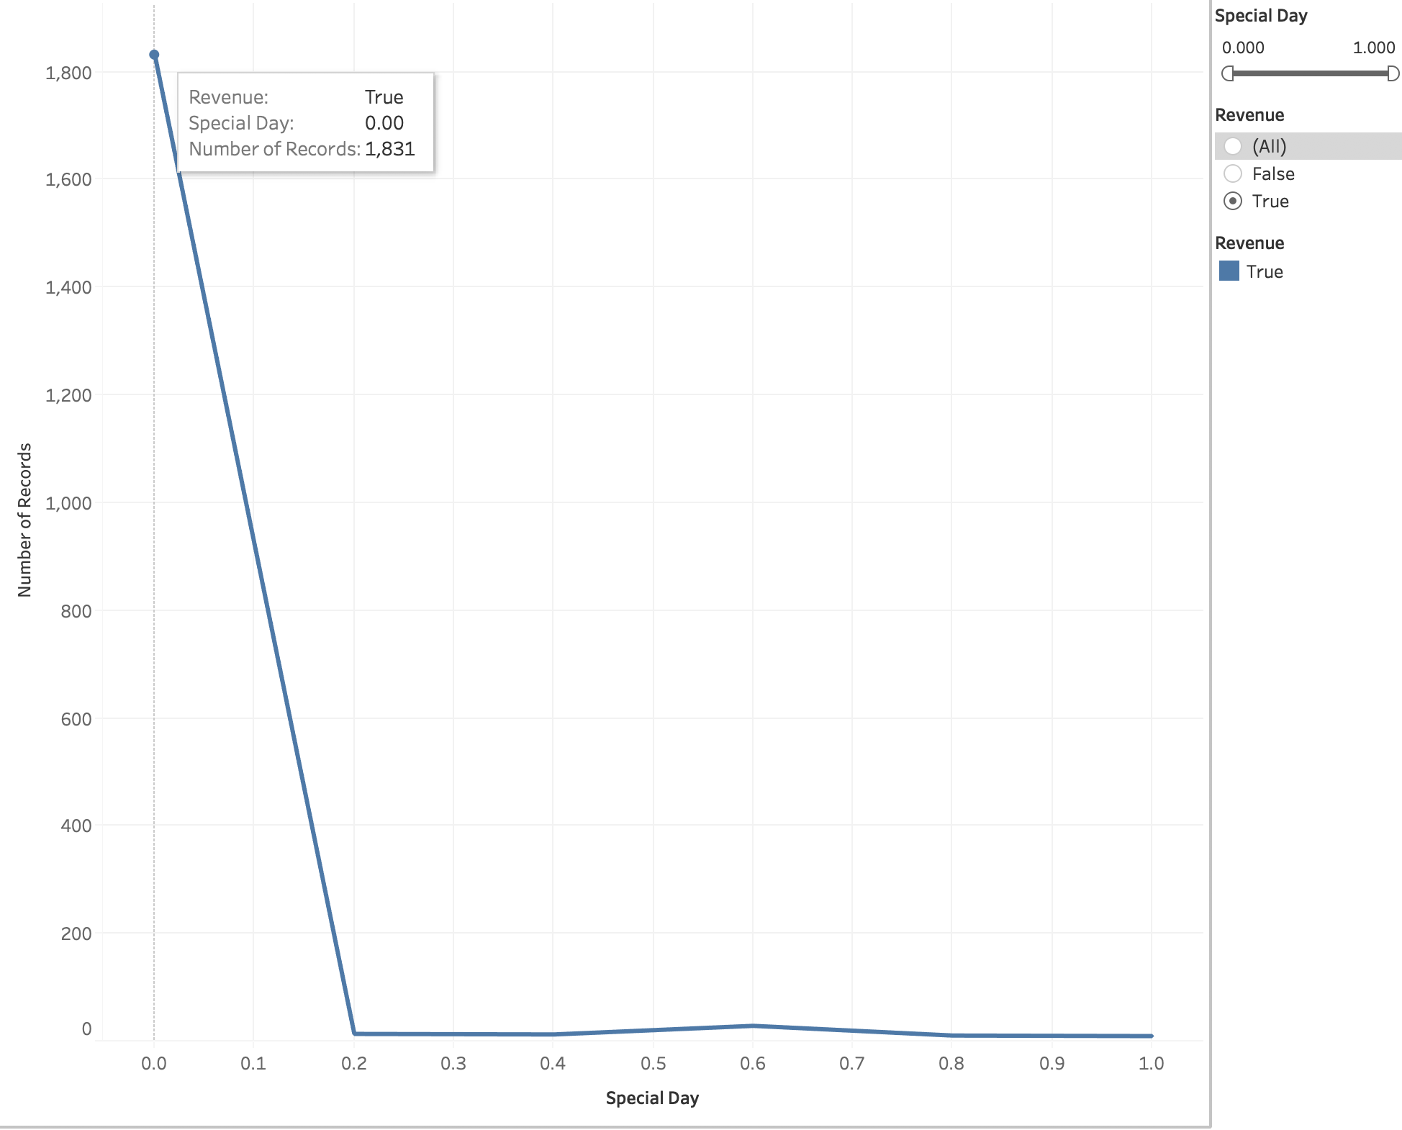

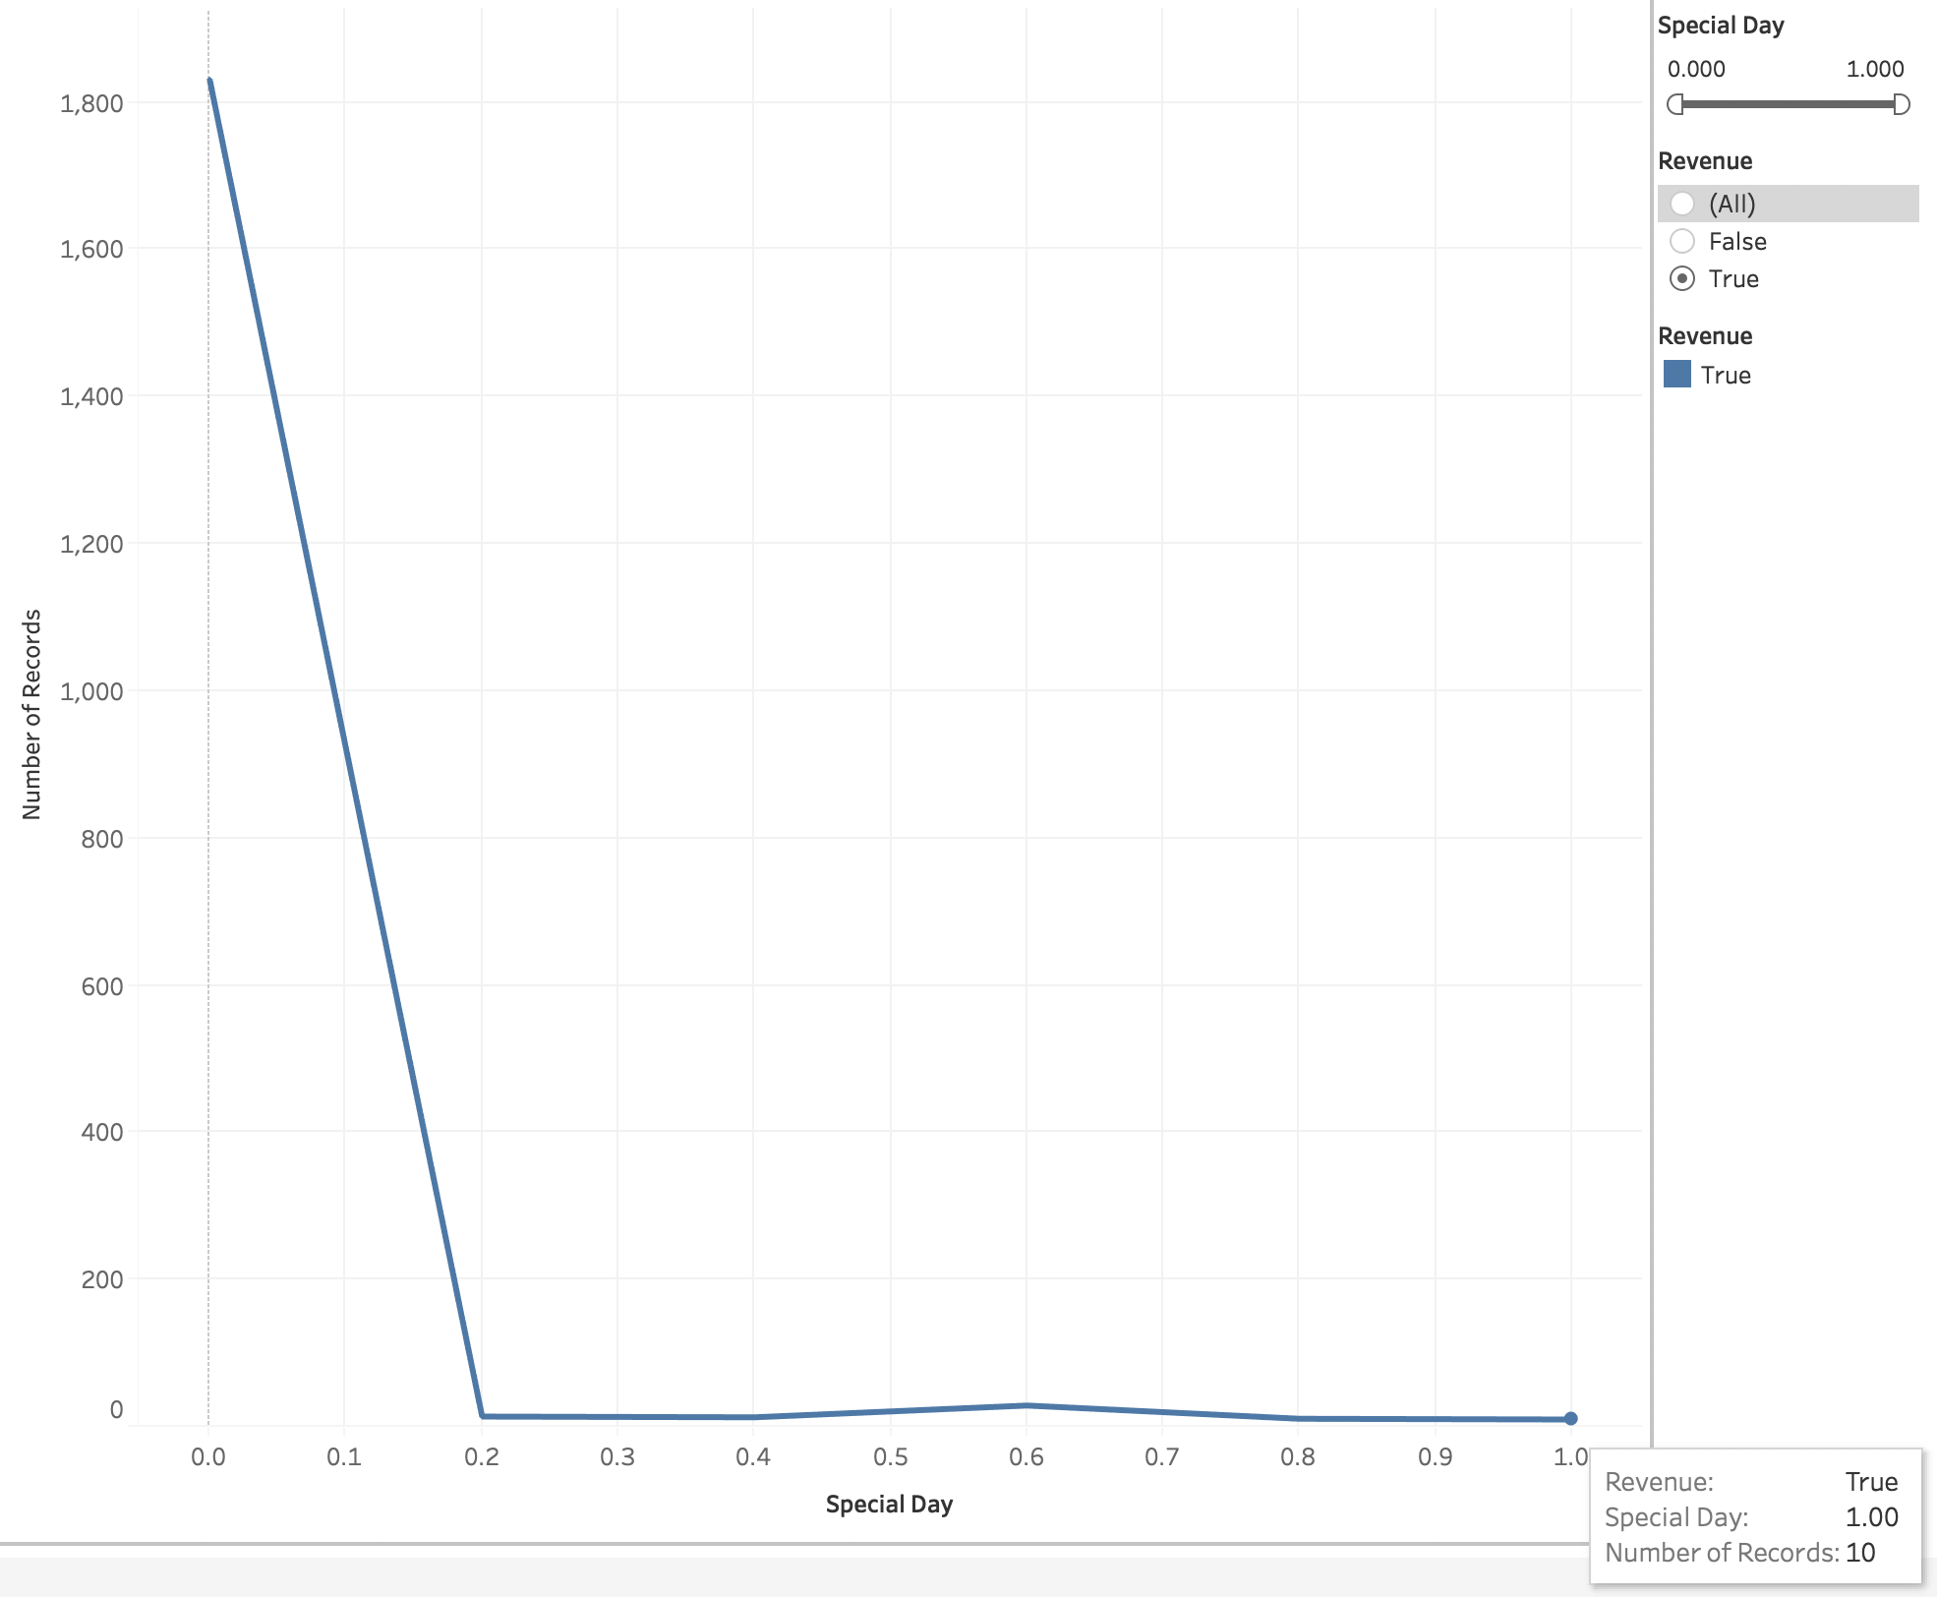

### 5.2.4 (DF) Predict shopping odds based on region.

The project shall predict if it is more likely for a visitor from a particular zip code to place order compared to visitor from any other zip code.

To get the following answers:

* Are the visitors from a specific region more likely to make a purchase than the ones from other regions?

As shown in the below graph, I can conclude that the visitors from Region-1 are more likely to make a purchase. There are around 40% of total visitors who made a purchase are from Region-1. Region 5 did the worst, as the least number of purchases are made by visitors from Regions 5 (2.73%) and 8 (2.94%). As I can link the demographic distribution of the visitors and their shopping intentions, this knowledge can help in making high impact business decisions to influence the intentions of the visitors from a region with lower revenue rate, to make a purchase. For example, business can consider running region specific campaigns in order to lure specific region customers.

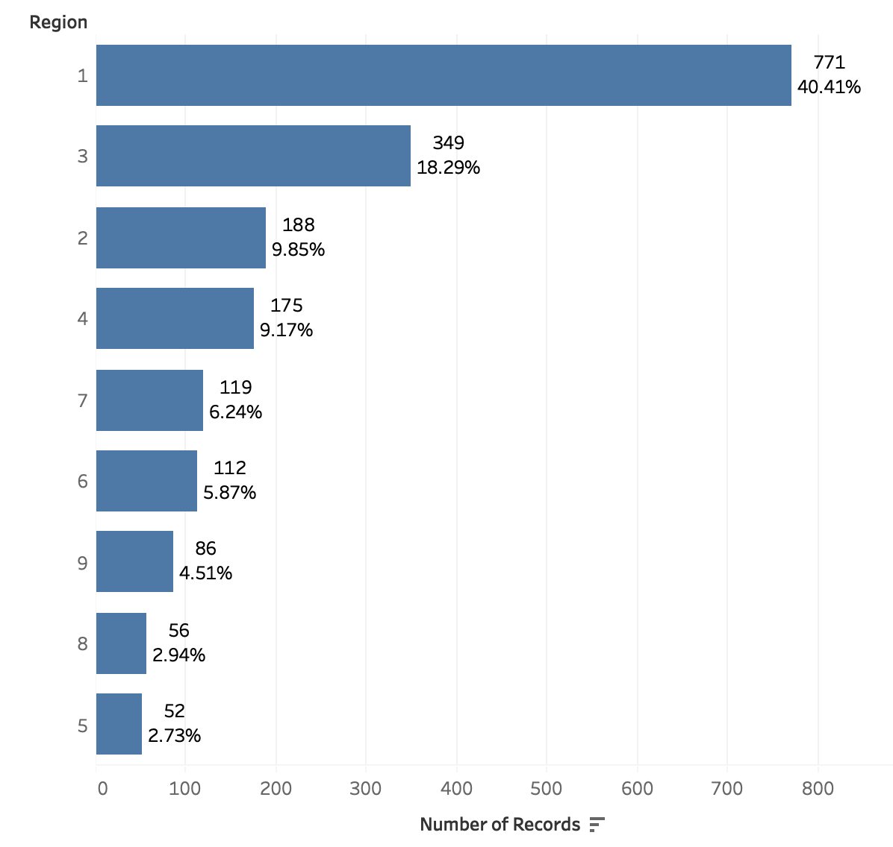

* Do new visitors have more probability to generate the revenue (make a purchase) than the returning visitors?

As indicated in the below graph, I can conclude compared to new visitor the “Returning Visitors” generate maximum revenue (around 77%). The “New Visitors” have generated around 22% of total Revenue. I also noticed that there is a very small fraction (<1%) of visitors that do not belong to either of the category so they end up belonging to the “Other” category.

With the knowledge about the section of users generating or not generating revenue, it is easier for the business to target the customers/visitors as per number of visit. For example, it is healthier for the business to have more “Returning Visitors” constituting total visitors. In order to retain the “Returning Visitors”, business can think about running programs like “Loyalty program”, to lure visitors by offering special discounts if they are returning visitors. Similarly, there could be programs to influence the shopping decisions of the new visitors, and also to make them revisit the site by offering first time discount, and then some percentage of discount/coupon for the subsequent purchases.

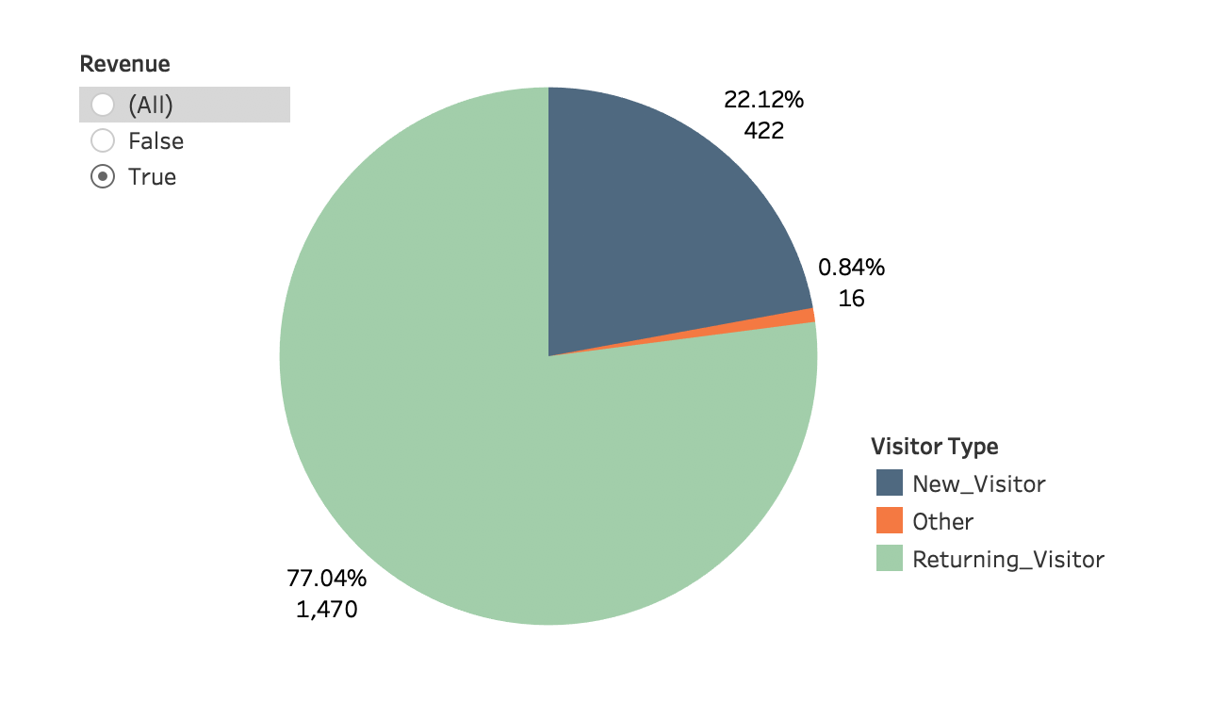

### 5.2.5 (NF) Nice to add Tensor flow.

Time permitting I would like to explore Tensor flow. I had initiated reading the tensor-flow documents but haven’t yet built enough understanding to start implementing it. In this project I am using XGBoost. Much of my time was spent learning about the Boosting algorithms, like Gradient Boosting Machines and XGBoost, and familiarize myself enough to effectively utilize them.

### 5.2.6 (NL) Learn Neural Network ML model.

I am interested in using Neural Network model along with Keras.

Using only sequential clickstream data, train a long short-term memory-based recurrent neural network that generates a sigmoid output showing the probability estimate of visitor’s intention to leave the site without finalizing the transaction in a prediction horizon.

Although I didn’t make use of neural nets as the algorithm of choice in this ML project, I still made sure to train the neural network model in Keras. The results are listed below I received with the three iterations:

Code is given in the appendix:



**Iteration-II**



**Iteration-III**



I also generated the probability predictions with the model

Code





I couldn’t further work on the Neural Nets and Keras, as I identified XGBoost as the algorithm of choice for our project.

## 5.3 Report on Design v1

Since the dataset has a class label it is a Classification problem. Classification is the method of predicting the class of a given input data point. Classification problems fall under the Supervised learning method.

I had initially identified Random Forest classification algorithm as one of the algorithms for building the ML model for this website. Some of the characteristics which made RF as a good candidate for our classification problem are: Random Forests train each tree independently, using a random sample of the data. This randomness helps to make the model more robust than a single decision tree, and less likely to over fit on the training data. Random Forests are easier to train. Additionally:

* RF is easier to tune as there are only two features to be selected:
  + Number of trees
  + Number of features at each node
* RF models are faster due to parallel execution.

I didn’t overlook the challenges with Random Forest (RF), which are:

* Random forests have been observed to overfit for some datasets with noisy classification/regression tasks.
* Unlike decision trees, the classifications made by random forests are difficult for humans to interpret.
* For data including categorical variables with different number of levels, random forests are biased in favor of those attributes with more levels.
* If the data contain groups of correlated features of similar relevance for the output, then smaller groups are favored over larger [groups](http://www.liquisearch.com/what_are_groups)

Looking at the dataset, and running some preliminary checks, I do see that some features are highly correlated like, “ProductRelated_Duration” and “ProductRelated”, with the correlation coefficient ~ 0.861. Below is the screen shot displaying the correlation between these two variables, in R:

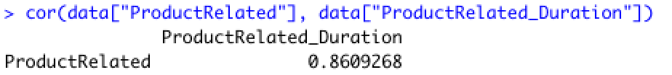

I also observed that the categorical variables have different number of levels, for example the   
“VisitorType” attribute has three levels – “New Visitor”, “Returning Visitor”, “Other”, the Weekend attribute has two levels, “False” and “True”, the “Month” variable/attribute has ten levels in this dataset.

The above factors made us explore “Gradient Boosting Machines”. Nevertheless, finding the probabilities of each event was another motivational factor to understand and explore GBM and its application.

GBM and RF differ in the way the trees are built: the order and the way the results are combined. (It has been shown that GBM performs better than RF if parameters are tuned carefully)

The Gradient Boosting Machines (GBM) builds trees one at a time, where each new tree helps to correct errors made by previously trained tree. The GBM is a power method to address learning to rank problems due to its two main features:

* It performs the optimization in function space (rather than in parameter space) which makes the use of custom loss functions much easier.
* Boosting focuses step by step on difficult examples that give a nice strategy to deal with unbalanced datasets by strengthening the impact of the positive class.

Like RF I do have some challenges with GBT, like:

* Sensitive to overfitting if the data is noisy.
* Training GBT based models takes longer because of the fact that trees are built sequentially.
* Harder to tune than RF as there are three tuning parameters:
  + Number of trees
  + Depth of trees
  + Learning Rate

With all the above features and characteristics, GBM seemed to be an improvement over Random Forest.

Note: I also suspected an unbalance of classification in the dataset, which is known as “imbalance classification problem”

Below plot shows the class variable distribution, “Revenue” in the given dataset: Where 0 = No Revenue, and 1 = Revenue events*.*





I did some preliminary tests with the GBM algorithm and I built an ML model by using this classification algorithm. Exploring the boosting algorithms further, I learnt about another recommended algorithm which is considered more efficient than GBM, that is **XGBoost. XGBoost** stands for “Extreme Gradient Boosting”. “Both XGBoost and GBM follow the principle of gradient boosting. There are, however, the difference in modeling details. Specifically, XGBoost uses a more regularized model formalization to control over-fitting, which gives it better performance. The name XGBoost, though, actually refers to the engineering goal to push the limit of computations resources for boosted tree algorithms. Which is the reason why many people use XGBoost. For model, it might be more suitable to be called as regularized gradient boosting.”

XGBoost focuses on the computational power, by parallelizing the tree formation.

Hence, **XGBoost** being a more efficient Gradient Boosting algorithm, was picked up as our algorithm of **choice for this project**.

Graphical Representation of Gradient Boosting



|  |  |  |
| --- | --- | --- |
| Abbreviation | Full Name | Attribute purpose |
| PV | Page Value | The "Page Value" feature represents the average value for a web page that a user visited before completing an e-commerce transaction. [11][13] |
| BR | Bounce Rates | The value of "Bounce Rate" feature for a web page refers to the percentage of visitors who enter the site from that page and then leave ("bounce") without triggering any other requests to the analytics server during that session. [9] [13] |
| ER | Exit Rates | The value of "Exit Rate" feature for a specific web page is calculated as for all pageviews to the page, the percentage that were the last in the session. [10] [13] |
| SD | Special Day | The "Special Day" feature indicates the closeness of the site visiting time to a specific special day (e.g. Mother’s Day, Valentine's Day) in which the sessions are more likely to be finalized with transaction. The value of this attribute is determined by considering the dynamics of e-commerce such as the duration between the order date and delivery date. For example, for Valentina’s day, this value takes a nonzero value between February 2 and February 12, zero before and after this date unless it is close to another special day, and its maximum value of 1 on February 8. [13] |
| PR, PRD,  AD, ADD,  INF, IND | Product Related ,  Product Related Duration, Administrative, Administrative Duration, Informational,  Informational Duration | All these attributes represent the number of different types of pages visited by the visitor in that session and total time spent in each of these page categories. The values of these features are derived from the URL information of the pages visited by the user and updated in real time when a user takes an action, e.g. moving from one page to another. [13] |
| REV | Revenue (Class Variable/Attribute) | REV = 0 is no-shopping/not-shopped event and REV = 1 is shopping/shopped event. [13] |
| VT | Visitor Type | Returning or New Visitor [13] |
| WK | Weekend | A Boolean value indicating whether the date of the visit is weekend [13] |
| MM | Month | Month of the year [13] |
| OS | Operating System |  |
| BR | Browser |  |
| RE | Region |  |
| TT | Traffic Type |  |

Following steps for this project:

Figure-1 : The high level process flow of the project



Below are the high-level process flow steps, I have been implementing, as shown in Figure-1:

* 1. Dataset Selection – The first step is to select a dataset. SIP model would use data extensively. I am planning to use the “Online Shoppers Purchasing Intension Dataset” from “[UCI Machine Learning Repository](https://archive.ics.uci.edu/ml/datasets/Online+Shoppers+Purchasing+Intention+Dataset)”
  2. Dataset Analysis, Clean-up & Preprocessing – In this step, the data is analyzed through visualization and other techniques to find any outliers (if any).

The preprocessing steps include:

* Searching for NAs and NULLs and removing the records which contain them.
* Identify and convert the attributes which need to be converted to numerical/integer data, like “month”, “visitorType”, “weekend” etc.
* Change the values of class attribute to binary values.
* Standardize the attributes. - *The attributes in the given dataset have different scales. I need to standardize the dataset to put all the attributes/variables on the same scale. By standardizing the variables, I will be able to compare scores between different types of variables.*

(See Assignment 4 appendix section for code to clean up and preprocess the data)

* 1. Split Training and Test Datasets – After preprocessing of the dataset, I will be arranging dataset into 2 parts i.e. Train and Test. The machine learning models (SVM, Random Forest etc.) will be trained and built on the training dataset and will then use Test dataset to predict the classification.

**Note:**

I split the dataset into train and test datasets keeping the ratio as 70:30 for **training and testing** datasets, respectively. I also tried to split the ratio into 70:15:15 for training, and testing validation.

Please refer the appendix for the code and model’s performance results with the 70:30 ratio.

Please refer the appendix section “Testing with the split ratio 70:15:15” for the code and the results.

* 1. Build models – After splitting into 2 parts i.e. Train & Test datasets, I will build our machine learning models using the identified algorithms on the training dataset.
  2. Test models – In this step I have to predict the classification using test data dataset.
  3. Compare ML model performance – In this step I have to compare the performance (like Accuracy, F1-score, Precision & Recall) of different models to identify the best model. The model with the best performance is considered as the chosen model. With all the tests I have done so far, I got the best performance results with the “XGBoost” classifier.
  4. Repeat steps from 4 to 6 by selecting the top best attributes, ranked by the attribute selections method/methods. The attribute selection is done to improve the performance of the ML models, by using the most relevant attributes, for example: in terms of info-gain, gain-ratio, or correlation with the class attribute. The attribute selection can also be done using “XGBoost”. *In this project I mainly are using “XGBoost” for feature/attribute selection.*

I used the “Feature Importance and Feature Selection with **XGBoost**”

*Below is the output of the Feature Importance and Feature Selection with XGBoost, I applied on dataset:*

*See appendix for the “Feature Importance and Feature Selection with XGBoost”.*



*I used these scores for feature selection in scikit-learn on the pre-trained model built with our identified algorithm – “XGBoost”, with* ***SelectFromModel*** *class, that takes a model and can transform a dataset into a subset with selected features. Below are the results I got:*



*The above results tell us that with few features selected I got lower performance than with all the features. The reason could be that the features that I got rid of still contain some information about our target variable, even if it’s minimal.*

*To effectively utilize the feature selection, I need to understand how each variable is contributing to the target variable.*

*I did some tests with individual attributes, by building the models again with the set of attributes and tested them to compare the accuracies. See appendix for* ***Attribute Selection with XGBoost Feature Selection Method details.***

*I also tested the accuracy of the model with respect to the months, since “Month” has been listed as the most important attribute by XGBoost feature selection method:*

*Please refer the appendix for the code*

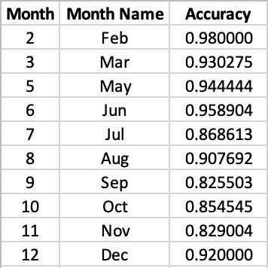

*As can be seen though the month of “November (11)” has the highest revenue (visits/transaction with revenue=1/True) –* *Please refer the graph “Total Revenue by Months”**, but it has lower accuracy in comparison to the highest accuracy of “Feb(2)”- 98%, the month which has recorded 98% of transactions with no revenue (revenue=0/False). Hence, almost all the visits/transactions in the month of Feb have been classified correctly.*

* Create visualizations to represent and showcase the data –Visualization is an efficient way to display and show the data. I have created quite a few visualizations in Tableau to display the data and for easy consumption of the data and our project, by the users.

*Please refer* *Report on Requirements v1* *sections to see some of the visualizations I built using Tableau.*

* Hyperparameter Tuning – “*In machine learning, hyperparameter optimization or tuning is the problem of choosing a set of optimal hyperparameters for a learning algorithm. These measures are called hyperparameters and have to be tuned so that the model can optimally solve the machine learning problem.”*
* **Hyperparameter Tuning**

I will be *tuning the hyperparameters* to make the results from our model/models optimum. I will be largely perform tuning of the parameters for our model built with **XGBoost** classifier.

I have figured out the following hyperparameters that will be tuned:

***XGBoost Parameters:***

*There are 3 categories of XGBoost Parameters:*

**General Parameters:** Guide the overall functioning.

Available in the General Parameters, the two parameters, silent and nthread are automatically tuned by XGBoost. I will be taking help of gbtree for booster parameter, which is the default value.

**Booster Parameters:** They guide the individual booster (tree/regression) at each and every step. *I provided the input to our XGBoost model with the following booster parameters. Firstly, I fixed a value for a parameter (learning_rate) and changed the values for the second parameter (n_estimators****)****. It was continued till I attained the maximum performance with this combination. After that I shifted our focus to the third parameter and started changing its values, while keeping the other two at the optimum values that I had previously got, I continued till I got the best performance. I followed these steps for all the parameters, until I got the best results* *(Please refer to the table for the results I got with different values of hyper-parameters)*

**learning_rate/eta**:

* It controls the learning rate, i.e., the rate at which our model learns patterns in data. After every round, it shrinks the feature weights to reach the best optimum.
* Lower eta leads to slower computation. It must be supported by increase in nrounds.
* Typically, it lies between 0.01 - 0.3

﻿**n_estimators**:

* The number of sequential trees to be modeled or number of boosting.
* Should be tuned using CV (Cross Validation)

﻿**max_depth:**

* It controls the depth of the tree.
* Larger the depth, more complex the model; higher chances of overfitting. There is no standard value for max_depth. Larger data sets require deep trees to learn the rules from data.
* Should be tuned using CV (Cross Validation)

﻿**subsample:**

1. It controls the number of samples (observations) supplied to a tree.
2. Typically, its values lie between (0.5-0.8)

﻿**colsample_bytree:**

* It controls the number of features (variables) supplied to a tree
* Typically, its values lie between (0.5,0.9)

﻿**gamma:**

* It controls regularization (or prevents overfitting). The optimal value of gamma depends on the data set and other parameter values.
* Higher the value, higher the regularization. Regularization means penalizing large coefficients which don't improve the model's performance. default = 0 means no regularization.

**Learning Task Parameters:** Guide the optimization performed. These parameters are used to define the optimization objective. I am using the default values for these parameters.

*I did some tests by tuning the above listed booster parameters, manually and in iterations. I got the best results with the highlighted values of the above listed parameters, accuracy ~ 90%*

**

***Method used to tune the parameters:***

As it is evident from the above table, I began with the value **0.01** for **learning_rate** parameter and changed the value of **n estimators** starting from **1000** and then changing it till **500,** by a step of **100,** at each iteration. The performance improved with the decrease of **n_estimators** value from **1000-700**. And it declined thereafter. Hence, I fixed the values of **learning_rate** as **0.01** and **n_estimators** as 700. Thereafter, I changed the value of **max_depth**, until I reached a value after which the performance started declining. I chose this value of **max_depth** as the optimum value for it, and performed the same process for the rest of the parameters, till I got the **max accuracy** (the best accuracy, before it started declining with the change in parameter values). This was the method I followed to get the combination of all the values, as highlighted in green in the above table, that produced the best accuracy for our ML model.

I have used **Weka** to run attribute selection methods (InfoGainAttributeEval & GainRatioAttributeEval) on the train dataset. I have chosen the attributes with high information gain or gain ratio to build the ML model. High info attributes help to improve the performance of the algorithm.

Weka **Ranker method – Ranker** search methodattributes are ranked by their individual evaluations. It’s used in conjunction with attribute evaluators.

1. **InfoGainAttributeEval** - Attributes are evaluated based on information gain, which is a purity measure based on info (entropy). The attribute evaluator evaluates the worth of an attribute by measuring the information gain (also called Entropy) with respect to the class.
2. **GainRatioAttributeEval -** The GainRatioAttributeEval uses gain ratio to overcome the bias of information gain (the information gain measure prefers to select attributes having a large number of values). The attributes are evaluated based on gain ratio. It evaluates the worth of an attribute by measuring the gain ratio with respect to the class. Subsets of features that are highly correlated with the class while having low inter-correlation are preferred.

**Weka screen shots attribute applying selection method on the train dataset:**

#### Output – InfoGainAttributeEval with Ranker search method:

*Above screen shot after applying InfoGainAttributeEval selection using Ranker search method. Rank is given to each attribute.*

#### Output - GainRatioAttributeEval selection method with Ranker search:



*Above screen shot after applying GainRatioAttributeEval selection using Ranker search method. Rank is given to each attribute as per the GrainRatio.*

To verify whether the selection process of the attribute has any effect on the efficiency of the ML model or not. As you notice Random Forest & GBM classifiers improves by selecting the top few attributes which are ranked by the above used attribute selection methods, I selected the attributes with the GainRatio of 0.015 and greater as ranked by the GainRatioAttributeEval attribute method. I rebuilt the ML models and tested project dataset using the high ranked selected attributes. I did not see any performance improvement of the model using the new training dataset, created by using the attribute selection method/methods. I am currently working on to implement “XGBoost” feature selection method for our identified ML algorithm, that is **XGBoost**



*Next, I used the* ***SelectFromModel*** *class on our ML model built using* ***XGBoost*** *algorithm. The* ***SelectFromModel*** *class can transform a dataset into a subset with selected features.*

*Below are the results I got after applying the “SelectFromModel” class on the XGBoost ML*

*model:*

“XGBoost Feature Importance and Selection is given in the Appendix”.



*As can be seen the accuracy is highest with all the attributes selected, and it reduces as the number of attributes decreases.*

*I did some tests with individual attributes, by building the models again with the set of attributes and tested them to compare the accuracies. See* “XGBoost Feature Importance and Selection is given in the Appendix”

Also, since I have used R (as part of DA courses) previously, I used R to analyze the data, mainly because of the ease of use.

Below is the screen shot displaying the correlation between these two variables, in R:



The ML classification algorithm which I am using for this project is **XGBoost**.

**Comparison of various technologies I am using:**

Comparing Python, R and Weka

The biggest difference between **Weka** and the other tools I am using like, **Python** and **R**, is flexibility. Weka is a good way to get familiar with machine learning/data mining in a practical context. It is packaged into a .jar file and comes with a GUI I can use to run most simple analysis and building the ML models. Weka is great for two things: learning about data science and testing very well-known machine learning algorithms on small datasets. Python and R are better tools due to ease of integration, more modern algorithms, and better memory management.

The positive side of Weka is, it requires no code. It's great for exploring small datasets, and also for cleaning and manipulating data. On the other hand, R and Python are flexible data science tools which require some programming skills. I can clean and manipulate our code and build the models with a great flexibility using Python and R.

Comparing the visualization libraries with Tableau:

I explored and used the following libraries as part of our preliminary data analysis:

Matplotlib - Matplotlib is a Python 2D plotting library which produces publication quality figures in a variety of hardcopy formats and interactive environments across platforms.

Seaborn - Seaborn is a Python data visualization library based on matplotlib. It provides a high-level interface for drawing attractive and informative statistical graphics.

*For example, I created a graph showing the* *Distribution of the data by class label – Revenue**, using the above listed libraries. Please refer to the code and the graph in the linked appendix section.*

But later I considered using Tableau instead, since it’s faster to create visualizations in Tableau than with the above listed libraries. Apart from visualizations, Tableau can be used for analyzing and manipulating the data. It’s easy to make changes to the already built visualizations in Tableau. The visualizations built in Tableau can be easily made more interactive and shareable.

*Please refer the* ***DF Create Data Visualization*** *sections under Report on Requirements v1 to see some of the visualizations I built using Tableau.*

## Appendix:

1. **XGBoost - XGBoost Feature Selection Method**

Below are the steps to see the impact on the accuracy after using each attribute. After checking performance accuracy with set of attributes:

* 1. **Four Attributes:** I started the top four models as per the above results I got from the. I trained this model using following 4 attributes:

x_train = x_train[['Month', 'PageValues', 'ProductRelated_Duration','ExitRates']]

x_test = x_test[['Month', 'PageValues', 'ProductRelated_Duration','ExitRates']]

Model Accuracy:

﻿

|  |  |
| --- | --- |
| XGBoostClassifier Training Accuracy | 0.9172749391727494 |
| XGBoostClassifier Testing Accuracy | 0.8972695323060287 |

As you notice the accuracy is close to what I got with all the attributes, this is the starting point to test the importance of other attributes, and to see if I can achieve better accuracy than what I got with all the attributes.

* 1. **Add Administrative attribute**

I have added “Administrative” attribute by the sorted list of importance of selected attribute, that is and rebuilt and tested the model:

x_train = x_train[['Month','PageValues', 'ExitRates', 'ProductRelated_Duration', 'Administrative']]

x_test = x_test[['Month', 'PageValues', 'ExitRates', 'ProductRelated_Duration', 'Administrative']]

|  |  |
| --- | --- |
| XGBoostClassifier Training Accuracy | 0.9214459506430309 |
| XGBoostClassifier Testing Accuracy | 0.8942957556096243 |

* 1. **Add Administrative_Duration attribute**

Accuracy has decreased after adding “Administrative”. Now add “Administrative_Duration” and rerun the tests:

﻿x_train = x_train[['Month','PageValues', 'ExitRates', 'ProductRelated_Duration', 'Administrative', 'Administrative_Duration']]

x_test = x_test[['Month', 'PageValues', 'ExitRates', 'ProductRelated_Duration', 'Administrative', 'Administrative_Duration']]

﻿

|  |  |
| --- | --- |
| XGBoostClassifier Training Accuracy | 0.9226045649403314 |
| XGBoostClassifier Testing Accuracy | 0.8940254122735874 |

* 1. **Remove 'Administrative', 'Administrative_Duration' add “BounceRates”**

Remove both these attributes, 'Administrative', 'Administrative_Duration' because accuracy has decreased further. Add “BounceRates” attribute and tested the model:

﻿x_train = x_train[['Month','PageValues', 'ExitRates', 'ProductRelated_Duration','BounceRates' ]]

x_test = x_test[['Month', 'PageValues', 'ExitRates', 'ProductRelated_Duration', 'BounceRates']]

﻿

|  |  |
| --- | --- |
| XGBoostClassifier Training Accuracy | 0.921561812072761 |
| XGBoostClassifier Testing Accuracy | 0.8948364422816978 |

* 1. ***Replace “BounceRates” attribute with 'VisitorType'***

﻿x_train = x_train[['Month','PageValues', 'ExitRates', 'ProductRelated_Duration', 'VisitorType' ]]

x_test = x_test[['Month', 'PageValues', 'ExitRates', 'ProductRelated_Duration', 'VisitorType']]

﻿

|  |  |
| --- | --- |
| XGBoostClassifier Training Accuracy | 0.9166956320240992 |
| XGBoostClassifier Testing Accuracy | 0.8969991889699919 |

As a result I see an improvement in accuracy.

* 1. Add **“Informational_Duration”** attribute:

Adding more attributes, as per their position in the sorted list by importance of the attributes next I added **“Informational_Duration”**

﻿x_train = x_train[['Month','PageValues', 'ExitRates', 'ProductRelated_Duration', 'VisitorType', 'Informational_Duration' ]]

x_test = x_test[['Month', 'PageValues', 'ExitRates', 'ProductRelated_Duration', 'VisitorType', 'Informational_Duration']]

﻿

|  |  |
| --- | --- |
| XGBoostClassifier Training Accuracy | 0.9175066620322094 |
| XGBoostClassifier Testing Accuracy | 0.8967288456339552 |

Result: I see the accuracy has decreased, though by very small amount. Next

* 1. Add***“TrafficType”:***

﻿x_train = x_train[['Month','PageValues', 'ExitRates', 'ProductRelated_Duration', 'VisitorType', 'Informational_Duration', 'TrafficType' ]]

x_test = x_test[['Month', 'PageValues', 'ExitRates', 'ProductRelated_Duration', 'VisitorType', 'Informational_Duration','TrafficType']]

﻿

|  |  |
| --- | --- |
| XGBoostClassifier Training Accuracy | 0.9185494148997798 |
| XGBoostClassifier Testing Accuracy | 0.8969991889699919 |

Result: I see an increase in accuracy. Next

* 1. ***Remove 'Informational_Duration'***

﻿x_train = x_train[['Month','PageValues', 'ExitRates', 'ProductRelated_Duration', 'VisitorType', 'TrafficType' ]]

x_test = x_test[['Month', 'PageValues', 'ExitRates', 'ProductRelated_Duration', 'VisitorType', 'TrafficType']]

﻿

|  |  |
| --- | --- |
| XGBoostClassifier Training Accuracy | 0.9171590777430193 |
| XGBoostClassifier Testing Accuracy | 0.8964585022979183 |

* 1. **Result: The accuracy decreased after removing 'Informational_Duration'. Let’s add it back and add the next attribute:**

﻿x_train = x_train[['Month','PageValues', 'ExitRates', 'ProductRelated_Duration', 'VisitorType', 'Informational_Duration', 'TrafficType', 'OperatingSystems' ]]

x_test = x_test[['Month', 'PageValues', 'ExitRates', 'ProductRelated_Duration', 'VisitorType', 'Informational_Duration','TrafficType', 'OperatingSystems']]

﻿

|  |  |
| --- | --- |
| XGBoostClassifier Training Accuracy | 0.9179701077511296 |
| XGBoostClassifier Testing Accuracy | 0.8969991889699919 |

* 1. **Adding ‘'OperatingSystems' didn’t impact the accuracy at all. Let’s remove it and add the next attribute “Region”.**

﻿x_train = x_train[['Month','PageValues', 'ExitRates', 'ProductRelated_Duration', 'VisitorType', 'Informational_Duration', 'TrafficType', 'Region']]

x_test = x_test[['Month', 'PageValues', 'ExitRates', 'ProductRelated_Duration', 'VisitorType', 'Informational_Duration','TrafficType', 'Region']]

|  |  |
| --- | --- |
| ﻿XGBoostClassifier Training Accuracy | 0.9178542463213996 |
| XGBoostClassifier Testing Accuracy | 0.8964585022979183 |

* 1. **Adding Region has decreased the accuracy. Let’s add attribute “Browser” without removing the Region field to see its impact.**

﻿x_train = x_train[['Month','PageValues', 'ExitRates', 'ProductRelated_Duration', 'VisitorType', 'Informational_Duration', 'TrafficType', 'Region', 'Browser']]

x_test = x_test[['Month', 'PageValues', 'ExitRates', 'ProductRelated_Duration', 'VisitorType', 'Informational_Duration','TrafficType', 'Region', 'Browser']]

﻿

|  |  |
| --- | --- |
| XGBoostClassifier Training Accuracy | 0.9183176920403198 |
| XGBoostClassifier Testing Accuracy | 0.8980805623141389 |

* 1. **I see a big accuracy improvement by adding the “Browser” attribute. Now delete the “Region” attribute and see if it effects the accuracy.**

﻿x_train = x_train[['Month','PageValues', 'ExitRates', 'ProductRelated_Duration', 'VisitorType', 'Informational_Duration', 'TrafficType', 'Browser']]

x_test = x_test[['Month', 'PageValues', 'ExitRates', 'ProductRelated_Duration', 'VisitorType', 'Informational_Duration','TrafficType', 'Browser']]

﻿

|  |  |
| --- | --- |
| XGBoostClassifier Training Accuracy | 0.9185494148997798 |
| XGBoostClassifier Testing Accuracy | 0.8972695323060287 |

* 1. **I can see that the accuracy has gone down after removing the region field.Let’s add it back and add the next attribute, as per sorted order of the feature importance.**

﻿x_train = x_train[['Month','PageValues', 'ExitRates', 'ProductRelated_Duration', 'VisitorType', 'Informational_Duration', 'TrafficType', 'Region', 'Browser', 'Informational']]

x_test = x_test[['Month', 'PageValues', 'ExitRates', 'ProductRelated_Duration', 'VisitorType', 'Informational_Duration','TrafficType', 'Region', 'Browser', 'Informational']]

﻿

|  |  |
| --- | --- |
| XGBoostClassifier Training Accuracy | 0.9185494148997798 |
| XGBoostClassifier Testing Accuracy | 0.8967288456339552 |

* 1. **I can see that the accuracy has decreased by adding ‘'Informational' field. Let’s remove it****and add the next attribute:**

﻿x_train = x_train[['Month','PageValues', 'ExitRates', 'ProductRelated_Duration', 'VisitorType', 'Informational_Duration', 'TrafficType', 'Region', 'Browser', 'Weekend']]

x_test = x_test[['Month', 'PageValues', 'ExitRates', 'ProductRelated_Duration', 'VisitorType', 'Informational_Duration','TrafficType', 'Region', 'Browser', 'Weekend']]

﻿

|  |  |
| --- | --- |
| XGBoostClassifier Training Accuracy | 0.9184335534700498 |
| XGBoostClassifier Testing Accuracy | 0.8975398756420654 |

* 1. **I can see that the accuracy has decreased by a small amount from the following****combination:**

x_test = x_test[['Month', 'PageValues', 'ExitRates', 'ProductRelated_Duration', 'VisitorType', 'Informational_Duration','TrafficType', 'Region', 'Browser']]. Where I achieved 89.8%.

* 1. **Let’s add our last column that is “Special Day” to the selected attributes and check the results.**

﻿x_train = x_train[['Month','PageValues', 'ExitRates', 'ProductRelated_Duration', 'VisitorType', 'Informational_Duration', 'TrafficType', 'Region', 'Browser', 'Weekend', 'SpecialDay']]

x_test = x_test[['Month', 'PageValues', 'ExitRates', 'ProductRelated_Duration', 'VisitorType', 'Informational_Duration','TrafficType', 'Region', 'Browser', 'Weekend', 'SpecialDay']]

﻿

|  |  |
| --- | --- |
| XGBoostClassifier Training Accuracy | 0.9180859691808597 |
| XGBoostClassifier Testing Accuracy | 0.8969991889699919 |

* 1. **I again see a decline in accuracy. I haven’t got the accuracy which I achieved with all the attributes, of nearly 90%. The maximum accuracy I achieved is 89.8.**
  2. **I tried adding the attributes, like “Administrative” and “Administrative_Duration” back. Got the following results:**

﻿x_train = x_train[['Month','PageValues', 'ExitRates', 'ProductRelated_Duration', 'VisitorType', 'Informational_Duration', 'TrafficType', 'Region', 'Browser', 'Weekend', 'Administrative' ]]

x_test = x_test[['Month', 'PageValues', 'ExitRates', 'ProductRelated_Duration', 'VisitorType', 'Informational_Duration','TrafficType', 'Region', 'Browser', 'Weekend', 'Administrative']]

|  |  |
| --- | --- |
| ﻿XGBoostClassifier Training Accuracy | 0.9209825049241107 |
| XGBoostClassifier Testing Accuracy | 0.8972695323060287 |

﻿x_train = x_train[['Month','PageValues', 'ExitRates', 'ProductRelated_Duration', 'VisitorType', 'Informational_Duration', 'TrafficType', 'Region', 'Browser', 'Weekend', 'Administrative_Duration' ]]

x_test = x_test[['Month', 'PageValues', 'ExitRates', 'ProductRelated_Duration', 'VisitorType', 'Informational_Duration','TrafficType', 'Region', 'Browser', 'Weekend', 'Administrative_Duration']]

|  |  |
| --- | --- |
| ﻿XGBoostClassifier Training Accuracy | 0.921677673502491 |
| XGBoostClassifier Testing Accuracy | 0.8959178156258448 |

* 1. **Adding both Administrative and Administrative_Duration:**

﻿x_train = x_train[['Month','PageValues', 'ExitRates', 'ProductRelated_Duration', 'VisitorType', 'Informational_Duration', 'TrafficType', 'Region', 'Browser', 'Weekend', 'Administrative', 'Administrative_Duration' ]]

x_test = x_test[['Month', 'PageValues', 'ExitRates', 'ProductRelated_Duration', 'VisitorType', 'Informational_Duration','TrafficType', 'Region', 'Browser', 'Weekend', 'Administrative', 'Administrative_Duration']]

﻿

|  |  |
| --- | --- |
| XGBoostClassifier Training Accuracy | 0.9230680106592515 |
| XGBoostClassifier Testing Accuracy | 0.894566098945661 |

* 1. **Removing “Administrative_Duration” and adding “ProductRelated”**

﻿x_train = x_train[['Month','PageValues', 'ExitRates', 'ProductRelated_Duration', 'VisitorType', 'Informational_Duration', 'TrafficType', 'Region', 'Browser', 'Weekend', 'Administrative', 'ProductRelated' ]]

x_test = x_test[['Month', 'PageValues', 'ExitRates', 'ProductRelated_Duration', 'VisitorType', 'Informational_Duration','TrafficType', 'Region', 'Browser', 'Weekend', 'Administrative', 'ProductRelated']]

|  |  |
| --- | --- |
| ﻿XGBoostClassifier Training Accuracy | 0.9239949020970919 |
| XGBoostClassifier Testing Accuracy | 0.8942957556096243 |

* 1. **As per the results, removed ‘ProductRelated’ as well, added “BounceRates”**

﻿x_train = x_train[['Month','PageValues', 'ExitRates', 'ProductRelated_Duration', 'VisitorType', 'Informational_Duration', 'TrafficType', 'Region', 'Browser', 'Weekend', 'Administrative', 'BounceRates' ]]

x_test = x_test[['Month', 'PageValues', 'ExitRates', 'ProductRelated_Duration', 'VisitorType', 'Informational_Duration','TrafficType', 'Region', 'Browser', 'Weekend', 'Administrative', 'BounceRates']]

﻿

|  |  |
| --- | --- |
| XGBoostClassifier Training Accuracy | 0.9245742092457421 |
| XGBoostClassifier Testing Accuracy | 0.8972695323060287 |

* 1. **Added “VistorType”**

﻿x_train = x_train[['Month','PageValues', 'ExitRates', 'ProductRelated_Duration', 'VisitorType', 'Informational_Duration', 'TrafficType', 'Region', 'Browser', 'Weekend', 'Administrative', 'BounceRates' , 'VisitorType']]

x_test = x_test[['Month', 'PageValues', 'ExitRates', 'ProductRelated_Duration', 'VisitorType', 'Informational_Duration','TrafficType', 'Region', 'Browser', 'Weekend', 'Administrative', 'BounceRates', 'VisitorType']]

﻿XGBoostClassifier Training Accuracy: 0.9245742092457421

XGBoostClassifier Testing Accuracy: 0.8972695323060287

* 1. **Since there is no change in the accuracy, I dropped 'VisitorType' attribute and added****‘Informational_Duration’. I still didn’t see any change in the accuracy:**

x_train = x_train[['Month','PageValues', 'ExitRates', 'ProductRelated_Duration', 'VisitorType', 'Informational_Duration', 'TrafficType', 'Region', 'Browser', 'Weekend', 'Administrative', 'BounceRates' , 'Informational_Duration']]

x_test = x_test[['Month', 'PageValues', 'ExitRates', 'ProductRelated_Duration', 'VisitorType', 'Informational_Duration','TrafficType', 'Region', 'Browser', 'Weekend', 'Administrative', 'BounceRates', 'Informational_Duration']]

|  |  |
| --- | --- |
| ﻿XGBoostClassifier Training Accuracy | 0.9245742092457421 |
| XGBoostClassifier Testing Accuracy | 0.8972695323060287 |

* 1. **Next, I removed 'Informational_Duration' and added ‘TrafficType’.I still don’t see any change in the results:**

﻿x_train = x_train[['Month','PageValues', 'ExitRates', 'ProductRelated_Duration', 'VisitorType', 'Informational_Duration', 'TrafficType', 'Region', 'Browser', 'Weekend', 'Administrative', 'BounceRates' , 'TrafficType']]

x_test = x_test[['Month', 'PageValues', 'ExitRates', 'ProductRelated_Duration', 'VisitorType', 'Informational_Duration','TrafficType', 'Region', 'Browser', 'Weekend', 'Administrative', 'BounceRates', 'TrafficType']]

|  |  |
| --- | --- |
| ﻿XGBoostClassifier Training Accuracy | 0.9245742092457421 |
| XGBoostClassifier Testing Accuracy | 0.8972695323060287 |

* 1. **I saw same pattern with ‘OperatingSystems’, ‘Region’, ‘Browser’, where there was no change in the results by adding them to the model.But after adding 'Informational' attribute, I saw an increase in accuracy to almost 89.9%**

﻿x_train = x_train[['Month','PageValues', 'ExitRates', 'ProductRelated_Duration', 'VisitorType', 'Informational_Duration', 'TrafficType', 'Region', 'Browser', 'Weekend', 'Administrative', 'BounceRates' , 'Informational']]

x_test = x_test[['Month', 'PageValues', 'ExitRates', 'ProductRelated_Duration', 'VisitorType', 'Informational_Duration','TrafficType', 'Region', 'Browser', 'Weekend', 'Administrative', 'BounceRates', 'Informational']]

﻿XGBoostClassifier Training Accuracy: 0.9241107635268219

XGBoostClassifier Testing Accuracy: 0.8986212489862125

* 1. **Now, I tried adding ‘Weekend’. But it didn’t make any change.**
  2. **Now, the last attribute I am left with is “SpecialDay’. After adding it to the selected attributes I had, I got the accuracy more close to what I have got with all the attributes, that is ~ 90%**

﻿x_train = x_train[['Month','PageValues', 'ExitRates', 'ProductRelated_Duration', 'VisitorType', 'Informational_Duration', 'TrafficType', 'Region', 'Browser', 'Weekend', 'Administrative', 'BounceRates' , 'Informational', 'SpecialDay']]

x_test = x_test[['Month', 'PageValues', 'ExitRates', 'ProductRelated_Duration', 'VisitorType', 'Informational_Duration','TrafficType', 'Region', 'Browser', 'Weekend', 'Administrative', 'BounceRates', 'Informational', 'SpecialDay']]

|  |
| --- |
| ﻿XGBoostClassifier Training Accuracy: 0.924226624956552 |
| XGBoostClassifier Testing Accuracy: 0.8988915923222492 |

**Conclusion:**

In-fact, it’s a bit higher than the one I got with all the attributes, which was ‘﻿0.8980805623141389’. I can say that the attributes which contributed most towards the performance of our model are.

**Attributes:**

Month,PageValues,ExitRates,ProductRelated_Duration,Informational_Duration,TrafficType,Region,Browser,Weekend,Administrative,BounceRates,Informational,SpecialDay

1. Random Forest/GBM/XGBoost Accuracy:

|  |  |  |
| --- | --- | --- |
| Classifier | Training Accuracy | Testing Accuracy |
| Random Forest | 0.9996524157108099 | 0.8821303054879697 |
| GradientBoosting | 0.9171590777430193 | 0.8864557988645579 |
| XGBoost | 0.924226624956552 | 0.8988915923222492 |

# Instructor’s Evaluation



Assignment 6. This is the final report on your implementation. It requires a short video from you (Section 6.10). Replace this paragraph with Assignments 1 - 5 *as is*, except that in Assignment 5, respond to each of your facilitator’s comments within each of their comments. Aa usual, retain the gray parts. Keep in mind the evaluation criteria (at the end) and that they are somewhat different for this last assignment. 12/1/2020 11:05 AM

# Implementation

.

## 6.1 Summary

This project is about behavior analysis of the online shoppers to predict the shopping intent of the visitors. The website pages have been categorized in different types. The number of different types of pages visited by the visitor in each session and the total time spent on each category of the pages is analyzed and is used to predict the behavior of the visiting customers. The project also helped us to get the probability of a visitor ending up as a customer, after spending time on certain categories of the pages. As part of the project, I learnt how to apply the concepts of Machine Learning to solve the complex data problems.

Functionally, as part of the project, I learnt about the shopping intentions of the visitors by their distribution e.g., :VisitorTypes “(New Visitors, Existing Visitors), “Region”, whether the session was recorded on a “Weekend”, is the transaction done close to a “Special Day” (for example days closer to valentine’s day etc.) etc. I have observed that, the “Month” of the visit has a big influence on the shopping intentions of users. I analyzed that the shopping trend slows down after new year, and it again picks up during summers and holidays, for example- I noticed that the slowest month for shopping is Feb and most of the visits that ended up in a purchase are from the month of November. I also noticed that there are more transactions ending in shopping by the visitor (Revenue as True) on the weekdays than on the weekends. I also noticed that there are some pages which have higher bounce rates along with the higher exit rates, which tells us that the website design needs to be reviewed and revisited, since higher bounce rates along with higher exit rates mean that the users are existing from the same page they landed on, without exploring the other pages of the website. This could also be a normal behavior, as it might be that the users got what they were looking for, on the same webpage they landed on and exited from the same page as soon as the task is finished. But, for an ecommerce site if both, the bounce rate and the exit rate are high, that means most probably the users didn’t complete the transactions, which would be impacting the “Revenue”. In that case, I might need to revisit the website design and other features. I might also like to consider running some campaigns to influence the shopping intentions of the visitors, to generate more revenue.

*Please refer the* *Google Analytics Metrics* *section under Appendix for more details about the metrics, like Bounce Rates and Exit Rates.*

## 6.2. Report on Requirements v2

### 6.2.1 (DF) Estimate probability of making purchase.

The project shall anticipate the shopping behavior of the visitor with the help of aggregated pageview data gathered during the visit along with session time and user related information, and shall provide the odds of making purchase for a particular visitor.

As per the performance results of the model I built using “XGBoost” classifier, it is clear that our model has an accuracy of 90% in predicting the purchasing intention of a visitor. Our model has a high accuracy but since having a significant accuracy is not the only metrics to be considered to test the performance of a model, I did consider calculating the other performance metrics like Precision, Recall, F1-Score. Those values were equally good. Below are the values of each of these metrics for our XGBoost ML model:



Here is the confusion matrix generated by the code:





Here is the class distribution of the test dataset:

**

Where Negative Event is “Revenue=1” and Positive event is “Revenue=0”:

TP (True Positives) – *Revenue 0 classified as Revenue 0* => 2950

FN (False Negatives) – *Revenue 0 classified as Revenue 1* => 127

FP (False Positives) – *Revenue 1 classified as Revenue 0* => 250

TN True Negatives – *Revenue 1 classified as Revenue 1* =>372

Where:

Total Positive (Revenue=0) =>

Total Negative (Revenue=1) =>

The **Precision** – is a *% of tuples that our classifier labeled as positive are actually positive* is 92% (score-0.92).

The **Recall** -*percentage of positive tuples that the classifier labelled as positives* is 96% (score-0.96).

And, the **F1-Measure/Score** -*harmonic mean of precision and recall, a measure of a test's accuracy*, is 94% (score-0.94).

*Considering “Revenue=1” as the Positive Event and “Revenue=0” as the Negative Event, I have:*

True Negatives (TN) – *Revenue 0 classified as Revenue 0* => 2950  
False Positives (FP) – *Revenue 0 classified as Revenue 1* => 127

False Negatives (FN) – *Revenue 1 classified as Revenue 0* => 250  
True Positives (TP) – *Revenue 1 classified as Revenue 1* =>372

Where:

Actual Negatives (Revenue=0) => N = TP + FN = 2950 + 127 = 3077

Actual Positives (Revenue=1) => P = FP + TN = 250 + 372 = 622

The **Precision** -*percentage of tuples (records/rows) that our classifier labeled as positive are actually positive* is 75% (score-0.75).

The **Recall** -*percentage of positive tuples that the classifier labelled as positives* is 60% (score-0.60).

And, the **F1-Measure/Score** -*harmonic mean of precision and recall, a measure of a test's accuracy*, is 66% (score-0.66).

As it can be concluded from the above results, I see that the values of -Precision, Recall and F1-Measure/Score, considering “Revenue=0” as the positive event, are significantly big compared to the ones I got considering “Revenue=1” as the positive event. It can be interpreted that our model has greater accuracy in predicting the purchasing intention of the visitor in the cases where the visitors won’t make a purchase. If I look closely, it could be considered a good business objective to focus on. As I dig deeper in the behavior of the visitors like, who didn’t make a purchase and who are more likely to not make a purchase; and think towards filling the gaps in UI of our website, or offer specific campaigns to influence these visitors, to make purchase and generate more “Revenue”.

***Note***: *To address the unbalance in class label (imbalance classification) in our dataset I tried “﻿Resampling Technique - Oversample Minority Class”. Below are the results I got by applying this resampling technique:*

**

*Confusion Matrix:*

**

*Classification Report:*

**

*I can see that with the “Resampling Technique of Oversampling Minority Class”, the overall accuracy has decreased a little (88% from 90%), but the values of the other metrics like- Precision, Recall and F1-Score are very close for both the events (Revenue=0 and Revenue=1). Therefore, this model has almost equal correctness of prediction in case of both events (Revenue=0 and Revenue=1).*

To predict the probability of purchasing, to target the customers with high likelihood of purchasing. I used the “﻿predict_proba” function in Python to calculate the ‘probability of purchasing’ with the ML model created using XGBoost. I printed the results with a variation. Please refer the below screen shots and the **code in the appendix section**, for details.

*Printing the probabilities of each attribute and the Actual and Predicted results:*

*Note: The values of the attributes are standardized so that are on the same scale and are given equal weightage by the model.*

*Note: This is a snippet of the results.*



*Printing the Actual and Predicted results:*

*Note: This is a snippet of the results*



*Printing the probabilities of each attribute, the Actual value and the probabilities of Predicted results:*

*Note: The values of the attributes are standardized so that are on the same scale and are given equal weightage by the model.*

*Note: This is a snippet of the results.*



*Printing the Actual values and the probability of the Predicted results:*

*Note: This is a snippet of the results*



### 6.2.2(DF) Create Data visualization

In this project I would prepare data visualizations for easy and efficient analysis/consumption of data. I am considering to take help of available libraries and visualization tools for effective and efficient representation of data.

Initially I considered the Python libraries for the purpose of data visualization, but pretty quickly I realized that this endeavor can be done in Tableau as well, which is less time-consuming and does the task with equal efficiency.

Other than the above visualizations under "D3”, I am listing some of the visualizations below that I have built in Tableau:

*Graph to show if the visitors tend to make a purchase in certain months compared to others:*



*As it is evident in the above graph, November is the month when highest number of purchases were made (almost 40%), and February is the worst performing month with lowest purchases (0.16%) were made/completed.*

*With little more digging, I can confirm that though “Nov” has highest number of transactions ending with Revenue (Revenue=1/True), there are 18.15% of transactions (from the total transactions in the dataset) with no Revenue (Revenue =0/False).*

*Further, the month of “May” has highest number of transactions, but of which only 2.96% ended up generating Revenue (Revenue=1/True)*



*After careful analysis of the monthly revenue, I know how many visits/transactions ended up in Revenue generation in a Month. As the data show, 25% of total visits/transactions did concluded with Revenue generation for the month of “Nov”. The month of “May” has 89% of transactions/visits not leading to generate Revenue (Revenue=0/False). It is also worth noting that 98% of transactions in “Feb” ended up without any Revenue.*



*With the above data distribution of class label-Revenue month-by-month I can perform further analysis to figure out the reason behind the very low purchases made in the month of Feb. One of the contributing factor could be that I were not running significant deals/campaigns during the month of “Feb”, and the possible solution is to set up more campaigns and good deals to lure the customers in the month of “Feb”. Similar trend is visible for the months Jul-Oct where I have a smaller number of purchases, which needs to be taken care as well.*

*Though I see most of the visits by the online shoppers in the months of May and Nov, but most of the visits didn’t generate Revenue/Shopping. This can be a point of concern for any business as it is losing the chance of converting visitors into customers. This trend or phenomenon needs to be studied further in detail to explore the possible reason behind such behavior as business cannot afford to ignore this trend.*

Bounce Rates Vs Exit Rates



*As it is evident from the above graph, most of the records have lower bounce rates, 5518 records with 0.00 Bounce Rate. It is a healthy sign for any website to have a lower Bounce, as it indicates that visitors are not leaving the site or web pages. Also, data shows us that most of the pages with high exit rates have lower bounce rates, which again is certainly a positive sign, as it tells us that the web pages from which the visitors generally exit the site are not the ones which are abundant most frequently.*

*I can also see that there are 700 records showing the high Bounce Rates as well as high Exit Rates. This indicates that there are some website pages or features which need to be revisited, as chances are that these could be the pages where the visitors landed and abundant the site immediately. Such type of instances do not bode well for the online shopping business model.*

*Though it can be debatable that this might not be abnormal behavior, as it might be the case that the users purchased what they were wanting, on the same webpage they landed on and exited from the same page, as soon as the transaction was performed. But, for an online shopping site if both, the bounce rate and the exit rate are high, that indicates the high chances the users didn’t complete the transactions, which would be negatively impacting the “Revenue”.*



### 6.2.3 (DF) Predict shopping odds based on holidays.

The project shall figure out if the shopping odds are in any way influenced by the day (weekday, weekends, special day or holidays) of the website visit by the visitor.

*As I can see from the below graph, more visits ended up in “Revenue” generation during the weekdays than in weekends.*

*After studying these specific shopping behaviors of the online shoppers, I can use these metrics to increase the chances for the visitors to make purchases in the weekends, for example, by running special weekend campaigns, like special discounted prices etc.*



*As it is evident from the below graphs, I can interpret that “Special Days” actually don’t influence the shopping intentions of the visitors that much. In the dataset the “Special Days” have values closer to “1”. As I can see in the graph, the max number of visits/transactions with “Revenue as True/1” are not from “Special Days” or close to Special Days (1831 visits/transactions with Revenue=True/1 are not from a special day or close to a special day (Special Day = 0.00).*

*I can recommend business to announce special deals to influence the visitors to make a purchase near the “Special Days”. Like “Free shipping on all orders” etc.*





### 6.2.4 (DF) Predict shopping odds based on region.

The project shall predict if it is more likely for a visitor from a particular zip code to place order compared to visitor from any other zip code.

To get the following answers:

* Are the visitors from a specific region more likely to make a purchase than the ones from other regions?

As shown in the below graph, I can conclude that the visitors from Region-1 are more likely to make a purchase. There are around 40% of total visitors who made a purchase are from Region-1. Region 5 did the worst, as the least number of purchases are made by visitors from Regions 5 (2.73%) and 8 (2.94%). As I can link the demographic distribution of the visitors and their shopping intentions, this knowledge can help in making high impact business decisions to influence the intentions of the visitors from a region with lower revenue rate, to make a purchase. For example, business can consider running region specific campaigns in order to lure specific region customers.



* Do new visitors have more probability to generate the revenue (make a purchase) than the returning visitors?

As indicated in the below graph, I can conclude compared to new visitor the “Returning Visitors” generate maximum revenue (around 77%). The “New Visitors” have generated around 22% of total Revenue. I also noticed that there is a very small fraction (<1%) of visitors that do not belong to either of the category so they end up belonging to the “Other” category.

With the knowledge about the section of users generating or not generating revenue, it is easier for the business to target the customers/visitors as per number of visit. For example, it is healthier for the business to have more “Returning Visitors” constituting total visitors. In order to retain the “Returning Visitors”, business can think about running programs like “Loyalty program”, to lure visitors by offering special discounts if they are returning visitors. Similarly, there could be programs to influence the shopping decisions of the new visitors, and also to make them revisit the site by offering first time discount, and then some percentage of discount/coupon for the subsequent purchases.



Code is given in the appendix:



**Iteration-II**



**Iteration-III**



I also generated the probability predictions with the model

Code





I couldn’t further work on the Neural Nets and Keras, as I identified XGBoost as the algorithm of choice for our project.

## 6.3 Report on Design

Since the dataset has a class label it is a Classification problem. Classification is the method of predicting the class of a given input data point. Classification problems fall under the Supervised learning method.

I had initially identified Random Forest classification algorithm as one of the algorithms for building the ML model for this website. Some of the characteristics which made RF as a good candidate for our classification problem are: Random Forests train each tree independently, using a random sample of the data. This randomness helps to make the model more robust than a single decision tree, and less likely to over fit on the training data. Random Forests are easier to train. Additionally:

* RF is easier to tune as there are only two features to be selected:
  + Number of trees
  + Number of features at each node
* RF models are faster due to parallel execution.

I didn’t overlook the challenges with Random Forest (RF), which are:

* Random forests have been observed to overfit for some datasets with noisy classification/regression tasks.
* Unlike decision trees, the classifications made by random forests are difficult for humans to interpret.
* For data including categorical variables with different number of levels, random forests are biased in favor of those attributes with more levels.
* If the data contain groups of correlated features of similar relevance for the output, then smaller groups are favored over larger [groups](http://www.liquisearch.com/what_are_groups)

Looking at the dataset, and running some preliminary checks, I do see that some features are highly correlated like, “ProductRelated_Duration” and “ProductRelated”, with the correlation coefficient ~ 0.861. Below is the screen shot displaying the correlation between these two variables, in R:



I also observed that the categorical variables have different number of levels, for example the   
“VisitorType” attribute has three levels – “New Visitor”, “Returning Visitor”, “Other”, the Weekend attribute has two levels, “False” and “True”, the “Month” variable/attribute has ten levels in this dataset.

The above factors made us explore “Gradient Boosting Machines”. Nevertheless, finding the probabilities of each event was another motivational factor to understand and explore GBM and its application.

GBM and RF differ in the way the trees are built: the order and the way the results are combined. (It has been shown that GBM performs better than RF if parameters are tuned carefully)

The Gradient Boosting Machines (GBM) builds trees one at a time, where each new tree helps to correct errors made by previously trained tree. The GBM is a power method to address learning to rank problems due to its two main features:

* It performs the optimization in function space (rather than in parameter space) which makes the use of custom loss functions much easier.
* Boosting focuses step by step on difficult examples that give a nice strategy to deal with unbalanced datasets by strengthening the impact of the positive class.

Like RF I do have some challenges with GBT, like:

* Sensitive to overfitting if the data is noisy.
* Training GBT based models takes longer because of the fact that trees are built sequentially.
* Harder to tune than RF as there are three tuning parameters:
  + Number of trees
  + Depth of trees
  + Learning Rate

With all the above features and characteristics, GBM seemed to be an improvement over Random Forest.

Note: I also suspected an unbalance of classification in the dataset, which is known as “imbalance classification problem”

Below plot shows the class variable distribution, “Revenue” in the given dataset: Where 0 = No Revenue, and 1 = Revenue events*.*





I did some preliminary tests with the GBM algorithm and I built an ML model by using this classification algorithm. Exploring the boosting algorithms further, I learnt about another recommended algorithm which is considered more efficient than GBM, that is **XGBoost. XGBoost** stands for “Extreme Gradient Boosting”. “Both XGBoost and GBM follow the principle of gradient boosting. There are, however, the difference in modeling details. Specifically, XGBoost uses a more regularized model formalization to control over-fitting, which gives it better performance. The name XGBoost, though, actually refers to the engineering goal to push the limit of computations resources for boosted tree algorithms. Which is the reason why many people use XGBoost. For model, it might be more suitable to be called as regularized gradient boosting.”

XGBoost focuses on the computational power, by parallelizing the tree formation.

Hence, **XGBoost** being a more efficient Gradient Boosting algorithm, was picked up as our algorithm of **choice for this project**.

Graphical Representation of Gradient Boosting



|  |  |  |
| --- | --- | --- |
| Abbreviation | Full Name | Attribute purpose |
| PV | Page Value | The "Page Value" feature represents the average value for a web page that a user visited before completing an e-commerce transaction. [11][13] |
| BR | Bounce Rates | The value of "Bounce Rate" feature for a web page refers to the percentage of visitors who enter the site from that page and then leave ("bounce") without triggering any other requests to the analytics server during that session. [9] [13] |
| ER | Exit Rates | The value of "Exit Rate" feature for a specific web page is calculated as for all pageviews to the page, the percentage that were the last in the session. [10] [13] |
| SD | Special Day | The "Special Day" feature indicates the closeness of the site visiting time to a specific special day (e.g. Mother’s Day, Valentine's Day) in which the sessions are more likely to be finalized with transaction. The value of this attribute is determined by considering the dynamics of e-commerce such as the duration between the order date and delivery date. For example, for Valentina’s day, this value takes a nonzero value between February 2 and February 12, zero before and after this date unless it is close to another special day, and its maximum value of 1 on February 8. [13] |
| PR, PRD,  AD, ADD,  INF, IND | Product Related ,  Product Related Duration, Administrative, Administrative Duration, Informational,  Informational Duration | All these attributes represent the number of different types of pages visited by the visitor in that session and total time spent in each of these page categories. The values of these features are derived from the URL information of the pages visited by the user and updated in real time when a user takes an action, e.g. moving from one page to another. [13] |
| REV | Revenue (Class Variable/Attribute) | REV = 0 is no-shopping/not-shopped event and REV = 1 is shopping/shopped event. [13] |
| VT | Visitor Type | Returning or New Visitor [13] |
| WK | Weekend | A Boolean value indicating whether the date of the visit is weekend [13] |
| MM | Month | Month of the year [13] |
| OS | Operating System |  |
| BR | Browser |  |
| RE | Region |  |
| TT | Traffic Type |  |

Following steps for this project:

Figure-1 : The high level process flow of the project



Below are the high-level process flow steps, I have been implementing, as shown in Figure-1:

* 1. Dataset Selection – The first step is to select a dataset. SIP model would use data extensively. I am planning to use the “Online Shoppers Purchasing Intension Dataset” from “[UCI Machine Learning Repository](https://archive.ics.uci.edu/ml/datasets/Online+Shoppers+Purchasing+Intention+Dataset)”
  2. Dataset Analysis, Clean-up & Preprocessing – In this step, the data is analyzed through visualization and other techniques to find any outliers (if any).

The preprocessing steps include:

* Searching for NAs and NULLs and removing the records which contain them.
* Identify and convert the attributes which need to be converted to numerical/integer data, like “month”, “visitorType”, “weekend” etc.
* Change the values of class attribute to binary values.
* Standardize the attributes. - *The attributes in the given dataset have different scales. I need to standardize the dataset to put all the attributes/variables on the same scale. By standardizing the variables, I will be able to compare scores between different types of variables.*

(See Assignment 4 appendix section for code to clean up and preprocess the data)

* 1. Split Training and Test Datasets – After preprocessing of the dataset, I will be arranging dataset into 2 parts i.e. Train and Test. The machine learning models (SVM, Random Forest etc.) will be trained and built on the training dataset and will then use Test dataset to predict the classification.

**Note:**

I split the dataset into train and test datasets keeping the ratio as 70:30 for **training and testing** datasets, respectively. I also tried to split the ratio into 70:15:15 for training, and testing validation.

Please refer the appendix for the code and model’s performance results with the 70:30 ratio.

Please refer the appendix section “Testing with the split ratio 70:15:15” for the code and the results.

* 1. Build models – After splitting into 2 parts i.e. Train & Test datasets, I will build our machine learning models using the identified algorithms on the training dataset.
  2. Test models – In this step I have to predict the classification using test data dataset.
  3. Compare ML model performance – In this step I have to compare the performance (like Accuracy, F1-score, Precision & Recall) of different models to identify the best model. The model with the best performance is considered as the chosen model. With all the tests I have done so far, I got the best performance results with the “XGBoost” classifier.
  4. Repeat steps from 4 to 6 by selecting the top best attributes, ranked by the attribute selections method/methods. The attribute selection is done to improve the performance of the ML models, by using the most relevant attributes, for example: in terms of info-gain, gain-ratio, or correlation with the class attribute. The attribute selection can also be done using “XGBoost”. *In this project I mainly are using “XGBoost” for feature/attribute selection.*

I used the “Feature Importance and Feature Selection with **XGBoost**”

*Below is the output of the Feature Importance and Feature Selection with XGBoost, I applied on dataset:*

*See appendix for the “Feature Importance and Feature Selection with XGBoost”.*



*I used these scores for feature selection in scikit-learn on the pre-trained model built with our identified algorithm – “XGBoost”, with* ***SelectFromModel*** *class, that takes a model and can transform a dataset into a subset with selected features. Below are the results I got:*



*The above results tell us that with few features selected I got lower performance than with all the features. The reason could be that the features that I got rid of still contain some information about our target variable, even if it’s minimal.*

*To effectively utilize the feature selection, I need to understand how each variable is contributing to the target variable.*

*I did some tests with individual attributes, by building the models again with the set of attributes and tested them to compare the accuracies. See appendix for* ***Attribute Selection with XGBoost Feature Selection Method details.***

*I also tested the accuracy of the model with respect to the months, since “Month” has been listed as the most important attribute by XGBoost feature selection method:*

*Please refer the appendix for the code*

**

*As can be seen though the month of “November (11)” has the highest revenue (visits/transaction with revenue=1/True) –* *Please refer the graph “Total Revenue by Months”**, but it has lower accuracy in comparison to the highest accuracy of “Feb(2)”- 98%, the month which has recorded 98% of transactions with no revenue (revenue=0/False). Hence, almost all the visits/transactions in the month of Feb have been classified correctly.*

* Create visualizations to represent and showcase the data –Visualization is an efficient way to display and show the data. I have created quite a few visualizations in Tableau to display the data and for easy consumption of the data and our project, by the users.

*Please refer* *Report on Requirements v1* *sections to see some of the visualizations I built using Tableau.*

* Hyperparameter Tuning – “*In machine learning, hyperparameter optimization or tuning is the problem of choosing a set of optimal hyperparameters for a learning algorithm. These measures are called hyperparameters and have to be tuned so that the model can optimally solve the machine learning problem.”*
* **Hyperparameter Tuning**

I will be *tuning the hyperparameters* to make the results from our model/models optimum. I will be largely perform tuning of the parameters for our model built with **XGBoost** classifier.

I have figured out the following hyperparameters that will be tuned:

***XGBoost Parameters:***

*There are 3 categories of XGBoost Parameters:*

**General Parameters:** Guide the overall functioning.

Available in the General Parameters, the two parameters, silent and nthread are automatically tuned by XGBoost. I will be taking help of gbtree for booster parameter, which is the default value.

**Booster Parameters:** They guide the individual booster (tree/regression) at each and every step. *I provided the input to our XGBoost model with the following booster parameters. Firstly, I fixed a value for a parameter (learning_rate) and changed the values for the second parameter (n_estimators****)****. It was continued till I attained the maximum performance with this combination. After that I shifted our focus to the third parameter and started changing its values, while keeping the other two at the optimum values that I had previously got, I continued till I got the best performance. I followed these steps for all the parameters, until I got the best results* *(Please refer to the table for the results I got with different values of hyper-parameters)*

**learning_rate/eta**:

* It controls the learning rate, i.e., the rate at which our model learns patterns in data. After every round, it shrinks the feature weights to reach the best optimum.
* Lower eta leads to slower computation. It must be supported by increase in nrounds.
* Typically, it lies between 0.01 - 0.3

﻿**n_estimators**:

* The number of sequential trees to be modeled or number of boosting.
* Should be tuned using CV (Cross Validation)

﻿**max_depth:**

* It controls the depth of the tree.
* Larger the depth, more complex the model; higher chances of overfitting. There is no standard value for max_depth. Larger data sets require deep trees to learn the rules from data.
* Should be tuned using CV (Cross Validation)

﻿**subsample:**

1. It controls the number of samples (observations) supplied to a tree.
2. Typically, its values lie between (0.5-0.8)

﻿**colsample_bytree:**

* It controls the number of features (variables) supplied to a tree
* Typically, its values lie between (0.5,0.9)

﻿**gamma:**

* It controls regularization (or prevents overfitting). The optimal value of gamma depends on the data set and other parameter values.
* Higher the value, higher the regularization. Regularization means penalizing large coefficients which don't improve the model's performance. default = 0 means no regularization.

**Learning Task Parameters:** Guide the optimization performed. These parameters are used to define the optimization objective. I am using the default values for these parameters.

*I did some tests by tuning the above listed booster parameters, manually and in iterations. I got the best results with the highlighted values of the above listed parameters, accuracy ~ 90%*

**

***Method used to tune the parameters:***

As it is evident from the above table, I began with the value **0.01** for **learning_rate** parameter and changed the value of **n estimators** starting from **1000** and then changing it till **500,** by a step of **100,** at each iteration. The performance improved with the decrease of **n_estimators** value from **1000-700**. And it declined thereafter. Hence, I fixed the values of **learning_rate** as **0.01** and **n_estimators** as 700. Thereafter, I changed the value of **max_depth**, until I reached a value after which the performance started declining. I chose this value of **max_depth** as the optimum value for it, and performed the same process for the rest of the parameters, till I got the **max accuracy** (the best accuracy, before it started declining with the change in parameter values). This was the method I followed to get the combination of all the values, as highlighted in green in the above table, that produced the best accuracy for our ML model.

## 6.4 Tools v2

|  |  |  |
| --- | --- | --- |
| Tool | Description | Project Use |
| Weka | Weka[25] is tried and tested open source machine learning software that can be accessed through a graphical user interface, standard terminal applications, or a Java API. It is widely used for teaching, research, and industrial applications, contains a plethora of built-in tools for standard machine learning tasks, and additionally gives transparent access to well-known toolboxes such as [scikit-learn](https://markahall.blogspot.co.nz/2015/06/cpython-integration-in-weka.html), [R](https://markahall.blogspot.com/2012/07/r-integration-in-weka.html), and [Deeplearning4j](https://deeplearning.cms.waikato.ac.nz). | I will be using **Weka** [25] primarily to run some preliminary tests on the dataset, like the attribute selection methods on the training dataset. Using the attribute selection methods, like InfoGainAttributeEval, GainRatioAttributeEval, I can choose the attributes with high information gain or gain ratio to build the ML model, which can help to improve the performance of the classification model.  Using **Ranker** search methodattributes are ranked by their individual evaluations. It’s used in conjunction with attribute evaluators. |
| Python 3 | Python is an interpreted, object-oriented, high-level programming language with dynamic semantics. It's high-level built-in data structures, combined with dynamic typing and dynamic binding, make it very attractive for Rapid Application Development, as well as for use as a scripting or glue language to connect existing components together. | I will be using this to develop project code. |
| Scikit-learn[27] | Is a free software machine learning library for the Python programming language. It features various classification, regression and clustering algorithms including support vector machines, random forests, gradient boosting, k-means and DBSCAN, and is designed to interoperate with the Python numerical and scientific libraries NumPy and SciPy. | Scikit-learn provide dozens of built in machine learning. After installing Scikit-learn package. I am using to StandardScaler function to scale/normalized my data, RandomForesetClassifier to predict Revenue (class attribute) can be generated or not.  from sklearn.preprocessing import StandardScaler  from sklearn.model_selection import train_test_split  from sklearn.ensemble import RandomForestClassifier  from sklearn.ensemble import GradientBoostingClassifier |
| Matplotlib | Matplotlib is a plotting library for the Python programming language and its numerical mathematics extension NumPy. | I will be using this to plot different graphs.  Sample code:  import matplotlib.pyplot as plt  plt.subplots(1)  sns.countplot(data['Revenue'], palette = 'Pastel1')  plt.title('Revenue', fontsize = 20)  plt.xlabel('Revenue?', fontsize = 15)  plt.ylabel('Count', fontsize = 10) |
| Spyder | Spyder is an IDE for developing python code. | This is the UI which is used to write, compile and execute the code. |
| Python libraries | Numpy - NumPy is the fundamental package for scientific computing with Python.  Pandas - pandas is an open source, BSD-licensed library providing high-performance, easy-to-use data structures and data analysis tools for the Python programming language.  Seaborn - Seaborn is a Python data visualization library based on matplotlib. It provides a high-level interface for drawing attractive and informative statistical graphics. | Numpy will help managing multi dimension array.  Panda’s readCSV function will be used to load and read project data.  Seaborn package help me improve and draw different types of plots. |
| Tableau | Tableau is a tool which helps understand data and create charts using drag and drop feature. | I will be using visualizations using Tableau for my project dataset. |
| XGBoost | XGBoost is an optimized distributed gradient boosting library. | I am using XGBoost library on my dataset to find parallel tree boosting which is known as GBDT and GBM. Using this library I can solve data science problems in a fast and accurate way. |

I have used **Weka** to run attribute selection methods (InfoGainAttributeEval & GainRatioAttributeEval) on the train dataset. I have chosen the attributes with high information gain or gain ratio to build the ML model. High info attributes help to improve the performance of the algorithm.

Weka **Ranker method – Ranker** search methodattributes are ranked by their individual evaluations. It’s used in conjunction with attribute evaluators.

1. **InfoGainAttributeEval** - Attributes are evaluated based on information gain, which is a purity measure based on info (entropy). The attribute evaluator evaluates the worth of an attribute by measuring the information gain (also called Entropy) with respect to the class.
2. **GainRatioAttributeEval -** The GainRatioAttributeEval uses gain ratio to overcome the bias of information gain (the information gain measure prefers to select attributes having a large number of values). The attributes are evaluated based on gain ratio. It evaluates the worth of an attribute by measuring the gain ratio with respect to the class. Subsets of features that are highly correlated with the class while having low inter-correlation are preferred.

**Weka screen shots attribute applying selection method on the train dataset:**

#### Output – InfoGainAttributeEval with Ranker search method:

*Above screen shot after applying InfoGainAttributeEval selection using Ranker search method. Rank is given to each attribute.*

#### Output - GainRatioAttributeEval selection method with Ranker search:



*Above screen shot after applying GainRatioAttributeEval selection using Ranker search method. Rank is given to each attribute as per the GrainRatio.*

To verify whether the selection process of the attribute has any effect on the efficiency of the ML model or not. As you notice Random Forest & GBM classifiers improves by selecting the top few attributes which are ranked by the above used attribute selection methods, I selected the attributes with the GainRatio of 0.015 and greater as ranked by the GainRatioAttributeEval attribute method. I rebuilt the ML models and tested project dataset using the high ranked selected attributes. I did not see any performance improvement of the model using the new training dataset, created by using the attribute selection method/methods. I am currently working on to implement “XGBoost” feature selection method for our identified ML algorithm, that is **XGBoost**



*Next, I used the* ***SelectFromModel*** *class on our ML model built using* ***XGBoost*** *algorithm. The* ***SelectFromModel*** *class can transform a dataset into a subset with selected features.*

*Below are the results I got after applying the “SelectFromModel” class on the XGBoost ML*

*model:*

“XGBoost Feature Importance and Selection is given in the Appendix”.



*As can be seen the accuracy is highest with all the attributes selected, and it reduces as the number of attributes decreases.*

*I did some tests with individual attributes, by building the models again with the set of attributes and tested them to compare the accuracies. See* “XGBoost Feature Importance and Selection is given in the Appendix”

Also, since I have used R (as part of DA courses) previously, I used R to analyze the data, mainly because of the ease of use.

Below is the screen shot displaying the correlation between these two variables, in R:



The ML classification algorithm which I am using for this project is **XGBoost**.

**Comparison of various technologies I am using:**

Comparing Python, R and Weka

The biggest difference between **Weka** and the other tools I am using like, **Python** and **R**, is flexibility. Weka is a good way to get familiar with machine learning/data mining in a practical context. It is packaged into a .jar file and comes with a GUI I can use to run most simple analysis and building the ML models. Weka is great for two things: learning about data science and testing very well-known machine learning algorithms on small datasets. Python and R are better tools due to ease of integration, more modern algorithms, and better memory management.

The positive side of Weka is, it requires no code. It's great for exploring small datasets, and also for cleaning and manipulating data. On the other hand, R and Python are flexible data science tools which require some programming skills. I can clean and manipulate our code and build the models with a great flexibility using Python and R.

Comparing the visualization libraries with Tableau:

I explored and used the following libraries as part of our preliminary data analysis:

Matplotlib - Matplotlib is a Python 2D plotting library which produces publication quality figures in a variety of hardcopy formats and interactive environments across platforms.

Seaborn - Seaborn is a Python data visualization library based on matplotlib. It provides a high-level interface for drawing attractive and informative statistical graphics.

*For example, I created a graph showing the* *Distribution of the data by class label – Revenue**, using the above listed libraries. Please refer to the code and the graph in the linked appendix section.*

But later I considered using Tableau instead, since it’s faster to create visualizations in Tableau than with the above listed libraries. Apart from visualizations, Tableau can be used for analyzing and manipulating the data. It’s easy to make changes to the already built visualizations in Tableau. The visualizations built in Tableau can be easily made more interactive and shareable.

*Please refer the* ***DF Create Data Visualization*** *sections under Report on Requirements v1 to see some of the visualizations I built using Tableau.*

## 6.5 Contrast between approaches

Since I have identified this use-case as a classification problem, I initially identified Random Forest classification algorithm as one of the algorithms for building the ML model for this website. Some of the characteristics which made RF as a good candidate for our classification problem are: Random Forests train each tree independently, using a random sample of the data. This randomness helps to make the model more robust than a single decision tree, and less likely to overfit on the training data. Random Forests are easier to train. Additionally:

* RF is easier to tune as there are only two features to be selected:
  + Number of trees
  + Number of features at each node
* RF models are faster due to parallel execution.

The Random Forest (RF) classifier has some of the following challenges, I need to consider:

* Random forests have been observed to overfit for some datasets with noisy classification/regression tasks.
* Unlike decision trees, the classifications made by random forests are difficult for humans to interpret.
* For data including categorical variables with different number of levels, random forests are biased in favor of those attributes with more levels.
* If the data contain groups of correlated features of similar relevance for the output, then smaller groups are favored over larger [groups](http://www.liquisearch.com/what_are_groups)

While running the preliminary tests on the dataset, I observed that some of the features/attributes are highly correlated like, “ProductRelated_Duration” and “ProductRelated”, with the correlation coefficient ~ 0.861. Below is the screen shot displaying the correlation between these two variables, in R:



I also observed that the categorical variables have different number of levels, for example the   
“VisitorType” attribute has three levels – “New Visitor”, “Returning Visitor”, “Other”, the Weekend attribute has two levels, “False” and “True”, the “Month” variable/attribute has ten levels in this dataset.

The above factors made us explore “Gradient Boosting Machines”. Nevertheless, finding the probabilities of each event was another motivational factor to understand and explore GBM and its application.

GBM and RF differ in the way the trees are built: the order and the way the results are combined. (It has been shown that GBM performs better than RF if parameters are tuned carefully)

The Gradient Boosting Machines (GBM) builds trees one at a time, where each new tree helps to correct errors made by previously trained tree. The GBM is a power method to address learning to rank problems due to its two main features:

* It performs the optimization in function space (rather than in parameter space) which makes the use of custom loss functions much easier.
* Boosting focuses step by step on difficult examples that give a nice strategy to deal with unbalanced datasets by strengthening the impact of the positive class.

Like RF I do have some challenges with GBT, like:

* Sensitive to overfitting if the data is noisy.
* Training GBT based models takes longer because of the fact that trees are built sequentially.
* Harder to tune than RF as there are three tuning parameters:
  + Number of trees
  + Depth of trees
  + Learning Rate

With all the above features and characteristics, GBM seemed to be an improvement over Random Forest.

I did some preliminary tests with the GBM algorithm and I built an ML model by using this classification algorithm. Exploring the boosting algorithms further, I learnt about another recommended algorithm which is considered more efficient than GBM, that is **XGBoost. XGBoost** stands for “Extreme Gradient Boosting”. “Both XGBoost and GBM follow the principle of gradient boosting. There are, however, the difference in modeling details. Specifically, XGBoost uses a more regularized model formalization *(by tuning the* ***lambda[default=0] and*** *alpha[default=1])* to control over-fitting *(as per the performance of our model, seems I am fine with the default values of these parameters)*. The name XGBoost, though, actually refers to the engineering goal to push the limit of computations resources for boosted tree algorithms. Which is the reason why many people use XGBoost. For model, it might be more suitable to be called as regularized gradient boosting.”

XGBoost focuses on the computational power, by parallelizing the tree formation.

There are some disadvantages with XGBoost as well, like:

* It tends to over-fit easily
* It may not capture high level non-linear relationship between features and target variable.

Since the advantages of **XGBoost** surpass the disadvantages over GBM, and XGBoost being a more efficient Gradient Boosting algorithm, I chose XGBoost as our algorithm of **choice for this project**.

## 6.6 What did *not* work well

While working on this project and getting a better understanding of the data, I realized that there could have been more potential in addressing a business problem with the ML model, if I had more descriptive data. For example, the “Region” field is a numeric field, making it not possible to know what these regions actually are. Also, the dataset doesn’t have data for two months (Jan and April), which makes it difficult to analyze the trend over the full year.

I also planned to apply Neural Nets to this dataset, in Keras and Tensorflow, and build a model using it. But I couldn’t really work on it (though had run some preliminary tests in Keras), since I identified Boosting algorithm-XGBoost as the best fit for my project.

## 6.7 What *did* work well

I believe the most significant aspect of the project was to have a model with a significant performance. My model accurately predicted the classification of my test dataset with 90% accuracy. I could also get the visitors’ probability of making a purchase or not making a purchase. I could also answer many important business questions, like the relationship of months with the shopping decisions and shopping trend, do the visitors from a particular region have more tendency to make a purchase, do the existing users have more intension to make a purchase than the new users? etc. And I could have created some meaningful and useful visualizations to represent the data.

## 6.8 Sample Source

* **Dataset analysis, clean-up and pre-processing**

Analyzing the dataset and pre-processing the data to make it ready for the ML models.

* We need to analyze the data to see if there are any Null or NA values.

*Fragment of code*

# load data

here=os.path.abspath(__file__)

input_dir=os.path.abspath(os.path.join(here ,os.pardir ))

fname='online_shoppers_intention.csv'

file = os.path.join(input_dir, fname)

abbr_to_num = {name: num for num,

name in enumerate(calendar.month_abbr) if num}

# Read file

data = pd.read_csv(file)

data.head()

# Inspecting the data

data.shape

#print(data)

data.head()

data.describe()

## Get column names

names = data.columns

print (names)

print("-----Data Pre-Processing-----")

# Check for nulls

data.isnull().sum().sum()

# ﻿Check for Nas

data.isna().sum().sum()

* The pre-processing steps would also include:
  + To check if there are any predictive attributes which are not in numerical format. We will be converting the non-numerical predictive attributes to numeric attributes.

*Fragment of code*

﻿# Convert Weekend attribute to integer

data.Weekend = data.Weekend.astype(int)

﻿# Convert visitorType attribute to integer

visitorType = {'Returning_Visitor': 0,'New_Visitor': 1, 'Other':2}

data.VisitorType = [visitorType[item] for item in data.VisitorType]

print(data.VisitorType)

data.VisitorType.head()

# Inspect data

data.head()

data.describe()

﻿# Convert Months to integers

new_month = []

for i,v in data['Month'].items():

new_month.append(abbr_to_num[v])

data['MM'] = new_month

data['Month'] = data['MM']

data = data.drop(['MM'], axis=1)

# Inspect the Month Attribute

data.Month.head()

* + Changing the class label from Boolean to binary format.

# Convert Revenue attribute to integer

data.Revenue = data.Revenue.astype(int)

* + Standardize the predictive attributes.

#Retrieve predictive/dependent variables and class/independent variable

﻿x = data

# removing the target column revenue from x

x = x.drop(['Revenue'], axis = 1)

y = data['Revenue']

# checking the shapes

print("Shape of x:", x.shape)

print("Shape of y:", y.shape)

# Inspect the data

x.head()

y.head()

﻿#Standarize the predictor attributes

from sklearn.preprocessing import StandardScaler

scalar = StandardScaler()

X = scalar.fit_transform(x)

*Please refer the appendix section for full code*

* **Split Training and Test Datasets**
  + Splitting the data into Training and Test datasets.

The dataset is split into Training dataset and test dataset to build the ML model/models on the training dataset and then tested on the test dataset to classify the new data into classes (Here: Revenue=0, Revenue=1)

We chose splitting the data into 70:30 ratio, as training and test datasets respectively

*Fragment of code*

﻿ # Split the data

from sklearn.model_selection import train_test_split

x_train, x_test, y_train, y_test = train_test_split(X, y, test_size=0.30, random_state=0)

We also applied 70%-15%-15%, split ratio for Training, Testing and Validation datasets respectively.

# Split the data

﻿x_train, x_test, y_train, y_test = train_test_split(X, y, test_size=0.15, random_state=0)

 x_train, x_val, y_train, y_val  = train_test_split(x_train, y_train, test_size=0.15, random_state=0)

* **Build the Classifier/ML models on the Training dataset and test it on Test dataset**
* Train and build the ML models on the training dataset using identified classification algorithms.
* Apply the built models on Test dataset
* Test the built models on the test dataset (to predict the classification of the new (test) dataset).

For our classification problem, we initially started with Random Forest -RF Classifier, and then identified Gradient Boosting Machines – GBM as superior and more appropriate algorithm for our classification problem. We ran some preliminary tests with both these classifiers and build the models and tested them on test datasets.

We then we chose XGBoost over GBM, because of its efficiency, and better features and characteristics, like regularized model formalization to control over-fitting, focus on the computational power, by parallelizing the tree formation.

Below is the fragment of the code we used to train and test the ML models with these three algorithms:

*Fragment of code*

﻿# Import the Classifier Algorithms

from sklearn.ensemble import RandomForestClassifier

from sklearn.ensemble import GradientBoostingClassifier

from xgboost import XGBClassifier

﻿#Fit a Random Forest model

modelRF = RandomForestClassifier()

modelRF.fit(x_train, y_train)

y_pred = modelRF.predict(x_test)

#

# Evaluate the model

print("Training Accuracy for RandomForestClassifier:", modelRF.score(x_train, y_train))

print("Testing Accuracy for RandomForestClassifier:", modelRF.score(x_test, y_test))

# Print the performance metrics

print(confusion_matrix(y_test,y_pred))

print(classification_report(y_test,y_pred))

﻿#Fit a Gradient Boosting model

modelGBM = GradientBoostingClassifier()

modelGBM.fit(x_train, y_train)

y_pred = modelGBM.predict(x_test)

y_pred_prob = modelGBM.predict_proba(x_test)

# Print the probablities

print("probablity :", y_pred_prob)

# Evaluate the model

print("Training Accuracy for GradientBoostingClassifier:", modelGBM.score(x_train, y_train))

print("Testing Accuracy for GradientBoostingClassifier:", modelGBM.score(x_test, y_test))

﻿### XGBoost Model

# Fit the XGBoost Model

modelXGB = XGBClassifier()

modelXGB.fit(x_train, y_train)

y_pred = modelXGB.predict(x_test)

y_pred_prob = modelXGB.predict_proba(x_test)

# Evaluate the model

print("Training Accuracy for XGBoostClassifier:", modelXGB.score(x_train, y_train))

print("Testing Accuracy for XGBoostClassifier:", modelXGB.score(x_test, y_test))

# Print the performance metrics

print(confusion_matrix(y_test,y_pred))

print(classification_report(y_test,y_pred))

*Please refer the appendix section for full code*

* **Attribute Selection**
* Shrink the feature space by taking into account variable importance, to improve the model.

*We used the “Feature Importance and Feature Selection with* ***XGBoost****”*

*Fragment of code*

﻿# plot feature importance

from xgboost import XGBClassifier

from xgboost import plot_importance

from sklearn.feature_selection import SelectFromModel

from sklearn.metrics import accuracy_score

from numpy import sort

# fit model no training data

modelXGB = XGBClassifier()

modelXGB.fit(x_train, y_train)

# plot feature importance

plot_importance(modelXGB)

plt.show()

# XGBoost Feature Importance Scores

# make predictions for test data and evaluate

y_pred = modelXGB.predict(x_test)

predictions = [round(value) for value in y_pred]

accuracy = accuracy_score(y_test, predictions)

print("Accuracy: %.2f%%" % (accuracy * 100.0))

# Fit model using each importance as a threshold

thresholds = sort(modelXGB.feature_importances_)

for thresh in thresholds:

# select features using threshold

selection = SelectFromModel(modelXGB, threshold=thresh, prefit=True)

select_X_train = selection.transform(x_train)

# train model

selection_model = XGBClassifier()

selection_model.fit(select_X_train, y_train)

# eval model

select_X_test = selection.transform(x_test)

y_pred = selection_model.predict(select_X_test)

predictions = [round(value) for value in y_pred]

accuracy = accuracy_score(y_test, predictions)

print("Thresh=%.3f, n=%d, Accuracy: %.2f%%" % (thresh, select_X_train.shape[1], accuracy*100.0))

*We followed the following steps to understand the effect of the attributes on the accuracy of the ML model:*

*We first picked the top 4 attributes as per the above results we got from the XGBoost Feature Selection Method.*

*We trained our model using these 4 attributes:*

x_train = x_train[['Month', 'PageValues', 'ProductRelated_Duration','ExitRates']]

Next created test data-set using the same 4 attributes:

x_test = x_test[['Month', 'PageValues', 'ProductRelated_Duration','ExitRates']]

# We built and tested the model using these 4 attributes

﻿#Standarize the predictor attributes

from sklearn.preprocessing import StandardScaler

scalar = StandardScaler()

X_Train = scalar.fit_transform(x_train)

X_Test = scalar.fit_transform(x_test)

﻿### XGBoost Model

# Fit the XGBoost Model

modelXGB = XGBClassifier()

modelXGB.fit(X_Train, y_train)

y_pred = modelXGB.predict(X_Test)

y_pred_prob = modelXGB.predict_proba(X_Test)

# Evaluate the model

print("Training Accuracy for XGBoostClassifier:", modelXGB.score(X_Train, y_train))

print("Testing Accuracy for XGBoostClassifier:", modelXGB.score(X_Test, y_test))

# Print the performance metrics

print(confusion_matrix(y_test,y_pred))

print(classification_report(y_test,y_pred))

*#Accuracy of the model:*

*﻿#Training Accuracy for XGBoostClassifier: 0.9172749391727494*

*#Testing Accuracy for XGBoostClassifier: 0.8972695323060287*

*Since this accuracy is close to what we got with all the attributes (~90%), we chose this as our starting point to test the importance of other attributes, and to see if we can achieve better accuracy than what we got with all the attributes.* *(Please refer the source code in Appendix-2 for the full code)*

*# We also applied the best combination of attributes we got along with the # best tuned values (with a change in gamma- we got better results with #gamma =5) of the hyperparameters to create a model.*

*﻿*

modelXGB_Tuned_as = XGBClassifier(learning_rate=0.01, n_estimators=700, max_depth=5, subsample=0.9, colsample_bytree=1.0, gamma=5, random=0)

modelXGB_Tuned_as.fit(X_Train, y_train)

y_pred = modelXGB_Tuned_as.predict(X_Test)

y_pred_prob = modelXGB_Tuned_as.predict_proba(X_Test)

# Evaluate the model

print("Training Accuracy for XGBoostClassifier_as:", modelXGB_Tuned_as.score(X_Train, y_train))

print("Testing Accuracy for XGBoostClassifier_as:", modelXGB_Tuned_as.score(X_Test, y_test))

# Print the performance metrics

print(confusion_matrix(y_test,y_pred))

print(classification_report(y_test,y_pred))

*#Accuracy of the model:*

﻿#*Training Accuracy for XGBoostClassifier_as: 0.924226624956552*

*#Testing Accuracy for XGBoostClassifier_as: 0.8988915923222492*

* **Hyperparameter Tuning**

*We tuned our XGBoost model with the booster parameters. We fixed a value for a parameter (learning_rate) and changed the values for the second parameter (n_estimators****)****. Until we achieved the maximum performance with this combination. Then we moved to the third parameter and kept changing its values, keeping the other two at the optimum values we got before, till we got the best results. We repeated these steps for all the parameters, until we got the best results***.**

﻿# Fit the Tuned XGBoost Model

#from xgboost import XGBClassifier

modelXGB_Tuned = XGBClassifier(learning_rate=0.01, n_estimators=700, max_depth=5, subsample=0.9, colsample_bytree=1.0, gamma=1, random_state=0)

modelXGB_Tuned.fit(x_train, y_train)

* **Resampling Techniques – Oversample minority class**

*To address the unbalance in class label (imbalance classification) in our dataset we tried “﻿Resampling Technique - Oversample Minority Class”.*

*Fragment of code*

﻿# Split the data

from sklearn.model_selection import train_test_split

x_train, x_test, y_train, y_test = train_test_split(x, y, test_size=0.30, random_state=0)

# concatenate our training data back together

x_train = pd.DataFrame(x_train)

y_train = pd.DataFrame(y_train)

X = pd.concat([x_train, y_train], axis=1)

# Standarize the predictor attributes

# standardized_X = preprocessing.scale(X)

# separate minority and majority classes

not_shopped = X[X.Revenue==0]

shopped = X[X.Revenue==1]

# upsample minority

shopped_upsampled = resample(shopped,

replace=True, # sample with replacement

n_samples=len(not_shopped), # match number in majority class

random_state=0) # reproducible results

# combine majority and upsampled minority

upsampled = pd.concat([not_shopped, shopped_upsampled])

*With “oversampling” we observed, the overall accuracy decreased a little (88% from 90%), but the values of the other metrics like- Precision, Recall and F1-Score got very close for both the events (Revenue=0 and Revenue=1).*

* **Create visualizations to represent and showcase the data**

*For the preliminary tests on the dataset, mainly for analysis purposes, I used the following visualization libraries:*

*Matplotlib - Matplotlib is a Python 2D plotting library which produces publication quality figures in a variety of hardcopy formats and interactive environments across platforms.*

*Seaborn - Seaborn is a Python data visualization library based on matplotlib. It provides a high-level interface for drawing attractive and informative statistical graphics.*

*But I primarily used* ***Tableau*** *for the visualizations.*

﻿# Check the Distribution of the data by class label - Revenue

data['Revenue'].value_counts()

plt.subplots(1)

sns.countplot(data['Revenue'], palette = 'Pastel1')

plt.title('Revenue', fontsize = 20)

plt.xlabel('Revenue?', fontsize = 15)

plt.ylabel('Count', fontsize = 10)

## 6.9 Source

Dataset Source:

<https://archive.ics.uci.edu/ml/datasets/Online+Shoppers+Purchasing+Intention+Dataset>

XGBoost source Code used in the project:

<https://xgboost.readthedocs.io/en/latest/python/python_intro.html>

The project source code is given in the appendix

## Appendix 1

**Google Analytics Metrics**

**Bounce Rate** is the percentage of single-page visits, or visits in which the person left the site from the entrance page. In other words, it is the percentage of visitors who don’t take any action and leave from the same page they landed on. If the bounce rate is higher for any of the web-page categories, like “Administrative”, “Informal” and “Product Related” categories, which in-turn lead to no revenue for that particular visit, we might have to review and reconsider the design, content and business flow of our pages.

Similarly, if the **Exit Rate** -the percentage of visitors who browse more than one page on the web site before leaving. In other words, exit rate is the percentage of people who left the site from that page, is higher for a particular web page category that could surface a problem on our website, like design, contents etc. But, we still need to analyze and dig further to find out if it’s an expected behavior, e.g., if there are particular steps and pages a user needs to visit to come to a specific page, which is the last page or completion of the process/transaction, then if the exit rate is higher for this page, it won’t be alarming.

Another important metrics which has been collected in the chosen dataset is: **Page Value.**

This metric tells us if the **page** has contributed to a conversion* or not. **Google's** definition is: **Page Value** is the average **value** for a **page** that a user visited before landing on the **goal** page** or completing an e-commerce transaction (or both)

*A completed activity, online or offline, that is important to the success of business.

**Goals measure how well the site or app fulfills the target objectives. A goal represents a completed activity, called a conversion, that contributes to the success of the business.

1. **XGBoost - XGBoost Feature Selection Method**

Below are the steps to see the impact on the accuracy after using each attribute. After checking performance accuracy with set of attributes:

* 1. **Four Attributes:** I started the top four models as per the above results I got from the. I trained this model using following 4 attributes:

x_train = x_train[['Month', 'PageValues', 'ProductRelated_Duration','ExitRates']]

x_test = x_test[['Month', 'PageValues', 'ProductRelated_Duration','ExitRates']]

Model Accuracy:

﻿

|  |  |
| --- | --- |
| XGBoostClassifier Training Accuracy | 0.9172749391727494 |
| XGBoostClassifier Testing Accuracy | 0.8972695323060287 |

As you notice the accuracy is close to what I got with all the attributes, this is the starting point to test the importance of other attributes, and to see if I can achieve better accuracy than what I got with all the attributes.

* 1. **Add Administrative attribute**

I have added “Administrative” attribute by the sorted list of importance of selected attribute, that is and rebuilt and tested the model:

x_train = x_train[['Month','PageValues', 'ExitRates', 'ProductRelated_Duration', 'Administrative']]

x_test = x_test[['Month', 'PageValues', 'ExitRates', 'ProductRelated_Duration', 'Administrative']]

|  |  |
| --- | --- |
| XGBoostClassifier Training Accuracy | 0.9214459506430309 |
| XGBoostClassifier Testing Accuracy | 0.8942957556096243 |

* 1. **Add Administrative_Duration attribute**

Accuracy has decreased after adding “Administrative”. Now add “Administrative_Duration” and rerun the tests:

﻿x_train = x_train[['Month','PageValues', 'ExitRates', 'ProductRelated_Duration', 'Administrative', 'Administrative_Duration']]

x_test = x_test[['Month', 'PageValues', 'ExitRates', 'ProductRelated_Duration', 'Administrative', 'Administrative_Duration']]

﻿

|  |  |
| --- | --- |
| XGBoostClassifier Training Accuracy | 0.9226045649403314 |
| XGBoostClassifier Testing Accuracy | 0.8940254122735874 |

* 1. **Remove 'Administrative', 'Administrative_Duration' add “BounceRates”**

Remove both these attributes, 'Administrative', 'Administrative_Duration' because accuracy has decreased further. Add “BounceRates” attribute and tested the model:

﻿x_train = x_train[['Month','PageValues', 'ExitRates', 'ProductRelated_Duration','BounceRates' ]]

x_test = x_test[['Month', 'PageValues', 'ExitRates', 'ProductRelated_Duration', 'BounceRates']]

﻿

|  |  |
| --- | --- |
| XGBoostClassifier Training Accuracy | 0.921561812072761 |
| XGBoostClassifier Testing Accuracy | 0.8948364422816978 |

* 1. ***Replace “BounceRates” attribute with 'VisitorType'***

﻿x_train = x_train[['Month','PageValues', 'ExitRates', 'ProductRelated_Duration', 'VisitorType' ]]

x_test = x_test[['Month', 'PageValues', 'ExitRates', 'ProductRelated_Duration', 'VisitorType']]

﻿

|  |  |
| --- | --- |
| XGBoostClassifier Training Accuracy | 0.9166956320240992 |
| XGBoostClassifier Testing Accuracy | 0.8969991889699919 |

As a result I see an improvement in accuracy.

* 1. Add **“Informational_Duration”** attribute:

Adding more attributes, as per their position in the sorted list by importance of the attributes next I added **“Informational_Duration”**

﻿x_train = x_train[['Month','PageValues', 'ExitRates', 'ProductRelated_Duration', 'VisitorType', 'Informational_Duration' ]]

x_test = x_test[['Month', 'PageValues', 'ExitRates', 'ProductRelated_Duration', 'VisitorType', 'Informational_Duration']]

﻿

|  |  |
| --- | --- |
| XGBoostClassifier Training Accuracy | 0.9175066620322094 |
| XGBoostClassifier Testing Accuracy | 0.8967288456339552 |

Result: I see the accuracy has decreased, though by very small amount. Next

* 1. Add***“TrafficType”:***

﻿x_train = x_train[['Month','PageValues', 'ExitRates', 'ProductRelated_Duration', 'VisitorType', 'Informational_Duration', 'TrafficType' ]]

x_test = x_test[['Month', 'PageValues', 'ExitRates', 'ProductRelated_Duration', 'VisitorType', 'Informational_Duration','TrafficType']]

﻿

|  |  |
| --- | --- |
| XGBoostClassifier Training Accuracy | 0.9185494148997798 |
| XGBoostClassifier Testing Accuracy | 0.8969991889699919 |

Result: I see an increase in accuracy. Next

* 1. ***Remove 'Informational_Duration'***

﻿x_train = x_train[['Month','PageValues', 'ExitRates', 'ProductRelated_Duration', 'VisitorType', 'TrafficType' ]]

x_test = x_test[['Month', 'PageValues', 'ExitRates', 'ProductRelated_Duration', 'VisitorType', 'TrafficType']]

﻿

|  |  |
| --- | --- |
| XGBoostClassifier Training Accuracy | 0.9171590777430193 |
| XGBoostClassifier Testing Accuracy | 0.8964585022979183 |

* 1. **Result: The accuracy decreased after removing 'Informational_Duration'. Let’s add it back and add the next attribute:**

﻿x_train = x_train[['Month','PageValues', 'ExitRates', 'ProductRelated_Duration', 'VisitorType', 'Informational_Duration', 'TrafficType', 'OperatingSystems' ]]

x_test = x_test[['Month', 'PageValues', 'ExitRates', 'ProductRelated_Duration', 'VisitorType', 'Informational_Duration','TrafficType', 'OperatingSystems']]

﻿

|  |  |
| --- | --- |
| XGBoostClassifier Training Accuracy | 0.9179701077511296 |
| XGBoostClassifier Testing Accuracy | 0.8969991889699919 |

* 1. **Adding ‘'OperatingSystems' didn’t impact the accuracy at all. Let’s remove it and add the next attribute “Region”.**

﻿x_train = x_train[['Month','PageValues', 'ExitRates', 'ProductRelated_Duration', 'VisitorType', 'Informational_Duration', 'TrafficType', 'Region']]

x_test = x_test[['Month', 'PageValues', 'ExitRates', 'ProductRelated_Duration', 'VisitorType', 'Informational_Duration','TrafficType', 'Region']]

|  |  |
| --- | --- |
| ﻿XGBoostClassifier Training Accuracy | 0.9178542463213996 |
| XGBoostClassifier Testing Accuracy | 0.8964585022979183 |

* 1. **Adding Region has decreased the accuracy. Let’s add attribute “Browser” without removing the Region field to see its impact.**

﻿x_train = x_train[['Month','PageValues', 'ExitRates', 'ProductRelated_Duration', 'VisitorType', 'Informational_Duration', 'TrafficType', 'Region', 'Browser']]

x_test = x_test[['Month', 'PageValues', 'ExitRates', 'ProductRelated_Duration', 'VisitorType', 'Informational_Duration','TrafficType', 'Region', 'Browser']]

﻿

|  |  |
| --- | --- |
| XGBoostClassifier Training Accuracy | 0.9183176920403198 |
| XGBoostClassifier Testing Accuracy | 0.8980805623141389 |

* 1. **I see a big accuracy improvement by adding the “Browser” attribute. Now delete the “Region” attribute and see if it effects the accuracy.**

﻿x_train = x_train[['Month','PageValues', 'ExitRates', 'ProductRelated_Duration', 'VisitorType', 'Informational_Duration', 'TrafficType', 'Browser']]

x_test = x_test[['Month', 'PageValues', 'ExitRates', 'ProductRelated_Duration', 'VisitorType', 'Informational_Duration','TrafficType', 'Browser']]

﻿

|  |  |
| --- | --- |
| XGBoostClassifier Training Accuracy | 0.9185494148997798 |
| XGBoostClassifier Testing Accuracy | 0.8972695323060287 |

* 1. **I can see that the accuracy has gone down after removing the region field.Let’s add it back and add the next attribute, as per sorted order of the feature importance.**

﻿x_train = x_train[['Month','PageValues', 'ExitRates', 'ProductRelated_Duration', 'VisitorType', 'Informational_Duration', 'TrafficType', 'Region', 'Browser', 'Informational']]

x_test = x_test[['Month', 'PageValues', 'ExitRates', 'ProductRelated_Duration', 'VisitorType', 'Informational_Duration','TrafficType', 'Region', 'Browser', 'Informational']]

﻿

|  |  |
| --- | --- |
| XGBoostClassifier Training Accuracy | 0.9185494148997798 |
| XGBoostClassifier Testing Accuracy | 0.8967288456339552 |

* 1. **I can see that the accuracy has decreased by adding ‘'Informational' field. Let’s remove it****and add the next attribute:**

﻿x_train = x_train[['Month','PageValues', 'ExitRates', 'ProductRelated_Duration', 'VisitorType', 'Informational_Duration', 'TrafficType', 'Region', 'Browser', 'Weekend']]

x_test = x_test[['Month', 'PageValues', 'ExitRates', 'ProductRelated_Duration', 'VisitorType', 'Informational_Duration','TrafficType', 'Region', 'Browser', 'Weekend']]

﻿

|  |  |
| --- | --- |
| XGBoostClassifier Training Accuracy | 0.9184335534700498 |
| XGBoostClassifier Testing Accuracy | 0.8975398756420654 |

* 1. **I can see that the accuracy has decreased by a small amount from the following****combination:**

x_test = x_test[['Month', 'PageValues', 'ExitRates', 'ProductRelated_Duration', 'VisitorType', 'Informational_Duration','TrafficType', 'Region', 'Browser']]. Where I achieved 89.8%.

* 1. **Let’s add our last column that is “Special Day” to the selected attributes and check the results.**

﻿x_train = x_train[['Month','PageValues', 'ExitRates', 'ProductRelated_Duration', 'VisitorType', 'Informational_Duration', 'TrafficType', 'Region', 'Browser', 'Weekend', 'SpecialDay']]

x_test = x_test[['Month', 'PageValues', 'ExitRates', 'ProductRelated_Duration', 'VisitorType', 'Informational_Duration','TrafficType', 'Region', 'Browser', 'Weekend', 'SpecialDay']]

﻿

|  |  |
| --- | --- |
| XGBoostClassifier Training Accuracy | 0.9180859691808597 |
| XGBoostClassifier Testing Accuracy | 0.8969991889699919 |

* 1. **I again see a decline in accuracy. I haven’t got the accuracy which I achieved with all the attributes, of nearly 90%. The maximum accuracy I achieved is 89.8.**
  2. **I tried adding the attributes, like “Administrative” and “Administrative_Duration” back. Got the following results:**

﻿x_train = x_train[['Month','PageValues', 'ExitRates', 'ProductRelated_Duration', 'VisitorType', 'Informational_Duration', 'TrafficType', 'Region', 'Browser', 'Weekend', 'Administrative' ]]

x_test = x_test[['Month', 'PageValues', 'ExitRates', 'ProductRelated_Duration', 'VisitorType', 'Informational_Duration','TrafficType', 'Region', 'Browser', 'Weekend', 'Administrative']]

|  |  |
| --- | --- |
| ﻿XGBoostClassifier Training Accuracy | 0.9209825049241107 |
| XGBoostClassifier Testing Accuracy | 0.8972695323060287 |

﻿x_train = x_train[['Month','PageValues', 'ExitRates', 'ProductRelated_Duration', 'VisitorType', 'Informational_Duration', 'TrafficType', 'Region', 'Browser', 'Weekend', 'Administrative_Duration' ]]

x_test = x_test[['Month', 'PageValues', 'ExitRates', 'ProductRelated_Duration', 'VisitorType', 'Informational_Duration','TrafficType', 'Region', 'Browser', 'Weekend', 'Administrative_Duration']]

|  |  |
| --- | --- |
| ﻿XGBoostClassifier Training Accuracy | 0.921677673502491 |
| XGBoostClassifier Testing Accuracy | 0.8959178156258448 |

* 1. **Adding both Administrative and Administrative_Duration:**

﻿x_train = x_train[['Month','PageValues', 'ExitRates', 'ProductRelated_Duration', 'VisitorType', 'Informational_Duration', 'TrafficType', 'Region', 'Browser', 'Weekend', 'Administrative', 'Administrative_Duration' ]]

x_test = x_test[['Month', 'PageValues', 'ExitRates', 'ProductRelated_Duration', 'VisitorType', 'Informational_Duration','TrafficType', 'Region', 'Browser', 'Weekend', 'Administrative', 'Administrative_Duration']]

﻿

|  |  |
| --- | --- |
| XGBoostClassifier Training Accuracy | 0.9230680106592515 |
| XGBoostClassifier Testing Accuracy | 0.894566098945661 |

* 1. **Removing “Administrative_Duration” and adding “ProductRelated”**

﻿x_train = x_train[['Month','PageValues', 'ExitRates', 'ProductRelated_Duration', 'VisitorType', 'Informational_Duration', 'TrafficType', 'Region', 'Browser', 'Weekend', 'Administrative', 'ProductRelated' ]]

x_test = x_test[['Month', 'PageValues', 'ExitRates', 'ProductRelated_Duration', 'VisitorType', 'Informational_Duration','TrafficType', 'Region', 'Browser', 'Weekend', 'Administrative', 'ProductRelated']]

|  |  |
| --- | --- |
| ﻿XGBoostClassifier Training Accuracy | 0.9239949020970919 |
| XGBoostClassifier Testing Accuracy | 0.8942957556096243 |

* 1. **As per the results, removed ‘ProductRelated’ as well, added “BounceRates”**

﻿x_train = x_train[['Month','PageValues', 'ExitRates', 'ProductRelated_Duration', 'VisitorType', 'Informational_Duration', 'TrafficType', 'Region', 'Browser', 'Weekend', 'Administrative', 'BounceRates' ]]

x_test = x_test[['Month', 'PageValues', 'ExitRates', 'ProductRelated_Duration', 'VisitorType', 'Informational_Duration','TrafficType', 'Region', 'Browser', 'Weekend', 'Administrative', 'BounceRates']]

﻿

|  |  |
| --- | --- |
| XGBoostClassifier Training Accuracy | 0.9245742092457421 |
| XGBoostClassifier Testing Accuracy | 0.8972695323060287 |

* 1. **Added “VistorType”**

﻿x_train = x_train[['Month','PageValues', 'ExitRates', 'ProductRelated_Duration', 'VisitorType', 'Informational_Duration', 'TrafficType', 'Region', 'Browser', 'Weekend', 'Administrative', 'BounceRates' , 'VisitorType']]

x_test = x_test[['Month', 'PageValues', 'ExitRates', 'ProductRelated_Duration', 'VisitorType', 'Informational_Duration','TrafficType', 'Region', 'Browser', 'Weekend', 'Administrative', 'BounceRates', 'VisitorType']]

﻿XGBoostClassifier Training Accuracy: 0.9245742092457421

XGBoostClassifier Testing Accuracy: 0.8972695323060287

* 1. **Since there is no change in the accuracy, I dropped 'VisitorType' attribute and added****‘Informational_Duration’. I still didn’t see any change in the accuracy:**

x_train = x_train[['Month','PageValues', 'ExitRates', 'ProductRelated_Duration', 'VisitorType', 'Informational_Duration', 'TrafficType', 'Region', 'Browser', 'Weekend', 'Administrative', 'BounceRates' , 'Informational_Duration']]

x_test = x_test[['Month', 'PageValues', 'ExitRates', 'ProductRelated_Duration', 'VisitorType', 'Informational_Duration','TrafficType', 'Region', 'Browser', 'Weekend', 'Administrative', 'BounceRates', 'Informational_Duration']]

|  |  |
| --- | --- |
| ﻿XGBoostClassifier Training Accuracy | 0.9245742092457421 |
| XGBoostClassifier Testing Accuracy | 0.8972695323060287 |

* 1. **Next, I removed 'Informational_Duration' and added ‘TrafficType’.I still don’t see any change in the results:**

﻿x_train = x_train[['Month','PageValues', 'ExitRates', 'ProductRelated_Duration', 'VisitorType', 'Informational_Duration', 'TrafficType', 'Region', 'Browser', 'Weekend', 'Administrative', 'BounceRates' , 'TrafficType']]

x_test = x_test[['Month', 'PageValues', 'ExitRates', 'ProductRelated_Duration', 'VisitorType', 'Informational_Duration','TrafficType', 'Region', 'Browser', 'Weekend', 'Administrative', 'BounceRates', 'TrafficType']]

|  |  |
| --- | --- |
| ﻿XGBoostClassifier Training Accuracy | 0.9245742092457421 |
| XGBoostClassifier Testing Accuracy | 0.8972695323060287 |

* 1. **I saw same pattern with ‘OperatingSystems’, ‘Region’, ‘Browser’, where there was no change in the results by adding them to the model.But after adding 'Informational' attribute, I saw an increase in accuracy to almost 89.9%**

﻿x_train = x_train[['Month','PageValues', 'ExitRates', 'ProductRelated_Duration', 'VisitorType', 'Informational_Duration', 'TrafficType', 'Region', 'Browser', 'Weekend', 'Administrative', 'BounceRates' , 'Informational']]

x_test = x_test[['Month', 'PageValues', 'ExitRates', 'ProductRelated_Duration', 'VisitorType', 'Informational_Duration','TrafficType', 'Region', 'Browser', 'Weekend', 'Administrative', 'BounceRates', 'Informational']]

﻿XGBoostClassifier Training Accuracy: 0.9241107635268219

XGBoostClassifier Testing Accuracy: 0.8986212489862125

* 1. **Now, I tried adding ‘Weekend’. But it didn’t make any change.**
  2. **Now, the last attribute I am left with is “SpecialDay’. After adding it to the selected attributes I had, I got the accuracy more close to what I have got with all the attributes, that is ~ 90%**

﻿x_train = x_train[['Month','PageValues', 'ExitRates', 'ProductRelated_Duration', 'VisitorType', 'Informational_Duration', 'TrafficType', 'Region', 'Browser', 'Weekend', 'Administrative', 'BounceRates' , 'Informational', 'SpecialDay']]

x_test = x_test[['Month', 'PageValues', 'ExitRates', 'ProductRelated_Duration', 'VisitorType', 'Informational_Duration','TrafficType', 'Region', 'Browser', 'Weekend', 'Administrative', 'BounceRates', 'Informational', 'SpecialDay']]

|  |
| --- |
| ﻿XGBoostClassifier Training Accuracy: 0.924226624956552 |
| XGBoostClassifier Testing Accuracy: 0.8988915923222492 |

**Conclusion:**

In-fact, it’s a bit higher than the one I got with all the attributes, which was ‘﻿0.8980805623141389’. I can say that the attributes which contributed most towards the performance of our model are.

**Attributes:**

Month,PageValues,ExitRates,ProductRelated_Duration,Informational_Duration,TrafficType,Region,Browser,Weekend,Administrative,BounceRates,Informational,SpecialDay

1. Random Forest/GBM/XGBoost Accuracy:

|  |  |  |
| --- | --- | --- |
| Classifier | Training Accuracy | Testing Accuracy |
| Random Forest | 0.9996524157108099 | 0.8821303054879697 |
| GradientBoosting | 0.9171590777430193 | 0.8864557988645579 |
| XGBoost | 0.924226624956552 | 0.8988915923222492 |

## Appendix 2

from __future__ import absolute_import, division, print_function, unicode_literals

import os

import calendar

import datetime

import numpy as np

import pandas as pd

import matplotlib.pyplot as plt

import seaborn as sns

pd.set_option('expand_frame_repr', False)

import calendar

abbr_to_num = {name: num for num, name in enumerate(calendar.month_abbr) if num}

# Import the Classifier Algorithms

from sklearn.ensemble import RandomForestClassifier

from sklearn.ensemble import GradientBoostingClassifier

from xgboost import XGBClassifier

from sklearn.metrics import classification_report, confusion_matrix

# Dataset analysis, clean-up and pre-processing

# Analyze the data to see if there are any NULL or NA values.

# load data

here=os.path.abspath(__file__)

input_dir=os.path.abspath(os.path.join(here ,os.pardir ))

fname='online_shoppers_intention.csv'

file = os.path.join(input_dir, fname)

abbr_to_num = {name: num for num,

name in enumerate(calendar.month_abbr) if num}

# Read file

data = pd.read_csv(file)

data.head()

# Inspecting the data

data.shape

#print(data)

data.head()

data.describe()

## Get column names

names = data.columns

print (names)

print("-----Data Pre-Processing-----")

# Check for nulls

data.isnull().sum().sum()

# Check for Nas

data.isna().sum().sum()

# Converting the non-numerical predictive attributes to numeric attributes.

# Convert Weekend attribute to integer

data.Weekend = data.Weekend.astype(int)

# Convert visitorType attribute to integer

visitorType = {'Returning_Visitor': 0,'New_Visitor': 1, 'Other':2}

data.VisitorType = [visitorType[item] for item in data.VisitorType]

print(data.VisitorType)

data.VisitorType.head()

# Inspect data

data.head()

data.describe()

# Convert Months to integers

new_month = []

for i,v in data['Month'].items():

frmt="%B" #if full month name is given

if len(v) == 3:

frmt="%b"

datetime_object = datetime.datetime.strptime(v, frmt)

month_number = datetime_object.month

new_month.append(month_number)

data['MM'] = new_month

data['Month'] = data['MM']

data = data.drop(['MM'], axis=1)

# Inspect the Month Attribute

data.Month.head()

# Changing the class label from Boolean to binary format.

# Convert Revenue attribute to integer

data.Revenue = data.Revenue.astype(int)

# Retrieve predictive/dependent variables and class/independent variable

x = data

# removing the target column revenue from x

x = x.drop(['Revenue'], axis = 1)

y = data['Revenue']

# checking the shapes

print("Shape of x:", x.shape)

print("Shape of y:", y.shape)

# Inspect the data

x.head()

y.head()

# Standardize the predictive attributes.

from sklearn.preprocessing import StandardScaler

scalar = StandardScaler()

X = scalar.fit_transform(x)

# Split Training and Test Datasets

# Splitting the data into Training and Test datasets in the ratio of 70:30, respectively

from sklearn.model_selection import train_test_split

x_train, x_test, y_train, y_test = train_test_split(X, y, test_size=0.30, random_state=0)

# Build the Classifier/ML models on the Training dataset and test it on Test dataset

# Import the Classifier Algorithms

#from sklearn.ensemble import RandomForestClassifier

#from sklearn.ensemble import GradientBoostingClassifier

#from xgboost import XGBClassifier

#Fit a Random Forest model

modelRF = RandomForestClassifier()

modelRF.fit(x_train, y_train)

y_pred = modelRF.predict(x_test)

# Evaluate the model

print("Training Accuracy for RandomForestClassifier:", modelRF.score(x_train, y_train))

print("Testing Accuracy for RandomForestClassifier:", modelRF.score(x_test, y_test))

# Print the performance metrics

print(confusion_matrix(y_test,y_pred))

print(classification_report(y_test,y_pred))

#Fit a Gradient Boosting model

modelGBM = GradientBoostingClassifier()

modelGBM.fit(x_train, y_train)

y_pred = modelGBM.predict(x_test)

y_pred_prob = modelGBM.predict_proba(x_test)

# Print the probablities

print("probablity :", y_pred_prob)

# Evaluate the model

print("Training Accuracy for GradientBoostingClassifier:", modelGBM.score(x_train, y_train))

print("Testing Accuracy for GradientBoostingClassifier:", modelGBM.score(x_test, y_test))

### XGBoost Model

# Fit the XGBoost Model

modelXGB = XGBClassifier()

modelXGB.fit(x_train, y_train)

y_pred = modelXGB.predict(x_test)

y_pred_prob = modelXGB.predict_proba(x_test)

# Evaluate the model

print("Training Accuracy for XGBoostClassifier:", modelXGB.score(x_train, y_train))

print("Testing Accuracy for XGBoostClassifier:", modelXGB.score(x_test, y_test))

# Print the performance metrics

print(confusion_matrix(y_test,y_pred))

print(classification_report(y_test,y_pred))

# Getting the Probability of Purchase for XGBoost Model

# Note: The attribute values are the standardized values

# Data conversion

y_test_array = np.asarray(y_test)

x_test_array = np.asarray(x_test)

x_test_df = pd.DataFrame(x_test)

y_test_df = pd.DataFrame(y_test)

y_pred = modelXGB.predict(x_test)

y_pred_df = pd.DataFrame(y_pred)

# Getting the probability of purchase

y_test_prob = modelXGB.predict_proba(x_test)

y_test_prob_df = pd.DataFrame(y_test_prob)

# Printing the Actual and Predicted values with Probabilities

for i in range(len(x_test)):

print("X=%s, Actual=%s, Predicted=%s, Predicted_Prob=%s" % (x_test[i], y_test_array[i], y_pred[i], y_test_prob[i]))

for i in range(len(x_test)):

print("X=%s, Actual=%s, Predicted=%s, Prob0=%s, Prob1=%s" % (x_test_df._get_value(i,10, takeable = True), y_test_df._get_value(i, 0, takeable = True), y_pred_df._get_value(i, 0, takeable = True), y_test_prob_df._get_value(i, 0, takeable = True), y_test_prob_df._get_value(i, 1, takeable = True)))

# Printing the Actual, Predicted values with Probabilities and Accuracy Scores

from sklearn.metrics import accuracy_score

for i in range(len(x_test)):

print("X=%s, Actual=%s, Predicted=%s, Prob0=%s, Prob1=%s, Accuracy=%s" %(x_test_df._get_value(i, 0, takeable = True), y_test_df._get_value(i, 0, takeable = True), y_pred_df._get_value(i, 0, takeable = True), y_test_prob_df._get_value(i, 0, takeable = True), y_test_prob_df._get_value(i, 1, takeable = True), accuracy_score(y_test_array[[i]], y_pred[[i]])))

# Getting the probabilities of the attributes without standardizing the attributes-XGBoost

# Split the data

from sklearn.model_selection import train_test_split

x_train, x_test, y_train, y_test = train_test_split(x, y, test_size=0.30, random_state=0)

### XGBoost Model

# Fit the XGBoost Model

from xgboost import XGBClassifier

modelXGB = XGBClassifier()

modelXGB.fit(x_train, y_train)

y_pred = modelXGB.predict(x_test)

y_pred_prob = modelXGB.predict_proba(x_test)

# Evaluate the model

print("Training Accuracy for XGBoostClassifier:", modelXGB.score(x_train, y_train))

print("Testing Accuracy for XGBoostClassifier:", modelXGB.score(x_test, y_test))

# Print the performance metrics

print(confusion_matrix(y_test,y_pred))

print(classification_report(y_test,y_pred))

# Getting the Probability of Purchase for XGBoost Model

# Note: The attribute values are the standardized values

# Data conversion

y_test_array = np.asarray(y_test)

x_test_array = np.asarray(x_test)

x_test_df = pd.DataFrame(x_test)

y_test_df = pd.DataFrame(y_test)

y_pred = modelXGB.predict(x_test)

y_pred_df = pd.DataFrame(y_pred)

# Getting the probability of purchase

y_test_prob = modelXGB.predict_proba(x_test)

y_test_prob_df = pd.DataFrame(y_test_prob)

# Printing the Actual and Predicted values with Probabilities

# for i in range(len(x_test)):

# print("X=%s, Actual=%s, Predicted=%s, Predicted_Prob=%s" %

# (x_test[i], y_test_array[i], y_pred[i], y_test_prob[i]))

for i in range(len(x_test)):

print("X=%s, Actual=%s, Predicted=%s, Prob0=%s, Prob1=%s" %

(x_test_df._get_value(i,10, takeable = True),

y_test_df._get_value(i, 0, takeable = True),

y_pred_df._get_value(i, 0, takeable = True),

y_test_prob_df._get_value(i, 0, takeable = True),

y_test_prob_df._get_value(i, 1, takeable = True)))

# Printing the Actual, Predicted values with Probabilities and Accuracy Scores

from sklearn.metrics import accuracy_score

for i in range(len(x_test)):

print("X=%s, Actual=%s, Predicted=%s, Prob0=%s, Prob1=%s, Accuracy=%s" %

(x_test_df._get_value(i, 0, takeable = True),

y_test_df._get_value(i, 0, takeable = True),

y_pred_df._get_value(i, 0, takeable = True),

y_test_prob_df._get_value(i, 0, takeable = True),

y_test_prob_df._get_value(i, 1, takeable = True),

accuracy_score(y_test_array[[i]], y_pred[[i]])))

# Hyperparameter Tuning

#We tuned our XGBoost model with the booster parameters.

#We fixed a value for a parameter #(learning_rate) and changed the values for the second parameter (n_estimators).

#Until we #achieved the maximum performance with this combination.

#Then we moved to the third #parameter and kept changing its values, keeping the other two at the optimum values we got

#before, till we got the best results. We repeated these steps for all the parameters, until we got #the best results.

# Fit the Tuned XGBoost Model

#from xgboost import XGBClassifier

modelXGB_Tuned = XGBClassifier(learning_rate=0.01, n_estimators=700, max_depth=5, subsample=0.9, colsample_bytree=1.0, gamma=1, random_state=0)

modelXGB_Tuned.fit(x_train, y_train)

# show the inputs and predicted outputs

# make a prediction

y_test_array = np.asarray(y_test)

x_test_array = np.asarray(x_test)

y_test_new = modelXGB_Tuned.predict(x_test)

# probability prediction months

y_pred = modelXGB_Tuned.predict(x_test)

y_pred_prob = modelXGB_Tuned.predict_proba(x_test)

x_test_df = pd.DataFrame(x_test)

y_test_df=pd.DataFrame(y_test_array)

y_pred_prob_df=pd.DataFrame(y_pred_prob)

# Evaluate the model

print("Training Accuracy for XGBoostClassifier_Tuned:", modelXGB_Tuned.score(x_train, y_train))

print("Testing Accuracy for XGBoostClassifier_Tuned:", modelXGB_Tuned.score(x_test, y_test))

# Print the performance metrics

print(confusion_matrix(y_test,y_pred))

# Getting the Probability of Purchase for XGBoost Model

# Note: The attribute values are the standardized values

# Data conversion

y_test_array = np.asarray(y_test)

x_test_array = np.asarray(x_test)

x_test_df = pd.DataFrame(x_test)

y_test_df = pd.DataFrame(y_test)

y_pred = modelXGB_Tuned.predict(x_test)

y_pred_df = pd.DataFrame(y_pred)

# Getting the probability of purchase

y_test_prob = modelXGB_Tuned.predict_proba(x_test)

y_test_prob_df = pd.DataFrame(y_test_prob)

# Printing the Actual and Predicted values with Probabilities

# for i in range(len(x_test)):

# print("X=%s, Actual=%s, Predicted=%s, Predicted_Prob=%s" % (x_test[i], y_test_array[i], y_pred[i], y_test_prob[i]))

for i in range(len(x_test)):

print("X=%s, Actual=%s, Predicted=%s, Prob0=%s, Prob1=%s" %

(x_test_df._get_value(i,10, takeable = True),

y_test_df._get_value(i, 0, takeable = True),

y_pred_df._get_value(i, 0, takeable = True),

y_test_prob_df._get_value(i, 0, takeable = True),

y_test_prob_df._get_value(i, 1, takeable = True)))

# Printing the Actual, Predicted values with Probabilities and Accuracy Scores

from sklearn.metrics import accuracy_score

for i in range(len(x_test)):

print("X=%s, Actual=%s, Predicted=%s, Prob0=%s, Prob1=%s, Accuracy=%s" %

(x_test_df._get_value(i, 0, takeable = True),

y_test_df._get_value(i, 0, takeable = True),

y_pred_df._get_value(i, 0, takeable = True),

y_test_prob_df._get_value(i, 0, takeable = True),

y_test_prob_df._get_value(i, 1, takeable = True),

accuracy_score(y_test_array[[i]], y_pred[[i]])))

# Getting the probabilities of the attributes without standardizing the attributes-XGBoost

# Split the data

from sklearn.model_selection import train_test_split

x_train, x_test, y_train, y_test = train_test_split(x, y, test_size=0.30, random_state=0)

### XGBoost Model

# Fit the XGBoost Model

from xgboost import XGBClassifier

modelXGB = XGBClassifier()

modelXGB.fit(x_train, y_train)

y_pred = modelXGB.predict(x_test)

y_pred_prob = modelXGB.predict_proba(x_test)

# Evaluate the model

print("Training Accuracy for XGBoostClassifier:", modelXGB.score(x_train, y_train))

print("Testing Accuracy for XGBoostClassifier:", modelXGB.score(x_test, y_test))

# Print the performance metrics

print(confusion_matrix(y_test,y_pred))

print(classification_report(y_test,y_pred))

# Getting the Probability of Purchase for XGBoost Model

# Note: The attribute values are the standardized values

# Data conversion

y_test_array = np.asarray(y_test)

x_test_array = np.asarray(x_test)

x_test_df = pd.DataFrame(x_test)

y_test_df = pd.DataFrame(y_test)

y_pred = modelXGB_Tuned.predict(x_test)

y_pred_df = pd.DataFrame(y_pred)

# Getting the probability of purchase

y_test_prob = modelXGB_Tuned.predict_proba(x_test)

y_test_prob_df = pd.DataFrame(y_test_prob)

# Printing the Actual and Predicted values with Probabilities

# for i in range(len(x_test)):

# print("X=%s, Actual=%s, Predicted=%s, Predicted_Prob=%s" % (

# x_test[i],

# y_test_array[i],

# y_pred[i],

# y_test_prob[i]))

for i in range(len(x_test)):

print("X=%s, Actual=%s, Predicted=%s, Prob0=%s, Prob1=%s"

% (x_test_df._get_value(i,10, takeable = True),

y_test_df._get_value(i, 0, takeable = True),

y_pred_df._get_value(i, 0, takeable = True),

y_test_prob_df._get_value(i, 0, takeable = True),

y_test_prob_df._get_value(i, 1, takeable = True)))

# Printing the Actual, Predicted values with Probabilities and Accuracy Scores

from sklearn.metrics import accuracy_score

for i in range(len(x_test)):

print("X=%s, Actual=%s, Predicted=%s, Prob0=%s, Prob1=%s, Accuracy=%s" %

(x_test_df._get_value(i, 0, takeable = True),

y_test_df._get_value(i, 0, takeable = True),

y_pred_df._get_value(i, 0, takeable = True),

y_test_prob_df._get_value(i, 0, takeable = True),

y_test_prob_df._get_value(i, 1, takeable = True),

accuracy_score(y_test_array[[i]], y_pred[[i]])))

# Attribute Selection

# We used the “Feature Importance and Feature Selection with XGBoost”

# plot feature importance

from xgboost import XGBClassifier

from xgboost import plot_importance

from sklearn.feature_selection import SelectFromModel

from sklearn.metrics import accuracy_score

from numpy import sort

# fit model no training data

modelXGB = XGBClassifier()

modelXGB.fit(x_train, y_train)

# plot feature importance

plot_importance(modelXGB)

plt.show()

# XGBoost Feature Importance Scores

# make predictions for test data and evaluate

y_pred = modelXGB.predict(x_test)

predictions = [round(value) for value in y_pred]

accuracy = accuracy_score(y_test, predictions)

print("Accuracy: %.2f%%" % (accuracy * 100.0))

# Fit model using each importance as a threshold

thresholds = sort(modelXGB.feature_importances_)

for thresh in thresholds:

# select features using threshold

selection = SelectFromModel(modelXGB, threshold=thresh, prefit=True)

select_X_train = selection.transform(x_train)

# train model

selection_model = XGBClassifier()

selection_model.fit(select_X_train, y_train)

# eval model

select_X_test = selection.transform(x_test)

y_pred = selection_model.predict(select_X_test)

predictions = [round(value) for value in y_pred]

accuracy = accuracy_score(y_test, predictions)

print("Thresh=%.3f, n=%d, Accuracy: %.2f%%" % (thresh, select_X_train.shape[1], accuracy*100.0))

# We followed the steps listed under Attribute Selection with XGBoost Feature Selection Method

# Note: At first, we didn’t set the seed but later we realized that

#it would be better to use the seed to avoid the fluctuations in the results.

#We used it in the main code, which changed the numbers by a very small amount (approx ~90%)

# To begin with we trained our model using the top 4 attributes from the attribute selection:

x_train = x_train[['Month', 'PageValues', 'ProductRelated_Duration','ExitRates']]

# Next we created the test dataset using the same attributes:

x_test = x_test[['Month', 'PageValues', 'ProductRelated_Duration','ExitRates']]

# Code:

x_train = x_train[['Month','PageValues', 'ExitRates', 'ProductRelated_Duration']]

x_test = x_test[['Month', 'PageValues', 'ExitRates', 'ProductRelated_Duration']]

#Standarize the predictor attributes

from sklearn.preprocessing import StandardScaler

scalar = StandardScaler()

X_Train = scalar.fit_transform(x_train)

X_Test = scalar.fit_transform(x_test)

### XGBoost Model

# Fit the XGBoost Model

modelXGB = XGBClassifier()

modelXGB.fit(X_Train, y_train)

y_pred = modelXGB.predict(X_Test)

y_pred_prob = modelXGB.predict_proba(X_Test)

# Evaluate the model

print("Training Accuracy for XGBoostClassifier:", modelXGB.score(X_Train, y_train))

print("Testing Accuracy for XGBoostClassifier:", modelXGB.score(X_Test, y_test))

# Print the performance metrics

print(confusion_matrix(y_test,y_pred))

print(classification_report(y_test,y_pred))

# Using the tuned model:

modelXGB_Tuned_as = XGBClassifier(learning_rate=0.01, n_estimators=700, max_depth=5, subsample=0.9, colsample_bytree=1.0, gamma=5)

modelXGB_Tuned_as.fit(X_Train, y_train)

# Evaluate the model

print("Training Accuracy for XGBoostClassifier_as:", modelXGB_Tuned_as.score(X_Train, y_train))

print("Testing Accuracy for XGBoostClassifier_as:", modelXGB_Tuned_as.score(X_Test, y_test))

# Print the performance metrics

print(confusion_matrix(y_test,y_pred))

print(classification_report(y_test,y_pred))

# Note: The best results we got are with the following Train and Test datasets

#with the tuned model, which is equal to our model with all the attributes selected.

#We got the same accuracy as we got with our tuned

#(Please check the hyperparameter tuning for more details) model with all the attributes selected, that is ‘0.8988915923222492’ ~ 0.90 (90%)

x_train = x_train[['Month','PageValues', 'ExitRates', 'ProductRelated_Duration',

'VisitorType', 'Informational_Duration', 'TrafficType',

'Region', 'Browser', 'Weekend', 'Administrative',

'BounceRates' , 'Informational', 'SpecialDay']]

x_test = x_test[['Month', 'PageValues', 'ExitRates', 'ProductRelated_Duration',

'VisitorType', 'Informational_Duration','TrafficType',

'Region', 'Browser', 'Weekend', 'Administrative',

'BounceRates', 'Informational', 'SpecialDay']]

## Appendix 3

The following section is more to learn the application of Neural Nets algorithm to build the ML models:

Using Keras to train and test the Neural Nets:

﻿# Building neural network with keras

import os

import datetime

import pandas as pd

from keras.models import Sequential

from keras.layers import Dense

import calendar

abbr_to_num = {name: num for num, name in enumerate(calendar.month_abbr) if num}

here=os.path.abspath(__file__)

input_dir=os.path.abspath(os.path.join(here ,os.pardir ))

fname='online_shoppers_intention.csv'

file = os.path.join(input_dir, fname)

abbr_to_num = {name: num for num,

name in enumerate(calendar.month_abbr) if num}

# Read file

data = pd.read_csv(file)

# Convert Weekend attribute to integer

data.Weekend = data.Weekend.astype(int)

# Convert Revenue attribute to integer

data.Revenue = data.Revenue.astype(int)

# Convert visitorType attribute to integer

visitorType = {'Returning_Visitor': 0,'New_Visitor': 1, 'Other':2}

data.VisitorType = [visitorType[item] for item in data.VisitorType]

# Convert Months to integers

new_month = []

for i,v in data['Month'].items():

frmt="%B" #if full month name is given

if len(v) == 3:

frmt="%b"

datetime_object = datetime.datetime.strptime(v, frmt)

month_number = datetime_object.month

new_month.append(month_number)

data['MM'] = new_month

data['Month'] = data['MM']

data = data.drop(['MM'], axis=1)

#Retrieve predictor/dependent variables and class/independent variable

array = data.values

X = array[:,0:17]

Y = array[:,17]

# Standarize the predictor attributes

from sklearn.preprocessing import StandardScaler

scalar = StandardScaler()

X = scalar.fit_transform(X)

# define the keras model

model = Sequential()

model.add(Dense(34, input_dim=17, activation='relu'))

model.add(Dense(17, activation='relu'))

model.add(Dense(1, activation='sigmoid'))

# compile the keras model

model.compile(loss='binary_crossentropy', optimizer='adam', metrics=['accuracy'])

# fit the keras model on the dataset

model.fit(X, Y, epochs=150, batch_size=30)

# Split the data

from sklearn.model_selection import train_test_split

x_train, x_test, y_train, y_test = train_test_split(X, Y, test_size=0.30, random_state=0)

print("Shape of x_train :", x_train.shape)

print("Shape of y_train :", y_train.shape)

print("Shape of x_test :", x_test.shape)

print("Shape of y_test :", y_test.shape)



# evaluate the keras model (Full Data)

_, accuracy = model.evaluate(X, Y)

print('Accuracy: %.2f' % (accuracy*100))

# evaluate the keras model on training data

_, accuracy = model.evaluate(x_train, y_train)

print('Accuracy: %.2f' % (accuracy*100))

# evaluate the keras model on test data

_, accuracy = model.evaluate(x_test, y_test)

print('Accuracy: %.2f' % (accuracy*100))



# make probability predictions with the model

predictions = model.predict(x_train)

# round predictions

rounded = [round(x[0]) for x in predictions]

# summarize the first 5 cases

for i in range(5):

print('%s => %d (expected %d)' % (x_train[i].tolist(), predictions[i], y_train[i]))



Iteration-II:



Iteration-III:



**##** **Distribution of the data by class label – Revenue**

# Check the Distribution of the data by class label - Revenue

data['Revenue'].value_counts()

plt.subplots(1)

sns.countplot(data['Revenue'], palette = 'Pastel1')

plt.title('Revenue', fontsize = 20)

plt.xlabel('Revenue?', fontsize = 15)

plt.ylabel('Count', fontsize = 10)

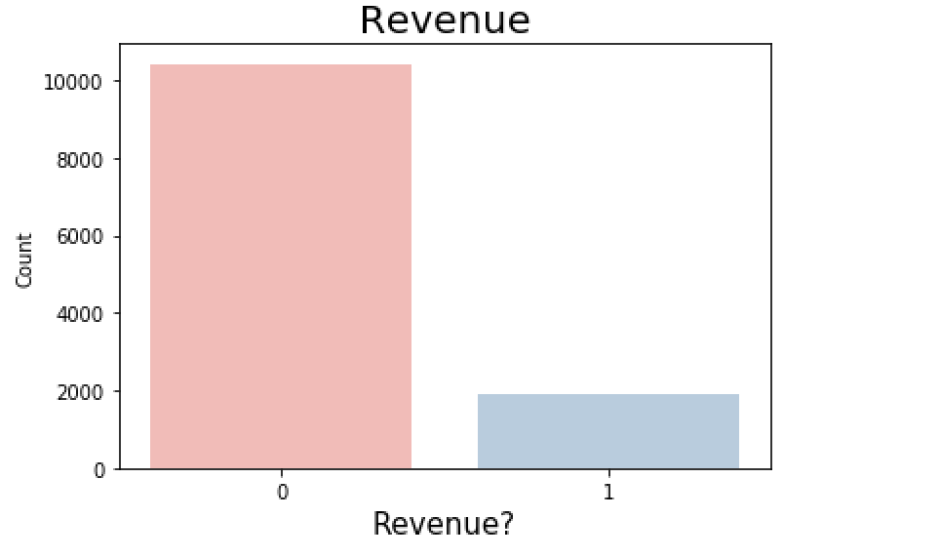

﻿## **Testing with the split ratio 70:30**

x = data

# removing the target column revenue from x

x = x.drop(['Revenue'], axis = 1)

y = data['Revenue']

# checking the shapes

print("Shape of x:", x.shape)

print("Shape of y:", y.shape)

# Inspect the data

x.head()

y.head()

# Standardize the predictive attributes.

from sklearn.preprocessing import StandardScaler

scalar = StandardScaler()

X = scalar.fit_transform(x)

# Split the data

from sklearn.model_selection import train_test_split

x_train, x_test, y_train, y_test = train_test_split(X, y, test_size=0.30, random_state=0)

﻿# Fit the Tuned XGBoost Model

#from xgboost import XGBClassifier

modelXGB_Tuned = XGBClassifier(learning_rate=0.01, n_estimators=700, max_depth=5, subsample=0.9, colsample_bytree=1.0, gamma=5)

modelXGB_Tuned.fit(x_train, y_train)

﻿# probability prediction months

y_pred = modelXGB_Tuned.predict(x_test)

y_pred_prob = modelXGB_Tuned.predict_proba(x_test)

﻿# Evaluate the model

print("Training Accuracy for XGBoostClassifier_Tuned:", modelXGB_Tuned.score(x_train, y_train))

print("Testing Accuracy for XGBoostClassifier_Tuned:", modelXGB_Tuned.score(x_test, y_test))

# Print the performance metrics

print(confusion_matrix(y_test,y_pred))

print(classification_report(y_test,y_pred))

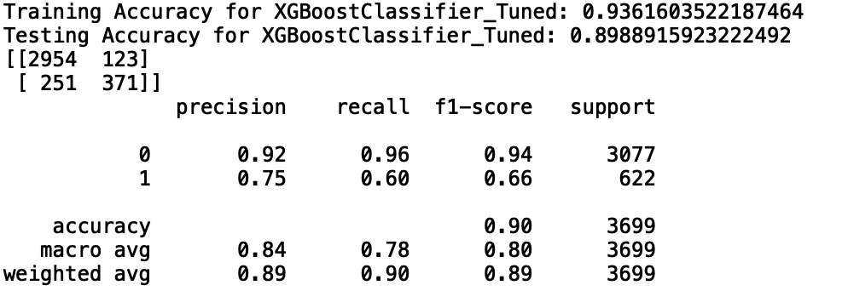

# **Testing with the split ratio 70:15:15**

x = data

# removing the target column revenue from x

x = x.drop(['Revenue'], axis = 1)

y = data['Revenue']

# checking the shapes

print("Shape of x:", x.shape)

print("Shape of y:", y.shape)

# Inspect the data

x.head()

y.head()

# Standardize the predictive attributes.

from sklearn.preprocessing import StandardScaler

scalar = StandardScaler()

X = scalar.fit_transform(x)

# Split the data

﻿x_train, x_test, y_train, y_test = train_test_split(X, y, test_size=0.15, random_state=0)

 x_train, x_val, y_train, y_val  = train_test_split(x_train, y_train, test_size=0.15, random_state=0)

 # Fit the ML model

modelXGB_Tuned = XGBClassifier(learning_rate=0.01, n_estimators=700, max_depth=5, subsample=0.9, colsample_bytree=1.0, gamma=5)

modelXGB_Tuned.fit(x_train, y_train)

 ﻿# Evaluate the model

print("Training Accuracy for XGBoostClassifier_Tuned:", modelXGB_Tuned.score(x_train, y_train))

print("Testing Accuracy for XGBoostClassifier_Tuned:", modelXGB_Tuned.score(x_test, y_test))

print("Validatation Accuracy for XGBoostClassifier_Tuned:", modelXGB_Tuned.score(x_val, y_val))

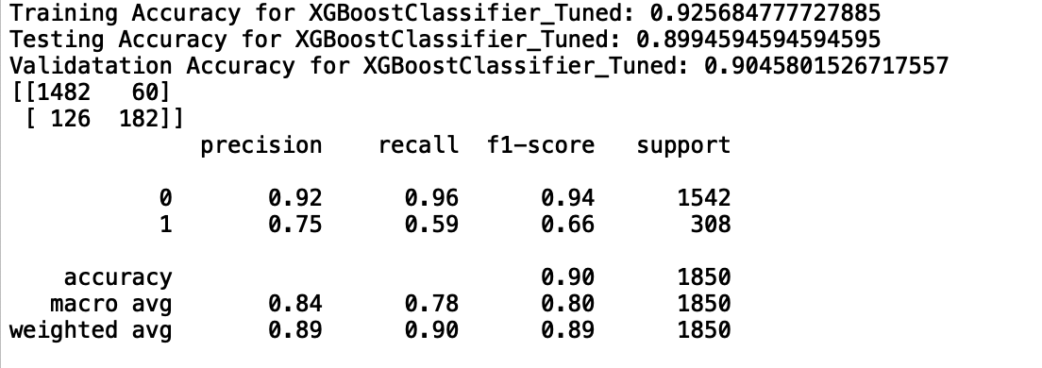

Performance Results of the ML Models (RF, GBM and XGBoost)

#Fit a Random Forest model

modelRF = RandomForestClassifier()

modelRF.fit(x_train, y_train)

y_pred = modelRF.predict(x_test)

# Evaluate the model

print("Training Accuracy for RandomForestClassifier:", modelRF.score(x_train, y_train))

print("Testing Accuracy for RandomForestClassifier:", modelRF.score(x_test, y_test))



# Print the performance metrics

print(confusion_matrix(y_test,y_pred))

print(classification_report(y_test,y_pred))

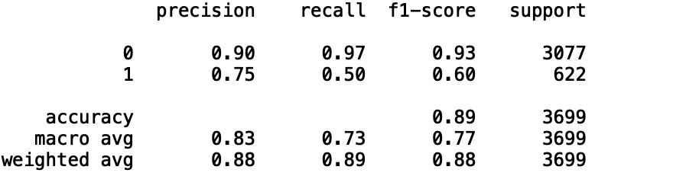

#Fit a Gradient Boosting model

modelGBM = GradientBoostingClassifier()

modelGBM.fit(x_train, y_train)

y_pred = modelGBM.predict(x_test)

y_pred_prob = modelGBM.predict_proba(x_test)

﻿### XGBoost Model

# Fit the XGBoost Model

modelXGB = XGBClassifier()

modelXGB.fit(x_train, y_train)

y_pred = modelXGB.predict(x_test)

y_pred_prob = modelXGB.predict_proba(x_test)

# Evaluate the model

print("Training Accuracy for XGBoostClassifier:", modelXGB.score(x_train, y_train))

print("Testing Accuracy for XGBoostClassifier:", modelXGB.score(x_test, y_test))

# Print the performance metrics

print(confusion_matrix(y_test,y_pred))

print(classification_report(y_test,y_pred))

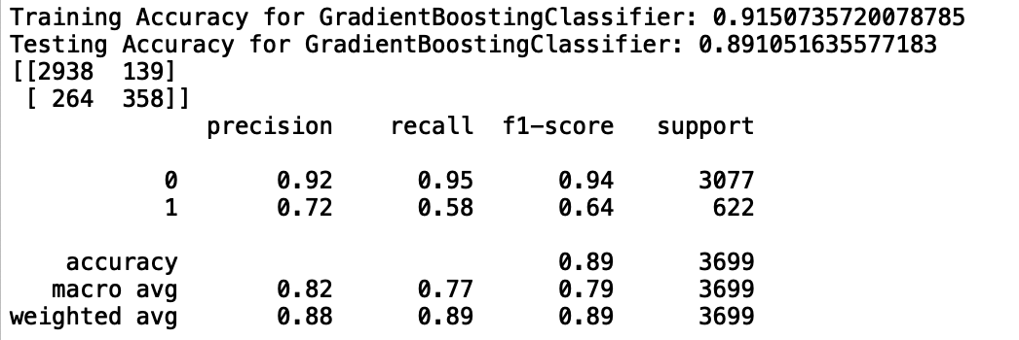

﻿### XGBoost Model

# Fit the XGBoost Model

from xgboost import XGBClassifier

modelXGB = XGBClassifier()

modelXGB.fit(x_train, y_train)

y_pred = modelXGB.predict(x_test)

y_pred_prob = modelXGB.predict_proba(x_test)

# Evaluate the model

print("Training Accuracy for XGBoostClassifier:", modelXGB.score(x_train, y_train))

print("Testing Accuracy for XGBoostClassifier:", modelXGB.score(x_test, y_test))

# Print the performance metrics

print(confusion_matrix(y_test,y_pred))

print(classification_report(y_test,y_pred))

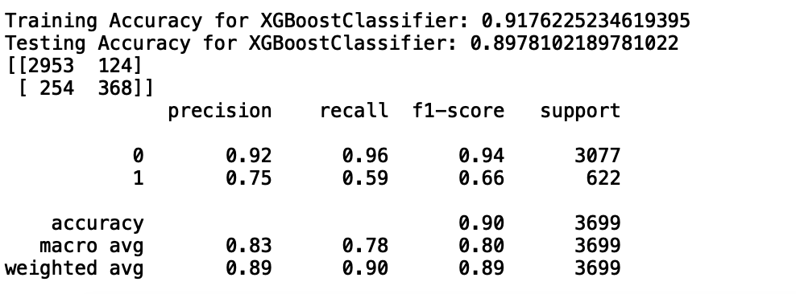

Performance of the XGBoost model with the Hyperparameter Tuning:

﻿# Fit the Tuned XGBoost Model

#from xgboost import XGBClassifier

modelXGB_Tuned = XGBClassifier(learning_rate=0.01, n_estimators=700, max_depth=5, subsample=0.9, colsample_bytree=1.0, gamma=1)

modelXGB_Tuned.fit(x_train, y_train)

﻿# probability prediction months

y_pred = modelXGB_Tuned.predict(x_test)

y_pred_prob = modelXGB_Tuned.predict_proba(x_test)

﻿# Evaluate the model

print("Training Accuracy for XGBoostClassifier_Tuned:", modelXGB_Tuned.score(x_train, y_train))

print("Testing Accuracy for XGBoostClassifier_Tuned:", modelXGB_Tuned.score(x_test, y_test))

# Print the performance metrics

print(confusion_matrix(y_test,y_pred))

print(classification_report(y_test,y_pred))



# **Snippet of the code to get the Accuracy by Months**

﻿# show the inputs and predicted outputs

# make a prediction

y_test_array = np.asarray(y_test)

x_test_array = np.asarray(x_test)

x_test_df = pd.DataFrame(x_test)

y_test_df = pd.DataFrame(y_test)

y_pred = modelXGB_Tuned.predict(x_test)

y_pred_df = pd.DataFrame(y_pred)

from sklearn.metrics import accuracy_score

f = open("month_xgb1.csv", "w")

for i in range(len(x_test)):

print("%s, %s, %s, %s, %s, %s" %(x_test_df._get_value(i, 10, takeable = True),\

y_test_df._get_value(i, 0, takeable = True), \

y_pred_df._get_value(i, 0, takeable = True), \

y_test_prob_df._get_value(i, 0, takeable = True), \

y_test_prob_df._get_value(i, 1, takeable = True), \

accuracy_score(y_test_array[[i]], y_pred[[i]])), file = f)

f.close()

# Added the columns to the file “month_xgb1.csv” and renamed it as “﻿month_xgb_accuracy.csv” # Note: We can use the same file as well, but we renamed it to avoid overwriting the file.

data_mon = pd.read_csv("month_xgb1.csv")

data_mon.columns

total = data_mon['Month'].value_counts()

correct = data_mon['Month'][data_mon['_Actual']==data_mon['_Predicted']].value_counts()

accuracy = correct/total

**Partial Dependence Plot**

To check the relationship between “Month” and “Revenue”, we plotted the “Partial Dependence Plot”

Keeping every other feature except month fixed and analyzing different levels of month and how it effects the probability of shopping.

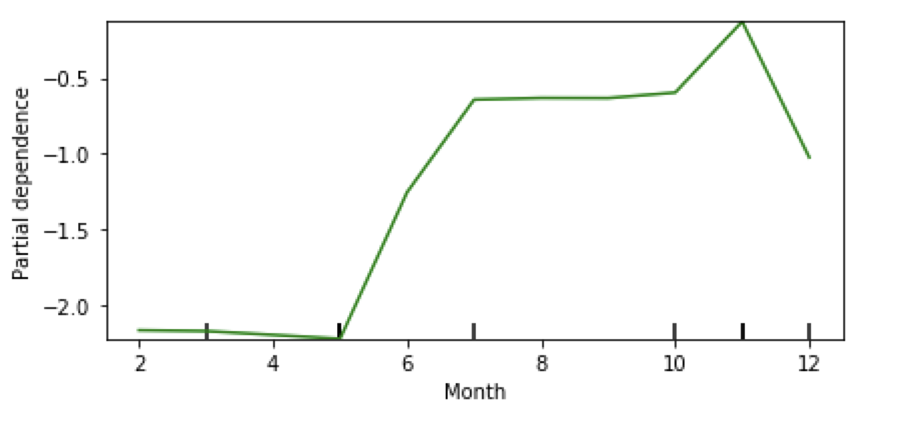

From the above plot we can interpret that people tend to shop more in the second half of the year than the first. This might be related to the expected slowdown after new year’s shopping. We can also see a surge in purchasing in summers and holiday times, that is in November, which is also an expected shoppers’ behavior, as people tend to shop more during summer and holiday times.